

DXC Lösungsbeschreibung

DXC Response to BOYFRIEND

Service concept System L – Lot 1

11. April 2022

**DXC Lösungsbeschreibung**

DXC Response to CARIAD

Plant L Service concept Lot **1**

11. April 2022

Table of contents

1Introduction6

2Service Concept Lot 17

2.1Locations13

2.2Ubcontracters16

2.3Technology, Systems, Tooling17

2.3.1DXC Experience with tools and systems at CARIAD17

2.3.2Technical Architecture Tool - Landscape17

2.3.3Testing Tools 19

2.4Leistungsumfang - DevOps Service Delivery 24

2.4.1Quality with regard to the development services to be provided25

2.4.2Exkurs: DXC CyberApplikation Security 30

2.4.3DevOps Model34

2.4.4Supportstruktur 43

2.4.5Interfaces46

2.4.6Zusammenarbeitsmodell 48

2.4.7IT-Service Continuity Prozess 48

2.4.8Knowledge management52

2.5Service Roles65

2.5.1Further education and training of the employees deployed70

2.6Reports and communication73

2.6.1Metrics and dashboards74

2.6.2Beispielberichte 77

2.7Service Level Agreement 77

2.7.1Critical success factors78

2.8Quality improvement / quality assurance80

2.8.1Acception, adaptation of an existing CSI process80

2.8.2The Continuous Service Improvement Approach82

2.8.3Template support in the CSI process83

2.8.4Inbox channels and dependencies84

2.8.5Risks85

2.8.6Innovations Management 86

2.9More89

3Annex of  reports91

3.1Process Reports91

3.2Performance Reports94

3.3Security Reports95

3.4Risk & Compliance Reports96

4Other Annexes97

4.1Assigning the DXC expert to the required CARIAD technologies97

4.2Overview of SAFe roles and responsibilities Portfolio up to Team Level100

List of tables

Table 1Assignment DXC Roles11

Tabelle 2DXC DevOps Sprint, Additional & Enablement Teams 12

Table 3CARIAD Test Tools22

Table 4Test Automation Tool TestMagic23

Table 5 Skills deployed45

Table 6Risk-based categories49

Table 7Recovery Solutions52

Table 8Tool Overview Knowledge Management Support55

Table 9CARIAD Guild Examples58

Table 10Service & Release Roles65

Table 11Resource overview (number/experiences) 67

Table 12Quantitative planning of resources69

Table 13Agile/DevOps metrics76

Table 14Team-level metrics76

Table 15Overview of critical success factors78

Table 16Schematic overview of a CSI decision template84

Table 17Risks & Mitigation86

Table 18Example Reports: – Process Reports94

Table 19Example Reports: – Performance Reports94

Table 20Example Reports: – Security Reports96

Table 21Example Reports: Risk & Compliance Reports96

Table 22DXC Expert Assignment to CARIAD99

Table 23R&Rs SAFe Portfolio Level100

Table 24R&Rs SAFe Solution Level101

Table 25R&Rs SAFe Program Level102

Table 26R&Rs SAFe Team Level103

List of illustrations

Figure 1DXC Application Services Delivery Model8

Figure 2Account Governance8

Abbildung 3Service & Release Management 9

Abbildung 4Account Delivery Team – Schlüsselrollen 9

Figure 5Account (DevOps) Organization11

Figure 6DXC Global Delivery Organization13

Figure 7DXC Delivery Mix as a Successful Model13

Figure 8DXC Delivery Organization for CARIAD (Locations/Countries) 14

Figure 9Assignment of deliveries, roles, and countries15

Figure 10DXC Technology (excerpt) 17

Figure 11DevOps Architecture18

Figure 12 Approach to intelligent automation18

Figure 13 Application Services Automation19

Figure 14SCORE Method20

Figure 15Overview testMagic from Universal Technology Solutions21

Figure 16SAFE - 5 Dimensions "Built-in Quality" 25

Figure 17DXC capabilities to support agile development26

Abbildung 18Cybersecurity Solution Services Overall Scope Map 30

Figure 19DXC AppSec Process32

Figure 20Example DevSecOps Integration and Process Flow33

Figure 21Responsibility of OSA34

Figure 22Basic process (Source: CARIAD Specifications V1) 34

Figure 23SAFe 5 Framework35

Figure 24SAFe Focus on Program & Team Level36

Figure 25Team backlog development under SAFe36

Figure 26Proposed Delivery Model – Based on SAFe37

Figure 27Incoming channels into end-to-end responsibility38

Figure 28Influence factors on the development process40

Abbildung 29Integration Dev Workflow und Ops Workflow 41

Figure 30Sprint teams integrate incidents, alarms into the current Sprint41

Figure 31 Inclusion of approved innovation topics in the backlog42

Figure 32Proxy Product Owner Schematic Role Distribution43

Figure 33Service & Release Management Activities43

Figure 34Service Management Activities44

Figure 35Hybrid Delivery Model47

Figure 36Various delivery cycles in the development process47

Figure 37Knowledge Management Cycle & Artifacts52

Figure 38Career & Knowledge Transfer Mission Statement "ITX Model" 54

Figure 39Adapted Spotify Guild Model56

Figure 40Exploitation example from a DXC Chapter57

Figure 41Extract from guilds currently operating at DXC58

Figure 42Knowledge Transfer Categories59

Figure 43Role-based knowledge transfer61

Figure 44Service Management Oriented Knowledge Management63

Figure 45Decision template68

Figure 46DXC Application Services in numbers69

Figure 47Example of a Skill Matrix for a DevOps Factory71

Abbildung 48Continuous Agile/DevOps Enablement Framework 71

Figure 49Partner Network Training72

Figure 50Communication Model73

Figure 51Meeting Board Structure (Part 1) 73

Figure 52Meeting Board Structure (Part 2) 74

Figure 53End-to-End Visibility - Data-Driven Eco-System77

Figure 54Service Times77

Figure 55Limiting process for potential service improvements82

Figure 56Service Improvement Inbound Channels and Processing Steps85

Figure 57DXC Understanding of Innovation86

Figure 58 Entry point for innovation in the SAFe model87

Figure 59Innovation Process Model87

Figure 60Double Diamond Approach88

Figure 61Innovation flow via the Innovation Board89

Figure 62DXC Services for VWG90

Figure 63DXC-Luxoft Projects90

List of CARIAD questions from Appendix L Service Concept

CARIAD Question 1: 1.1.1.a) b. Locations/ countries13

CARIAD Question 2: 1.1.1.a) a. Division of roles? Onshore/Offshore/Onsite? 15

CARIAD Question 3: 1.1.2 a) If you want to use subcontractors, what role do they play in your service concept and how do you integrate them into the service provision? b) How is the subcontractor controlled by you and monitored with regard to the provision of services? c) In what periods will the planned subcontractors be used? (At the beginning of the service, permanently during the entire term, etc.) 16

CARIAD Question 4: 1.1.3.a) Present your experience and knowledge of the technologies currently in use at AG. 17

CARIAD Question 5: 1.1.3.b) With which own tools and/or systems do you plan to support the provision of the service? 17

CARIAD Question 6: 1.1.3.c) Describe your proposed solution for a uniform tool landscape for testing. 19

CARIAD Question 7: 1.1.4.a) How do you ensure high quality in terms of the development services to be provided? 25

CARIAD Question 8: 1.1.4.b) How do you implement the required DevOps model? 34

CARIAD Question 9: 1.1.4.c) How do you provide the required support structure? 43

CARIAD Question 10: 1.1.4.d) What interfaces are there to other delivery units involved? What do they look like? 46

CARIAD Question 11: 1.1.4.e) What is your cooperation model with other service delivery units of the WORKING Group? 48

CARIAD Question 12: 1.1.4.f) Describe your proposal for building the IT Service Continuity Process. 48

CARIAD Question 13: 1.1.4.g) Describe your concept for building and managing knowledge. 52

CARIAD Question 14: 1.1.5.a) Show how you map the required roles in your service organization. 65

CARIAD Question 15: 1.1.5.c) How do you ensure that there is no dependence on individual employees due to their monopoly knowledge? 65

CARIAD Question 16: 1.1.5.b) How do you reduce dependence on individuals? 66

CARIAD Question 17: 1.1.5.d) How do you and your team cope with peak performance? 66

CARIAD Question 18: 1.1.5.e) What is your specific proxy regulation? 66

CARIAD Question 19: 1.1.5.f) Represent the number of resources (FTE) per team, including anonymized skill profiles and their respective professional experience, and for which task/process they are intended. 67

CARIAD Question 20: 1.1.5.g) Make as transparent as possible how you came to the quantitative planning of resources and explain your calculation scheme. 68

CARIAD Question 21: 1.1.5.h) How do you ensure that the full number of planned resources can be made available at short notice, no later than 14 days after signing the contract69

CARIAD Question 22: 1.1.5. i) Which resources work with which tasks at which delivery location (absolute and % distribution)? 70

CARIAD Question 23: 1.1.5.j) How many employees are there for the service in the company, how many would first have to be recruited in a targeted manner (data in % and absolute)? 70

CARIAD Question 24: 1.1.5.k) What efforts are being made with regard to the further education and training of the staff deployed? 70

CARIAD Question 25: 1.1.6.a) Describe the planned communication model vis-à-vis the AG. 73

CARIAD Question 26: 1.1.6.b) On what basis are reports produced? 74

CARIAD Question 27: 1.1.7.a) Illustration/operation of service hours77

CARIAD Question 28: 1.1.7.b) Illustration/operation of the service level requirement78

CARIAD Question 29: 1.1.7.c) From your point of view, what are the critical success factors for compliance with the Service Level Agreement78

CARIAD Question 30: 1.1.8.a) Roadmap for the further development/optimization of the service over the term of the contract80

CARIAD Question 31: 1.1.8.b) What risks do you expect within the provision of the service and what are your risk minimization measures? 85

CARIAD Question 32: 1.1.9.a) What experience do you have at the AG / in the corporate environment89

# Introduction

DXC has analyzed CARIAD's information and requirements in the tender documents, the information from the bidder meeting and the answers provided from various bidder questions and understands the challenges associated with building a complex DevOps organization for the entire Volkswagen Group.

DXC will meet these challenges with a holistic and innovative solution proposal. DXC is convinced that with this offer from CARIAD it can offer a tailor-made and innovative solution at an attractive price . This will further expand and advance the existing long-term and strategic partnership between the Volkswagen Group and DXC.

The DXC solution described below combines the proven best practices of the ITIL Service Management Standard with the advantages of the agile software development methodology or the SAFe framework. The DevOps organization presented by DXC creates the conceptual and organizational framework, which is to be understood as a kind of factory approach to transfer the requirements required by CARIAD **into a holistic and self-contained service concept.**

The design of the DXC solution takes into account all defined goals of CARIAD:

* Overall responsibility for the services along the development chain - from the receipt of the requirements to the development and transfer to the real operation
* Partnership-based cooperation and continuous improvement of the services to be provided
* The availability of qualified and experienced resources in local, nearshore and offshore locations
* Agile new and further development of microservices, software increments
* Drive test automation for systems and components, including regression, load, and performance testing
* Provision of operational tasks in day-to-day business (operational responsibility)
* Seamless troubleshooting, hypercare and problem solving, which are within the responsibility or affect the adjacent systems and interfaces
* Proactive Innovation Management & Continuous Service Management Improvement

DXC is applying for both lots of the tender provided. The DXC solution proposal is designed in such a way that it can be easily used for all lots as well as the development platforms behind them. Both service concepts therefore overlap completely for Lot 1 (Core) and Lot 2 (CAR2X).

In addition, the solution offered includes all the services required by CARIAD in the tender. Appendix B attached to this invitation to tender therefore does not contain any exclusions from the services required by CARIAD.

The solution concept presented in this document has a multi-level structure. First, a completely uniform presentation of the DXC solution proposal is carried out. In the following sections, individual sub-areas of the solution are then further deepened in the structure specified by CARIAD.

# Service Concept Lot 1

In the following, we would like to introduce you to our service concept for **Lot 1 "Core" +**  "**Other** **Services"** + "**Enabler Services",** as required by CARIAD in the specifications.

The core element of the DXC service concept is the implementation of a self-contained DevOps service organization (factory) with clear roles and responsibilities. This also includes an inherent communication model that ensures stable and high-quality service delivery as well as flexible and agile in terms of action and reaction speed. This enables DXC to meet the short-term requirements of CARIAD customers.

CARIAD will benefit significantly from our experience in setting up and operating industrial service concepts. We have successfully proven this with hundreds of customers. The service concept provides for the current situation to be assessed in daily stand-up meetings, in particular with regard to the following aspects:

* What is the status in troubleshooting and problem solving of new and existing P1, P2 and P3 tickets, which are the responsibility of both our Level 2 and Level 3 teams and third parties?
* Which tickets are to be classified as critical and what is the processing status of these tickets?
* What is the status of application development in the respective development teams?

The daily examination of these 3 questions enables DXC, in accordance with the requirements of CARIAD, to react flexibly to new situations and thus adapt the backlog of upcoming tasks, problem solutions and development activities accordingly. As a result, DXC will significantly reduce the volume of reactive or "unplanned work" while significantly increasing the proportion of proactive changes or "planned work".

DXC relies on a SAFe-focused delivery model that provides a common basis for smooth collaboration between the operational units of the DevOps organization through its automated digital processes. The model is also designed in accordance with the certifications required by CARIAD, e.B. TISAX and Automotiv SPICE. It thus enables the assumption of end-to-end responsibility for connected car services.

The realization of the DXC DevOps organization for CARIAD is also supported by DXC's proven and globally uniform collaboration model. It is also characterized by a unified and standardized approach to the provision of services with defined roles and clear responsibilities, interfaces and procedures. At the same time, however, the model is also designed so flexibly that it can easily be tailored to the specific situation of CARIAD. The model enables DXC to provide CARIAD with the required services in 7x24-hour operation throughout the entire software lifecycle.

Other key components of the DXC solution include:

* A **dedicated account team** aligned with CARIAD's strategic goals and operational requirements. The team will be based in Ingolstadt to facilitate access to CARIAD's management services and end users.
* **Providing German-speaking resources on a local and global scale** for service delivery, including incident management and proxy product engagement, along with the automotive expertise of DXC's global delivery centers.

The following figure illustrates the organizational structure of the DevOps organization envisaged by DXC.

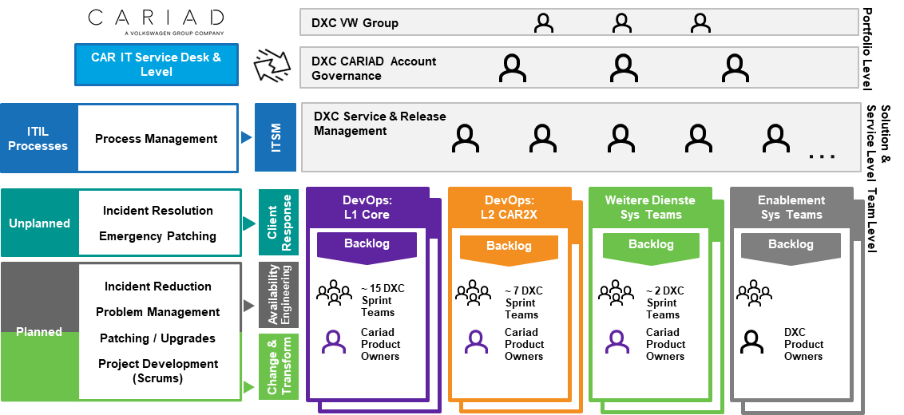

1. DXC Delivery Model for Application Services

The DXC solution includes an account governance team that oversees the service delivery and governance functions. This CARIAD account team will be seamlessly integrated into the global account organization of the DXC Volkswagen Group.

This team consists of the most important account delivery functions and is supported by the underlying delivery team.

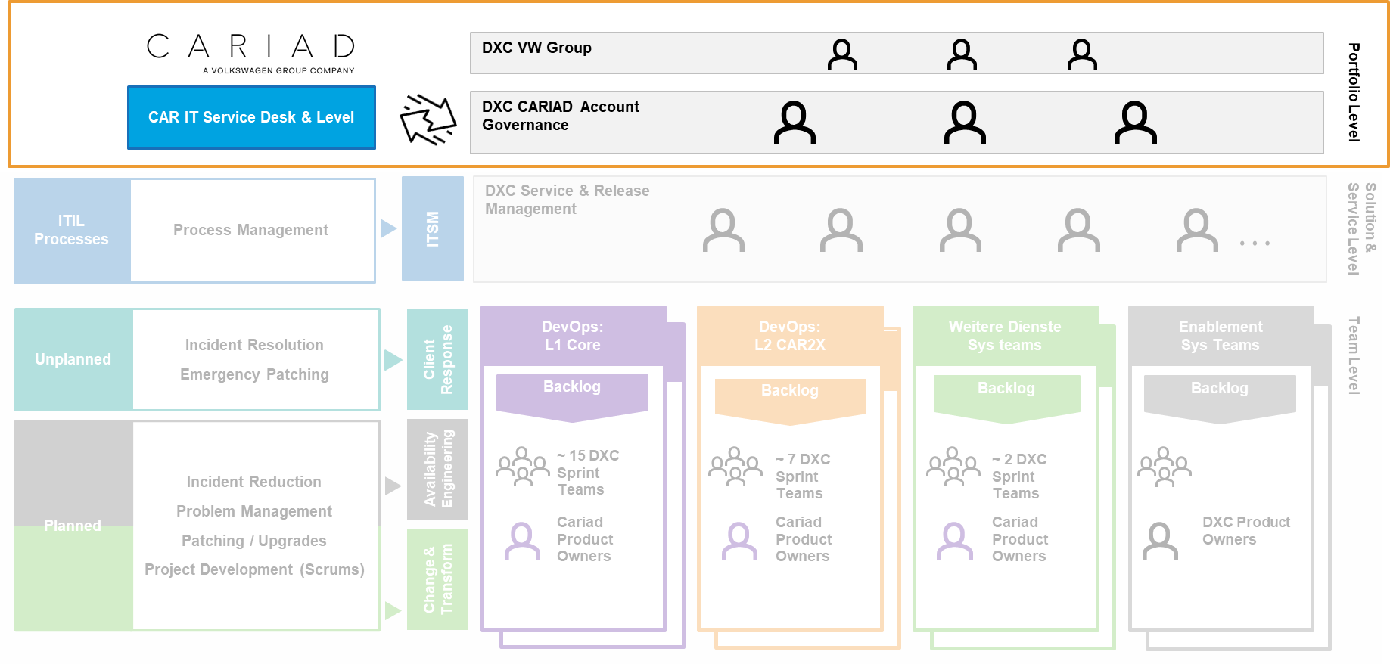

1. Account Governance

The DXC team is led by an Account General Manager who is responsible for the relationships between DXC, CARIAD and other vendors. He will play an important role in established relationships and will be supported by a broader support team. This team will be adapted in size and scope in order to devote itself purposefully to the daily tasks and thus maximize the benefits for CARIAD.

The DXC Account Team will be based in Ingolstadt and will be aligned with CARIAD's strategic goals and operational requirements.

The DXC Service & Release Management layer of the DXC Service Delivery Model forms the bridge between the operational ITIL services and the agile requirements of software development and the associated devOps sprint teams.

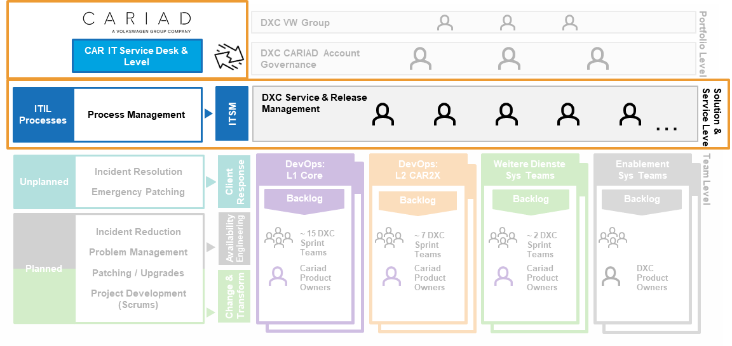

1. Service & Release Management

DXC will provide a german-language Service & Release Management feature that will handle the roles required by CARIAD.

As part of the current tender, we have provided the following account organization with its core roles on the basis of its specifications V1.

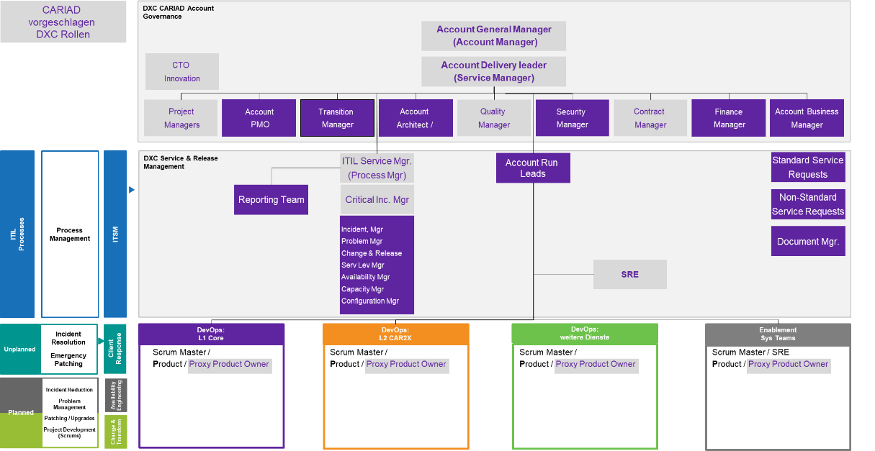

1. Account Delivery Team – Schlüsselrollen

The table below illustrates the roles that meet the requirements in Section 2.4.6 of the Specifications, together with the processes supported in Section 2.3.3 of the ITIL Standard Processes and the collaboration forums in which they will participate:

| **DXC Official Role Designation** | **Assignment of DXC roles to the AN roles mentioned in the specifications** | **Field of responsibility** |
| --- | --- | --- |
| Account General Manager | Account Manager | The Account General Manager (AGM) is the contact person for all strategic matters of CARIAD |
| Account Delivery Leader | Service Manager | For service management, it is used as a central point of contact with regard to deliveries and services. |
| Account Business Manager |  | The Account Business Manager (ABM) is responsible for all financial, billing, contract fulfillment, and new business management functions. Further team functions (e.B. Commercial Contract Service Request and Catalog Management)  Support the ADL as needed. |
| Account Enterprise Architect |  | Architect for Enterprise Solutions. Works together with SRE. VW/Audi/CARIAD Solutions Overview |
| Chief Technology Officer (CTO |  | Innovation Manager |
| Standard Service Request Manager | Process Manager | DXC Manager Rolle für Standard Service Requests Management |
| Non-Standard Service Request Manager | Process Manager | DXC Manager Rolle der Non Standard Requests (Angebotsanfragen - Projektanfrage) |
| Document Manager |  | Document Management |
| Project Manager |  | Management of projects |
| Account PMO |  | Project Management Office |
| Account Run Lead |  | Specialist operations managers and process managers are used for the operational provision of services. They support the Account Delivery Lead and also take on tasks with direct customer communication in their area of responsibility in coordination with the ADL. |
| Contract Manager |  | Contract Management |
| Quality Manager |  | Quality Management & Continuous Service Improvement (CSI Process) Chapter 2.8.2 |
| Security Officer |  | An Account Security Officer is used for security, data protection & compliance management, who is also the contact person for risk management. |
| Account Architect |  | Account Architect für DXC End-to-End Lösungen |
| Account Reporting Team |  | The Account Reporting Team is responsible for creating account reports for sla measurements using tools |
| ITSM Service Manager | Process Manager | Responsible for ensuring the respective ITIL processes. |
| Incident Manager | Process Manager | Incident Management |
| Critical Incident Manager (CIM) | Critical Incident Manager | Critical Incident Management (CIM),  CIM Phone,  Problem Management,  Event Management, inkl. KPM |
| Problem Manager | Process Manager | Problem Management |
| Change und Release Manager | Process Manager | Change Management,  Release Management,  Service Validation und Testing,  Deployment Management |
| Configuration Manager | Process Manager | Configuration Management |
| Availability und Capacity Manager | Process Manager | Availability, Capacity Management und Service Reporting |
| Service Level Manager | Process Manager | Service Level Management |
| Proxy Product Owners | Proxy Product Owner | Interface between and the DevOps team |
| DevOps Sprint Teams | DevOps Team | Scrum Master, Entwickler und Testers, Enablement Team, Technical Architects, Release Train Engineers, Application Security, Agile Coach |
| Site Reliability Engineer | Site Reliability Engineer (SRE) | Overarching role in application development. End-to-end responsibility of individual applications |

1. Assignment DXC Roles

**DevOps Sprint Teams**

This section describes the tasks performed by the DevOps Sprint Teams provided by DXC and how they are set up within the account organization to handle both unplanned and planned tasks.

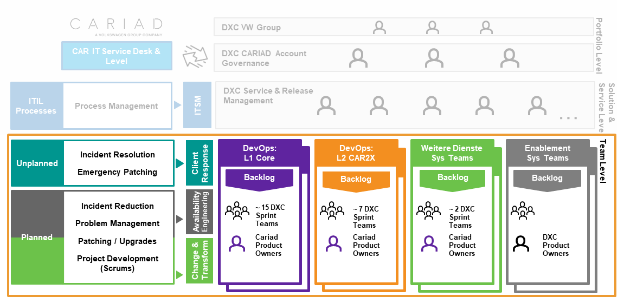

1. Account (DevOps) Organisation

For the sake of simplicity, we present a consolidated picture in this document, in which the "Other Services" and "Enabler Services" are fully taken into account and can be an integral part of a possible assignment.

Depending on the lot, the sprint teams are composed of experienced experts for the respective application category. **They will process the planned development tasks in an end-to-end responsibility in a structured manner according to the current prioritization from the respective backlog.** The use of automation tools and monitoring platforms such as Dynatrace enables continuous quality and efficiency improvements in application development by providing predictive capabilities to avoid service interruptions.­

At the same time, the underlying sprint teams are set up in such a way that they can cover unplanned work such as critical incidents or emergency patching in addition to the planned ongoing application developments.

The 24x7 service model offered by DXC enables the continuation and maintenance of the services even in the event of emergency changes outside normal business hours.

The DXC DevOps Sprint Teams offered are organizationally assigned to the lots specified by CARIAD (Core and Car2X) as well as the "Other Services" and "Enabler Services" Sprint Teams.

| Funktion | Skills Provided |
| --- | --- |
| DevOps Sprint Teams | * Matched to the Lot Core and CAR2X. * Multiple sprint teams will provide both development and operational capabilities for each portfolio. * CARIAD provides the product owners, DXC the proxy product owners. * The teams are independent through business analysts, test engineers and developers. * Operational and functional changes are compiled in a combined backlog that is prioritized together. Details can be found in Chapter 0 DevOps Model |
| Sprint Teams "Other Services" | * Based on the Lot Core, CAR2X. * Multiple sprint teams will provide both development and operational capabilities for each portfolio. * CARIAD provides the product owners, DXC the proxy product owners. * The teams are independent through business analysts, test engineers and developers. * Operational and functional changes are compiled in a combined backlog that is prioritized together. Details can be found in Chapter 0 DevOps Model |
| Enablement Sprint Teams | * The enablement teams contribute the architecture components and program increments to the solution and program backlogs. This allows development teams to create reusable technology frameworks at any time and resolve "technical debts" while developing the features. * They support the functional teams with shared services, architecture support, automation tools, security, pipeline and site reliability capabilities. * DXC provides product owners for the Enablement Sprint teams to ensure that teams can constantly evolve the approach, have a roadmap for improvement, and reap the benefits of fast-moving technological change. * The functional sprint teams should be able to concentrate on their core task without the workflow being affected by the system. This model has been successfully used by DXC in large-scale DevOps programs such as the one for Lloyds of London and follows an industry best practice pattern outlined in the book "Team Topologies" by Manuel Pais and Matthew Skelton. |

1. DXC DevOps Sprint, Additional & Enablement Teams

## Locations

DXC has extensive experience in Agile and DevOps. We can always rely on more than 27,000 Agile and DevOps practitioners with in-depth expertise in handling Agile and DevOps projects. DXC has also built a powerful DevOps global delivery organization from which we will designate the people needed for CARIAD.

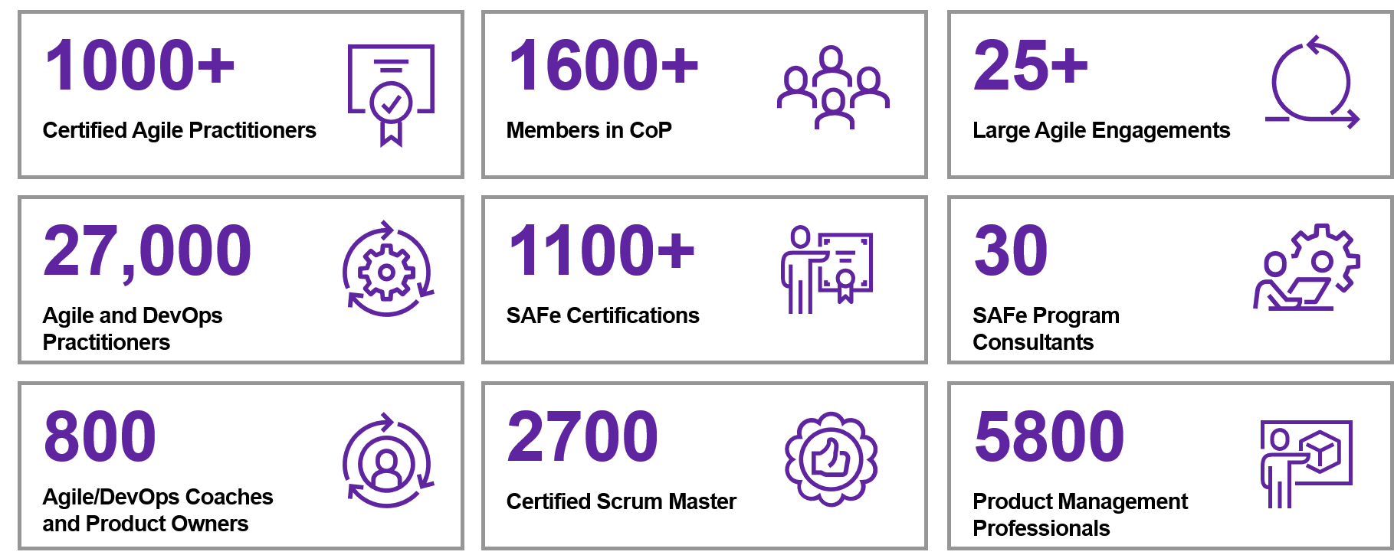

1. DXC Global Lieferorganization

Our DXC team for CARIAD specializes in high-quality services in the field of DevOps, operational integration, service management, for global companies, german and English-speaking customers. The following operating model reflects our understanding of the provision of all advertised services. This operating model is a preliminary model and will be further refined and deepened in the coming weeks together with CARIAD.

The choice of global delivery centers is based on specific competencies for CARIAD's requirements. Depending on the focus, DXC will support CARIAD to meet different requirements, such as customer proximity, data protection or cost-effectiveness.

In summary, DXC has shown the planned delivery organizations / locations for CARIAD in the figure below.

|  |  |
| --- | --- |
|  | **CARIAD Question 1:** 1.1.1.a) b. Locations/Countries |

DXC has a wide range of possible delivery models due to its global presence. Based on your needs and our experience in the DevOps application environment, we've put together a healthy mix of service locations and team splitting, which is explained below.

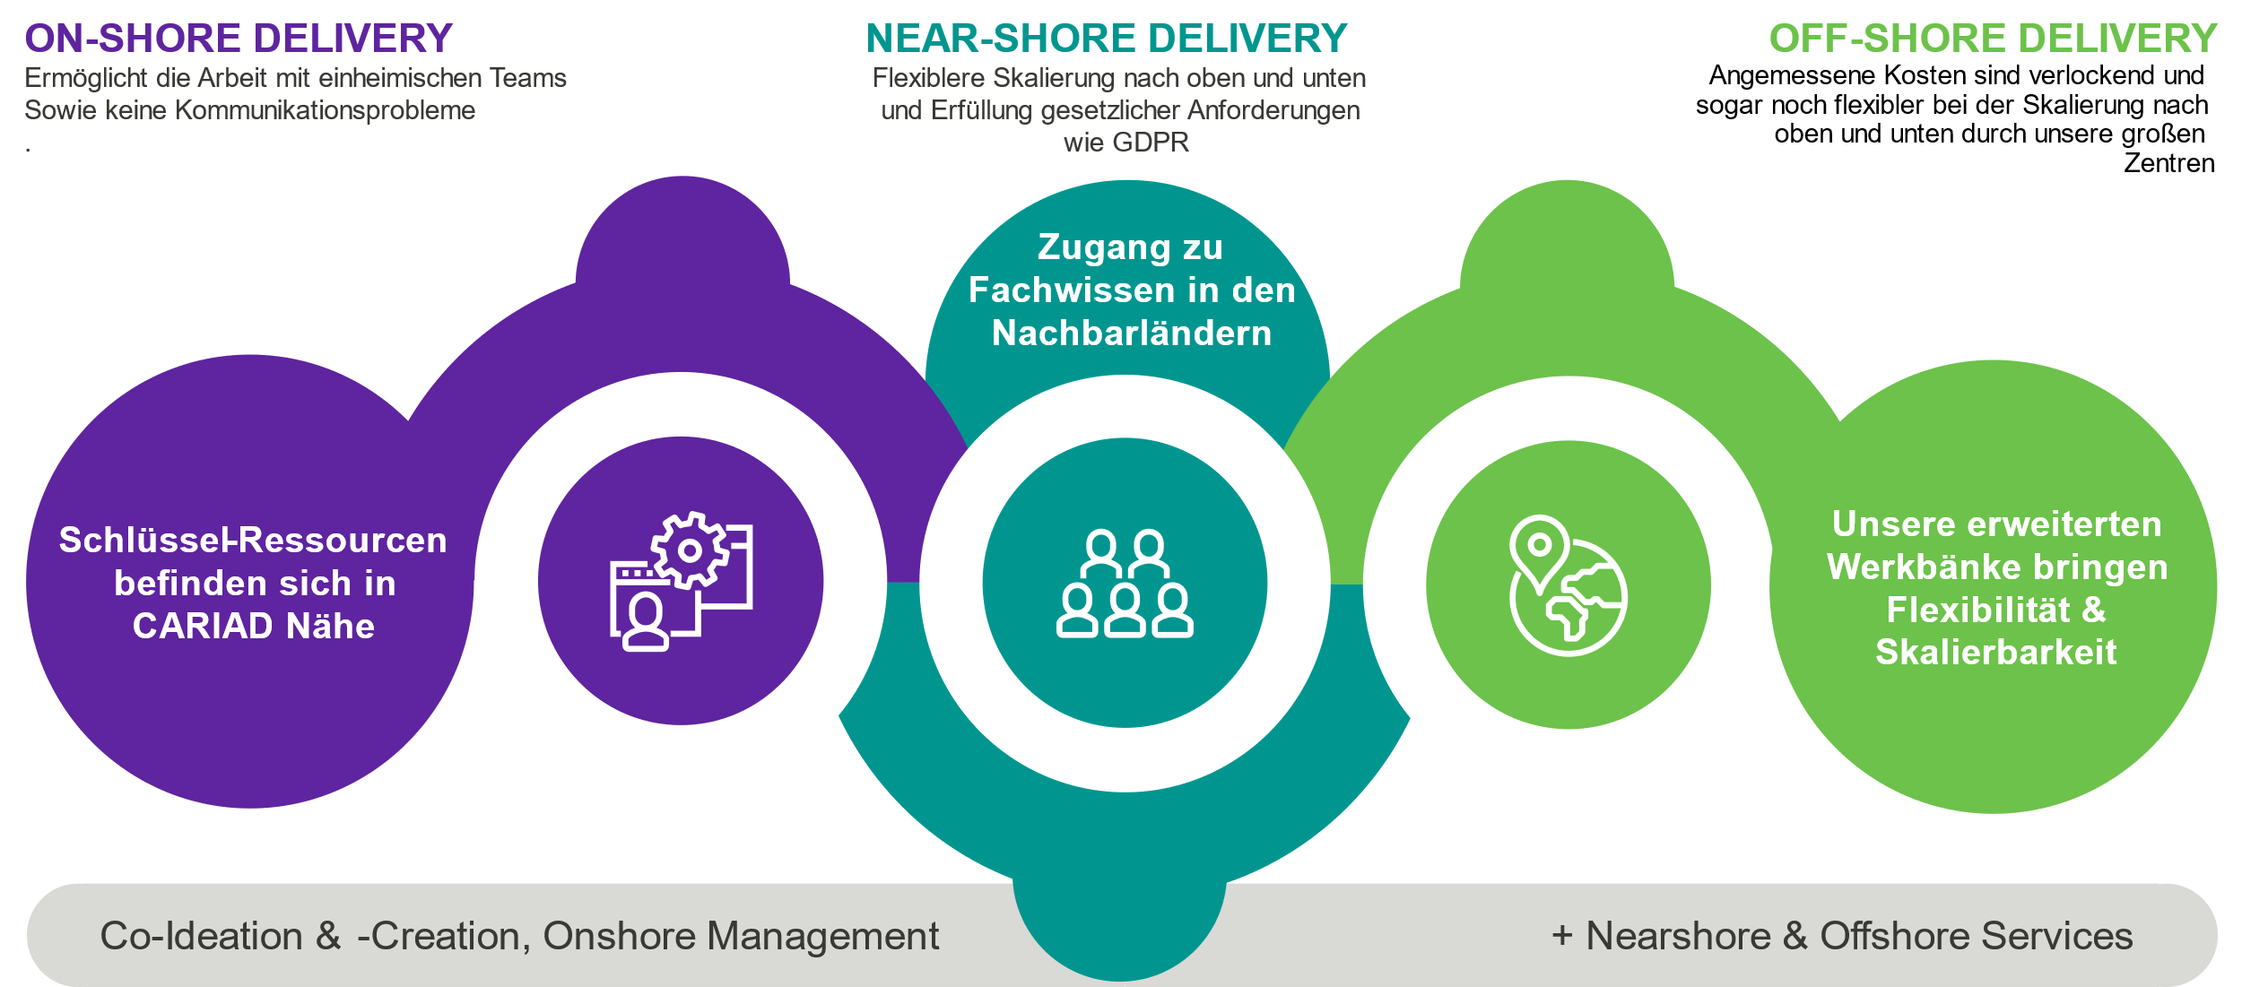

1. DXC delivery mix as a successful model

Even though we do not have detailed requirements regarding delivery locations at this time, we are convinced that the following options are of interest. They deliver customer proximity, reduced language barriers as well as scalability and cost attractiveness at the same time:

**Onshore: Germany**

DXC plans to control the services from Ingolstadt. Due to the proximity to CARIAD, the attendance dates required in Chapter 2.4.7 of the specifications are thus taken into account. In this case, the exchange of information can take place entirely in German. (COVID-related regulations are of course observed by DXC to protect our customers and employees.)­

**Nearshore: Bulgaria**

DXC has strategic delivery centers in several European countries. For CARIAD we plan to provide services from Bulgaria. Possible voting meetings on site in Ingolstadt are easy to realize due to the short distance, the remote voting through the same time zone is also easily given (COVID-related regulations are of course observed by DXC to protect our customers and employees).

For the locations within the European Union, it is an additional advantage that the employees are European citizens, and the location falls under European law. Certain European compliance guidelines are thus ensured.

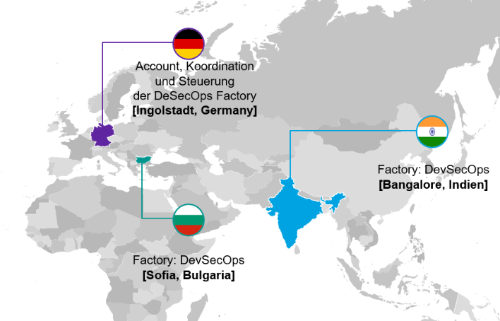

1. DXC Delivery Organization for CARIAD (Locations/Countries)

**Offshore: If**

Our delivery location in India is also one of DXC's strategic delivery centers. It is characterized in particular by a large number of software developers and technical experts, as well as flexible up- and down-scaling. For CARIAD, a dedicated team would be put together here, which would take over the technical and technical requirements for the applications and then be responsible together with the on-site team.

Very short-term trips to Ingolstadt are not possible immediately due to the visa requirement. However, there is a possibility that DevOps experts will be fully active at a CARIAD location for a longer period of time at the beginning of the contract period. (COVID-related regulations are of course observed by DXC to protect our customers and employees).

The selection is not limited to a specific delivery location. Therefore, DXC supports CARIAD in selecting the appropriate delivery location in accordance with CARIAD requirements. DXC firmly believes that all proposed locations meet CARIAD's high quality standards.

|  |  |
| --- | --- |
|  | **CARIAD Question 2:** 1.1.1.a) a. Division of roles? Onshore/Offshore/Onsite? |

The following explanations specifically address the question "Which services/functions are provided by which of your locations? and also to the question of the division of roles into onshore/offshore/onsite?" a.

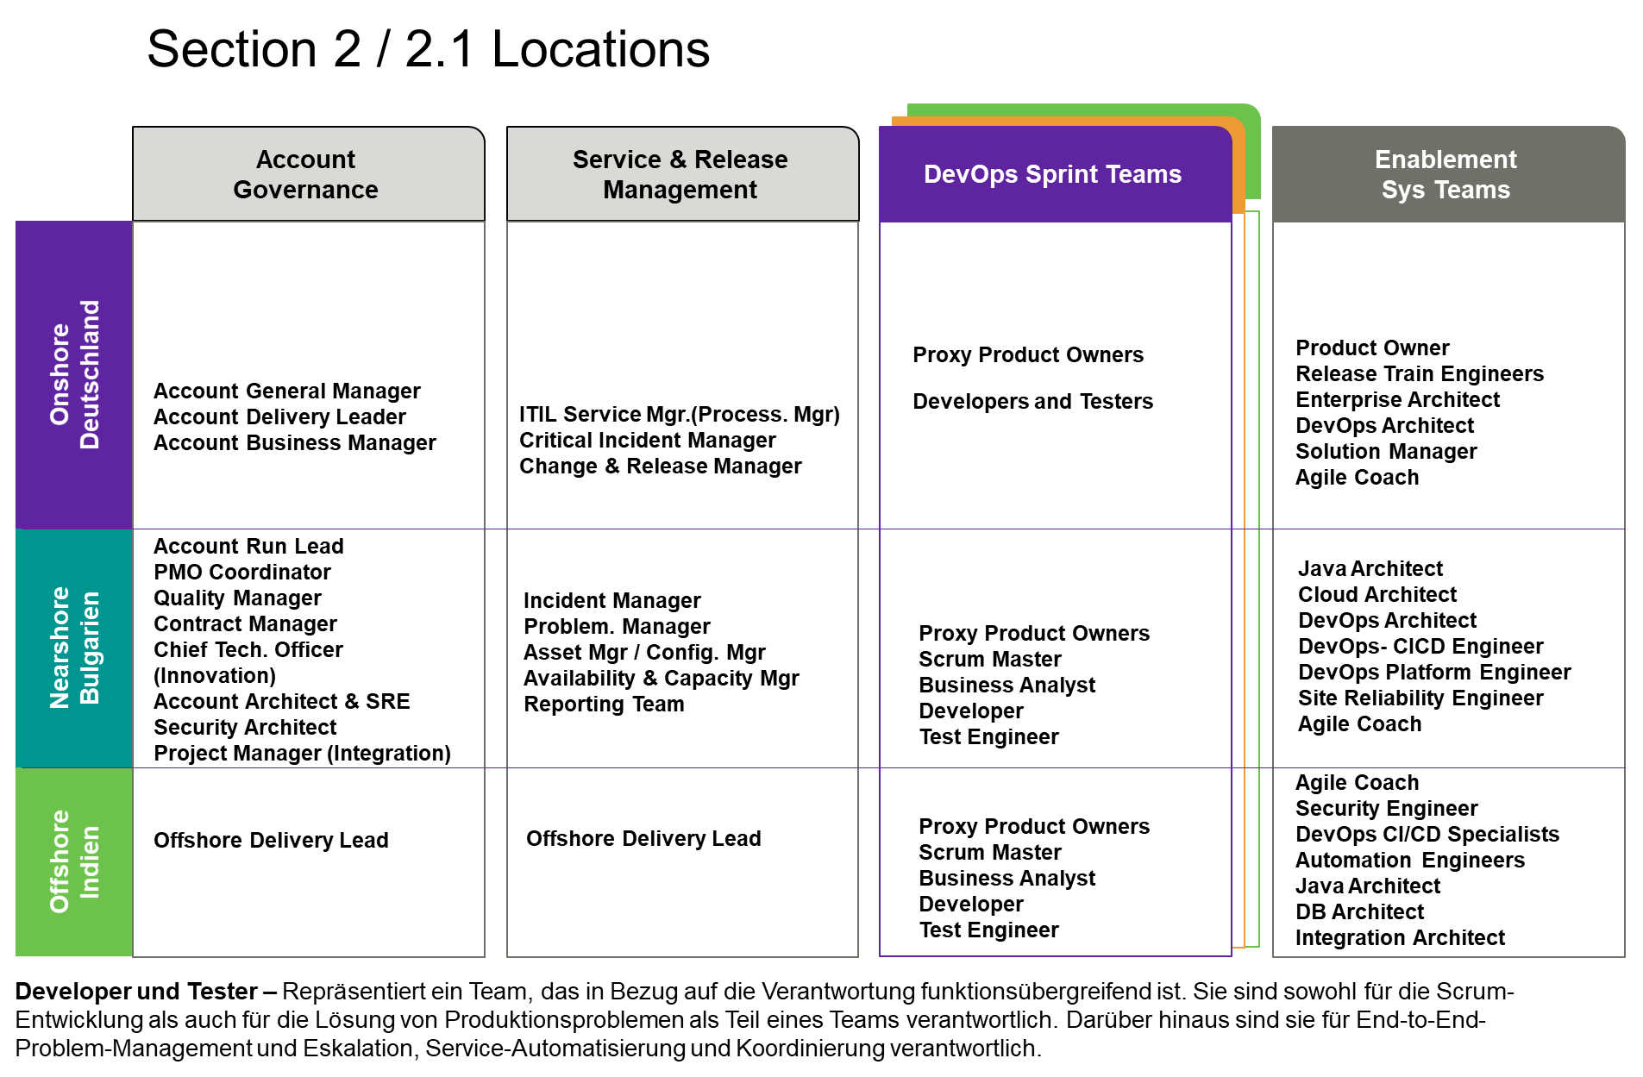

1. Assignment of delivery services, roles and countries

**Onshore Roles**

The recommended roles for Onsite are a team that covers all aspects of service delivery, i.e. Program Governance, Service Management Leads, Domain Architects, Security Lead, Release Train Engineers, and Proxy Product Owner. Further roles are the Critical Incident Manager (incl. CIM Phone according to "Lastenheft_1.0") and the Capacity Coordinator for planning the resource forecast.

As CARIAD is already participating in the modernization and transition to the cloud, we have embraced architecture-related capabilities that will work closely with the company and its transformation. Further proxy product owners were placed in Germany to strengthen the cooperation with CARIAD and to be present at PI-Planning meetings and other important events. The RTEs will drive the release trains, which align with the Core and Car2X program backlog. A team is put together to tackle the critical problems and how to solve them.

**Nearshore Roles**

The nearshore team will focus on enablement services as well as systems that require intensive monitoring and security-related access. The DXC team will work in the same time zone as Germany and act as an extended arm of the DXC Germany team. You will also be involved in critical incidents and troubleshooting activities. All roles of the Sprint Team will be merged to drive collaboration and synergy.

**Offshore Rollers**

This is the team that takes over the core function of processing the backlogs. This Agile Sprint team works on different application or product requirements according to the backlog. The same team will also handle the operational product defects that feed into the product backlog. In addition, there is a mechanism to replenish the team with additional employees in the event of a surge in demand.

The main activities include:

* Agile Scrum team working according to devOps methodology
* Core group of employees who will be available for the term of the contract
* Includes design thinking, consulting, product development, DevOps implementation
* Primary focus: development; Secondary: Extensions/Backlog/Operation

**Summary**

The service delivery model is based on the scope of CARIAD and DXC's global delivery centers specified in the tender:

* DXC's automotive industry experience
* German-speaking roles as the key to cooperation with the customer (incl. CIM and CIM Phone)
* 24x7-Support
* Build cross-functional DevOps teams that align with Core and Car2X, eV application landscape on MBB and ODP platforms
* Availability of skilled workers and coping with a possible surge in demand for future projects in order to mitigate risks associated with the availability of resources

## Subcontractor

|  |  |
| --- | --- |
|  | **CARIAD Question 3:** 1.1.2a) If you want to use subcontractors, what role do they play in your service concept and how do you integrate them into the service provision?b) How is the subcontractor controlled by you and monitored with regard to the provision of services?c) In which periods will the planned subcontractors be used? (At the beginning of the service, permanently during the entire term, etc.) |

In the design of the solution, the involvement of subcontractors was not currently envisaged. DXC reserves the right to call in subcontractors if necessary after consultation with CARIAD.

## Technology, Systems, Tooling

### DXC experience with tools and systems at CARIAD

|  |  |
| --- | --- |
|  | **CARIAD Question 4:** 1.1.3.a) Present your experience and knowledge of the technologies currently in use at AG. |

The tender listed several tools and technologies currently used by MBB and the ODP platform. DXC has extensive knowledge of all the technologies and tools currently used by CARIAD. Our delivery centers work with the tools in the daily scope of work.

In the appendix, chapter 5.1 is a presentation and assignment of the expertise and experience of DXC employees to the technologies required by CARIAD.

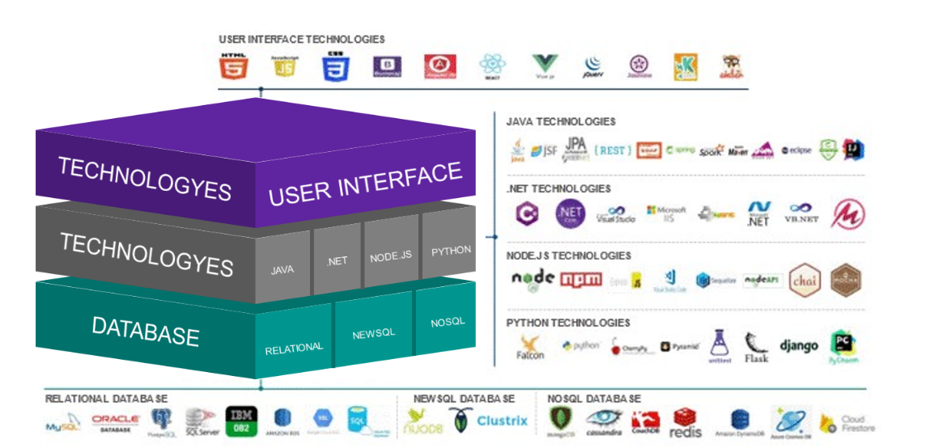

1. DXC Technology (excerpt)

### Technical Architecture Tool - Landscape

|  |  |
| --- | --- |
|  | **CARIAD Question 5:** 1.1.3.b) With which own tools and/or systems do you plan to support the provision of the service? |

All the tools and techniques listed below are to be regarded as proposals and must be further specified together with CARIAD, as no technical documentation on applications, associated technologies used and their dependencies can be provided by CARIAD for this phase of the tender.

The tender also describes several CI/CD tools in use at CARIAD. DXC has extensive experience in using and deploying these tools in various customer environments.

**Our approach to CI/CD tools is based on the following principles:**

* **Use of the tool already available at CARIAD**
* **Identify if there is an absolute need for additional tools during the transition period**

The diagram listed illustrates our association of the tools to the DevOps architecture view. There are certain areas that DXC will evaluate as we move into regular operations after the transition period to improve them if necessary.

DXC has implemented solutions with these tools for multiple customers, and the team is highly skilled and experienced to make future proposals for a higher level of automation that provides stability and benefits for CARIAD.

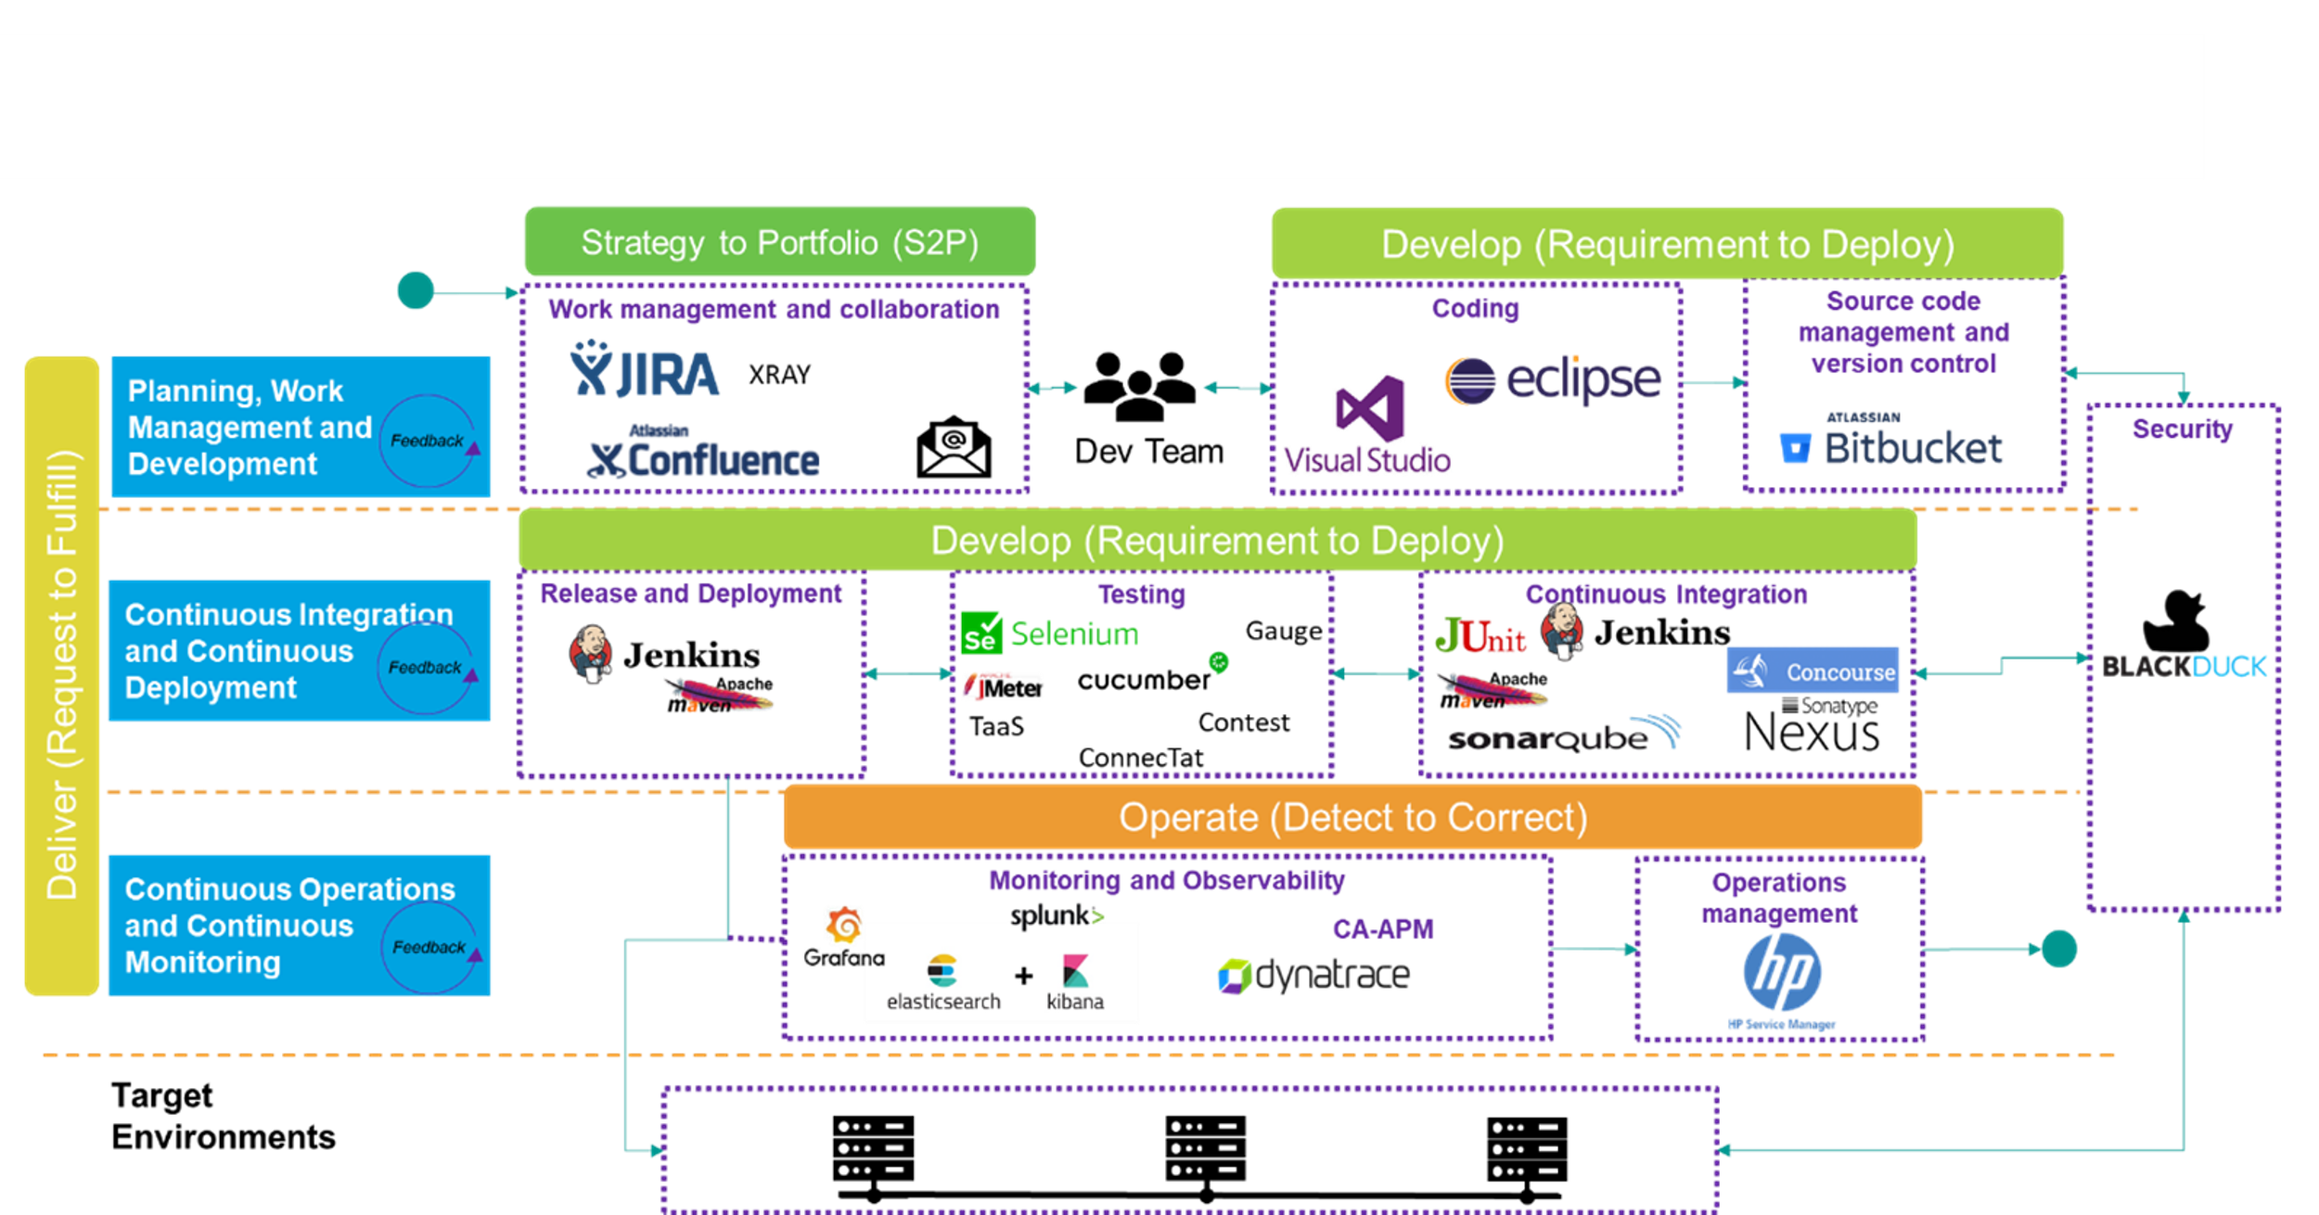

1. DevOps Architecture

During the next tender phase, the DXC team will get an overview of the implementation details for the current DevOps tools, the associated environment and platform, use the current state and provide a concretization of the CARIAD architecture.­

**DXC Proposal to Automate Application Services**

DXC has pioneered the Application Service Automation Framework and offers a comprehensive approach to intelligent automation. It leverages analytics, AI/ML, lean processes and leading automation capabilities to achieve greater insight, speed and efficiency at the enterprise level.

CARIAD uses several monitoring tools, including Dynatrace and CA APM Tool. We can further expand application automation by offering tools that focus on the autoResolve, autoResolve, autoImprove, and autoManage features. This will further transform application support services by continuously automating key processes to increase productivity, improve quality by reducing disruptions, and ensure service consistency.

The approach is based on a framework of four accelerators for service automation and takes into account the central CARIAD goal of continuous improvement (specifications, in particular Chapter 2.3 Objectives and Service Description).

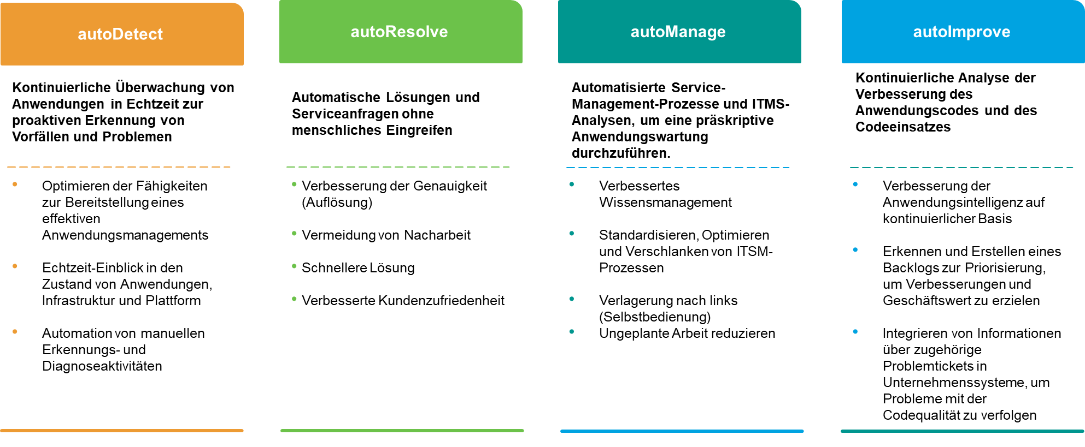

1. Approach to intelligent automation

The framework provides a comprehensive approach to intelligent automation. It leverages analytics, AI/ML, lean processes, and leading automation capabilities to achieve greater insight, speed, and efficiency at scale.

The benefits of service automation accelerators and tools are listed below:

* **autoDetect** reduces incident resolution time by automatically monitoring applications and detecting incidents. DXC plans to use the existing monitoring tools, i.e. Dynatrace and CA APM. DXC will continue to evaluate the existing configuration of these two tools and propose improvements to Application Performance Management.
* **autoResolve** automatically resolves incidents and service requests with technologies such as Micro Focus Operations Orchestration (OO), Automation Anywhere, and Lean Dispatcher
* **autoImprove** Shortens Time To Market by Automating Continuous Improvement and Change Management Automation Anywhere
* **autoManage** supports quality improvement by automating intelligent workflows and applying analysis methods. Examples include it service management optimization, SLA analysis, and workflow automation.

The following diagram illustrates the proposed approach to automating application services.

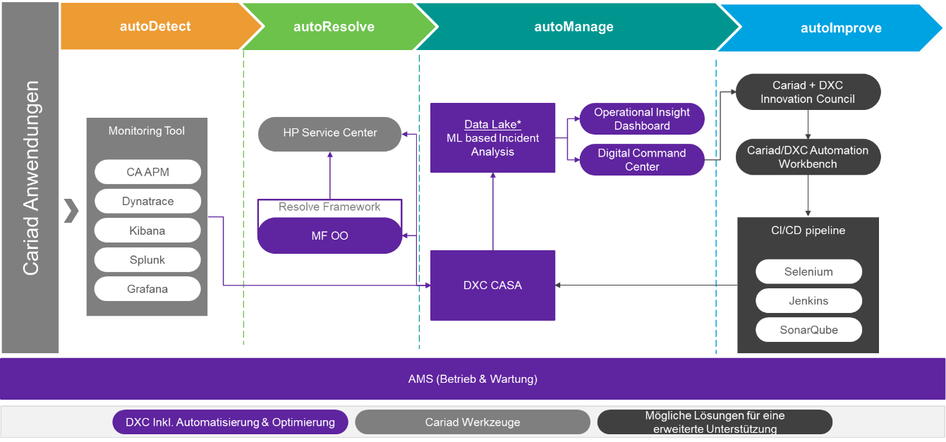

1. Automate application services

### Testing Tools

|  |  |
| --- | --- |
|  | **CARIAD Question 6:** 1.1.3.c) Describe your proposed solution for a uniform tool landscape for testing. |

In order to be able to provide the offered service effectively and efficiently on a permanent basis, we are happy to support CARIAD in the project to harmonize the test tool landscape. **In doing so, we integrate the aforementioned requirements (specifications Chapter 2.4.11.2.1.1) and will present a corresponding concept as required (Specifications, Chapter 3.6.1.1.9).**  We will also take into account the criteria highlighted in the bidding workshop and clarified in the bidder question lists. We benefit both from the experience that CARIAD has gained with the current tool landscape and from the successes that DXC has achieved in projects in the test area ­ .

DXC is planning a possible expansion of the existing tool landscape to further support the agile DevOps approach and the associated further automation.­

We see the following important criteria for a uniform testing tool landscape:

* Supports the chosen agile DevOps approach
* Enables a high degree of automation in all test steps and types
* Good integration with the existing interfaces and into the overall tool landscape, especially into the CI/CD pipeline
* Reduction of the number of test tools to a manageable number while maintaining the operation of the various test devices (functional, non-functional)
* Leverage up-to-date state-of-the-art capabilities for test imaging, intelligent test generation, guidance, and reporting through the application of artificial intelligence and machine learning (AI/ML)
* Combination of the components successfully used at CARIAD with proven and strategic standard tools from DXC's point of view

DXC will use the SCORE methodology to set up a unified testing framework for CARIAD's portfolio. The SCORE methodology™ is DXC's proprietary methodology for creating and implementing Testing Centers of Excellence. This methodology provides a comprehensive approach to designing a unified testing framework for the existing application portfolio.

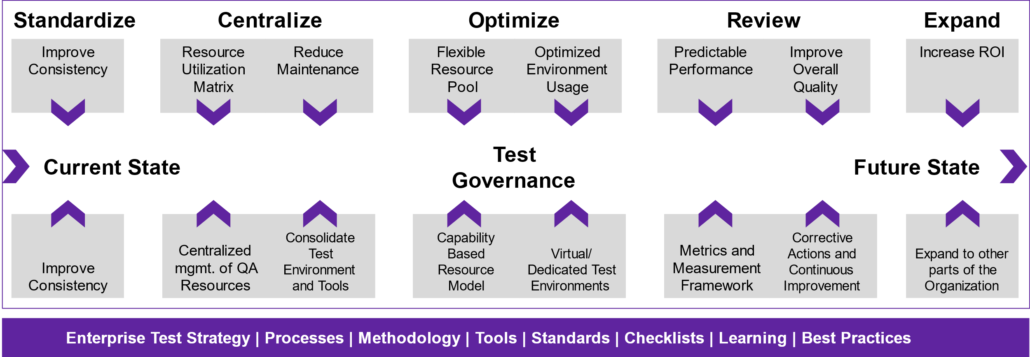

1. SCORE Method

DXC understands that CARIAD currently uses three different testing frameworks. To achieve a unified testing framework, DXC will conduct an assessment with the goal of developing a roadmap for implementing a unified testing framework, including testing processes and tools.

The following are the main activities that are planned:

* Collect the various project artifacts such as test plans, test strategy, test cases, test execution and bug reports
* Review and analysis of the current state of processes, test goals and challenges
* Review and analysis of the existing process asset library and classification of process artifacts for further use or as candidates for process improvement
* Assessment of the integration, use and suitability of the test tools with regard to the project life cycle of CARIAD
* Analysis of the application technology landscape and evaluation of the potential automation coverage and return on investment (ROI) that can be achieved with the existing tools and with tools to be proposed by DXC
* Identify opportunities to reuse, improve, and create new process artifacts

At the end of the evaluation, DXC (in accordance with the specifications, chapter 3.6.1.1.9) will present an evaluation report and a concept that will identify the following points:

* A representation of the current state of the test organization, in which the strengths and potential for improvement in the test areas are described in detail
* Recommendations and expected benefits for each test area
* Proposal for a test automation architecture including integration of test tools
* A roadmap with a timetable and milestones for the implementation of the aforementioned recommendations

Based on the aforementioned important criteria and subject to the aforementioned evaluation to be carried out, we consider the following high-level test tool stack to be suitable:

* Test Management: Jira / Xray with interface to TestMagic
* Functional test (black box): TestMagic
* Web-Performance-Test: TestMagic
* Statische Code-Analyse (Whitebox): Sonarqube / Teamscale
* Defect Management: Jira with interface to TestMagic
* Test reporting: Jira / Xray with interface to TestMagic

Universal Technology Solutions' TestMagic test automation tool is a standard tool strategically used by DXC, which is also part of the DXC [1]SRA (Standard Reference Architecture), and which DXC has expertise in several service delivery locations.

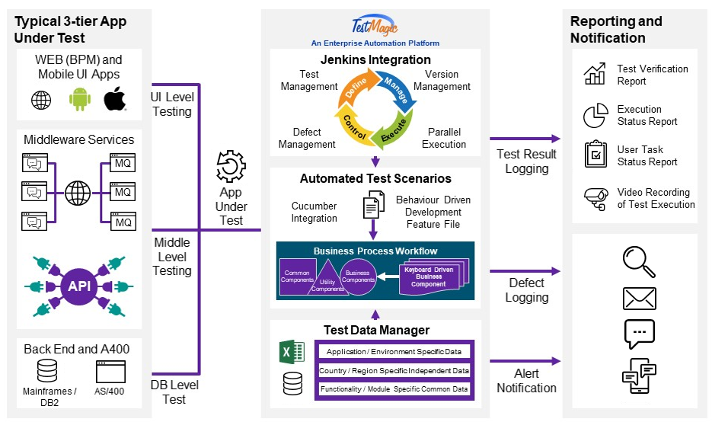

1. Overview TestMagic of Universal Technology Solutions

The following table shows the test tools currently used at CARIAD and indicates which of them can/should be replaced by TestMagic (table partly copied from specifications Chapter 2.4.11.2):

| Tool Name | Abstract | Possible replacement by TestMagic |
| --- | --- | --- |
| CA APM | Application Performance Management |  |
| Dynatrace | Application Performance Monitoring |  |
| XRAY | Test Management Add-on fürJIRA |  |
| Connected | REST interface test tool (These tests are already running automatically in the pipeline and are described as an XRAY.) | **X** |
| Contest | REST Interfaces Test Tool (The tool is available as source code in Bitbucket and as a description in XRAY. These tests are already running automatically in the pipeline and are described as an XRAY.) | **X** |
| Gauge | Test Automation Tool, enables BDD, open source (for REST interfaces, mainly for functional smoke tests) | **X** |
| Again | Testing tool + load generator for non-functional tests. Essentially, it consists of JMeter and load generators. The source code is present in the bitbucket. | **X** |
| Cucumber | BDD Testing Tool, Open source (available as source code in Bitbucket and as a description in XRAY.) | **X** |
| Selenium / Selenium GRID | Test Automation Tool for Web Applications, Open source | **X** |
| KPM | Ticket Tool, VW Group Tool to Support the Error Elimination Process (FAP) and Group Problem Management Process |  |
| SonarQube | Source Code Statisches Analyse Tool, GNU GPL |  |
| Black Duck | Solution for managing security, license compliance, and code quality risks associated with using open source in applications and containers |  |
| Teamscale | Source Code Static Analysis Tool, Clone Detection, Test Gap Analysis |  |

1. CARIAD Test-Tools

The proposed test automation tool TestMagic is characterized by the following important features, which we consider to be advantageous for the service offered, here also compared to Selenium, which is currently used at CARIAD:

| Features of TestMagic | In comparison: Properties of Selenium |
| --- | --- |
| Easy to learn as no complicated proprietary scripting language, no programming skills required | High learning effort, scripting language skills required, high scripting effort |
| Cross-technology test automation of end-to-end business processes | Not possible |
| CI-/CD- / DevOps-Integration (Jenkins) | Also, with additional libraries |
| Integration mit Jira, ALM/QC, RQM, Test Rail, Cucumber | Also, with additional libraries |
| A common tool for functional testing and web performance testing | Not possible |
| No multiple effort for the development of test automation for functional test and web performance test | Not possible |
| Reduced maintenance for test automation components due to AI test object identification | Not possible |
| Built-in exception handling | Must be handled separately |
| Integrated defect management (optional) with auto-defect logging | Must be handled separately |
| Web-service-Test (REST, SOAP, MicroServices,) | With additional tools (SoapUI, Postman) |
| Integrated Service Virtualization | Not possible |
| Parallel test execution on different machines including load balancing | Also |
| Testdatenverschlüsselung | Also |
| Enables BDD | Also |
| Test automation development possible before the SW is completed | Not possible |

1. Testautomatisierungstool TestMagic

Other advantageous features of TestMagic include integrated requirements management and test management for mobile devices.

**Remarks on the test tool landscape:**

In specifications Ch. 2.4.11.2 tools - also test tools - are called those that are mandatory to use (see also Chapter 2.3.2.8). In specifications Chapter 2.4.11.2.1.1 and here in Appendix L, the Contractor is asked to describe a test tool landscape. The assumption is that this objection will be resolved as follows: At the beginning of the project / services, the existing tool landscape is taken over by the Contractor from the Client. **In the course of the project / services, this will be replaced by the desired tool landscape, which will achieve a standardization of the tool landscape.**

In Specifications, Chap. 2.1.4.5 and in Appendix K tab "Enabler Services" the test frameworks are mentioned. It is assumed that these three test frameworks include the current test tool stack (specifications Chapter 2.4.11.2), possibly including emulators and data generators.

**Testprozess:**

We have understood the current test and acceptance process including the quality checks to be carried out , which extends from the process steps of a new requirement to go live .

In coordination with CARIAD, we will optimize the current process with regard to the advantages of an agile DevOps approach.

In doing so, we will take full account of the criteria that are important to CARIAD:

* A very high proportion of automated tests
* A good fit of automated tests into the DevOps pipeline
* Functional test in different stages (unit test, system test, integration test, end-to-end test, functional regression test)
* Non-functional test such as load and performance test (incl. stress test) in different stages (in a development iteration, in the component L&P test, comprehensive L&P test, thus also non-functional regression test)
* Definitions of Ready (for a user story) and Definitions of Done (for a user story, a development iteration, a feature, a release)
* Quality gates during the transition between the process steps such as static code analysis and test coverage, but also the previously mentioned definitions of done
* Introduction of an administration of different test data versions, suitable for the respective software versions.

## Leistungsumfang - DevOps Service Delivery

In the following, we would like to illustrate our solution concept, which includes our proposed approach to the realization of the required DevOps model. It is important for CARIAD that the provider **assumes end-to-end responsibility in the form of a DevOps approach** over the entire lifecycle of an application.

The solution concept designed by DXC takes into account all of CARIAD's defined objectives:

* End-to-end responsibility for the services along the development chain - from the receipt of the requirements to the development and the transfer to real operation.­
* Preparation of release recommendations
* Agile new and further development of functions ("microservices" / "software increments")
* Drive test automation for systems and components, including regression, load, and performance testing
* Ensuring compliance with the agreed service levels by carrying out a hypercare phase (analogous to the requirements, chapter 2.3.1.8 of the specifications)
* Software-Wartung (LCM)
* Continuous optimization of connected car services (refactoring, scaling...)
* Provision of operational tasks in day-to-day business (operational responsibility)
* Drive seamless troubleshooting and problem resolution (2nd and 3rd level support)
* Active tracking of tickets that have been forwarded to third parties
* Assumption of end-to-end responsibility for Connected Car Service, which are within the responsibility or affect the adjacent systems and interfaces
* The concept for the realization of the service tasks should take into account the DevOps idea "You build it, you run it"

DXC's SAFe-focused delivery model is perfectly tailored to CARIAD's requirements. It covers both operational performance and functional delivery. The model enables DXC to take a consistent, repeatable approach with defined roles, interfaces and procedures to provide CARIAD with efficient operational support, maintenance and development in accordance with the required service levels.

In concrete terms, our end-to-end approach means that the DevOps teams work dedicated only for CARIAD and take **complete end-to-end responsibility for their applications** . Our DevOps teams are not only responsible for development, but they also install and configure the operating environments. You have access to the monitoring systems to determine how the applications perform during load and stress in the real environment.

The members of a DevOps team work in 7x24 shifts so that **they can quickly bring about the resolution of incidents and thus reduce or even avoid service disruptions for end customers to a minimum.**

**Note:** First of all, we would like to take this opportunity to point out that the term "DevOps" listed in your specifications V1 and in this document is equivalent to the term DevSecOps (Development Security Operation) for us. DevSecOps is the seamless integration of security testing and protection throughout the software development and deployment lifecycle and is firmly anchored in our services.

### Quality with regard to the development services to be provided

|  |  |
| --- | --- |
|  | **CARIAD Question 7:** 1.1.4.a) How do you ensure high quality in terms of the development services to be provided? |

In the automotive environment, development services are regularly part of an overall system consisting of hardware, software, services, etc. This means that development services are very rarely isolated. They are provided in cooperation with many teams from different areas over the product lifecycle.

This requires a system design with defined requirements for the subsystems and their interfaces. Furthermore, reliable delivery at defined times with coordinated processes must be ensured.

Software development addresses these requirements with agile methods such as SAFe. With SAFe, which is also used by CARIAD, agile development processes can be scaled. There are procedures for the coordination of teams/products. With regard to quality assurance, SAFe includes continuous optimization measures at various levels. Examples include reviews including actions and the Innovation and Planning Iteration.

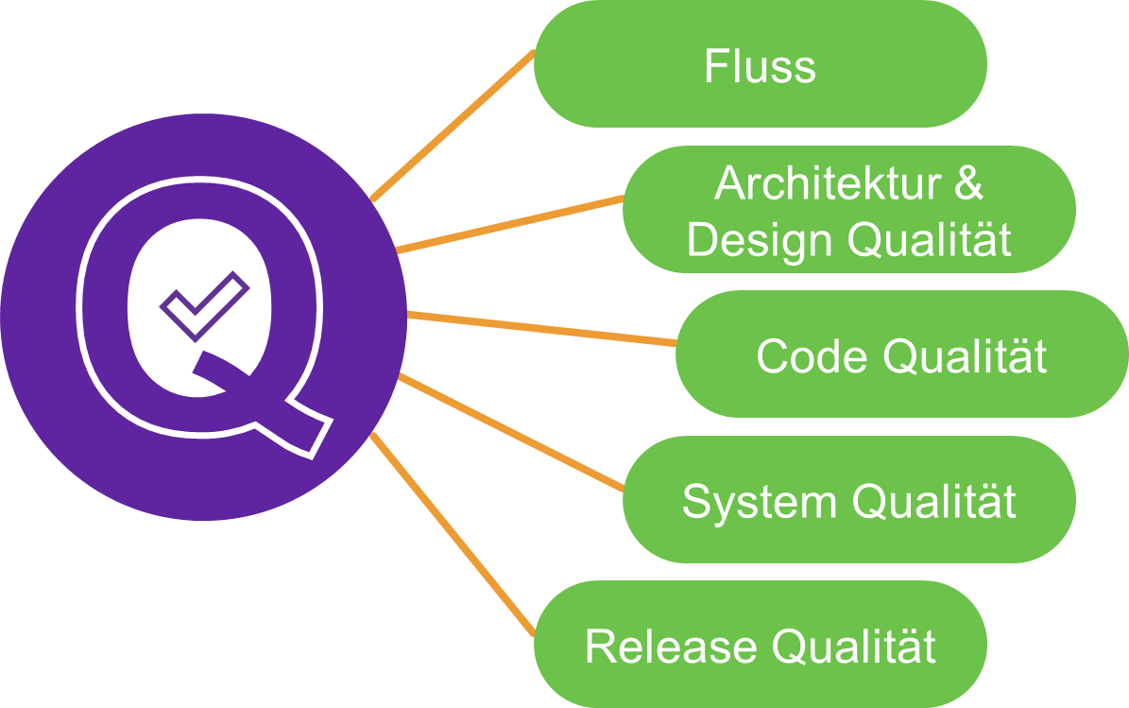

1. SAFE - 5 Dimensionen „Built-in Quality“

Under the keyword "Built-in Quality", the SAFe Framework also deals with agile methods and development methods that ensure quality even in the hardware-related complex system environment with many peripheral systems. SAFe describes five dimensions of integrated quality assurance:

The methods mentioned are used in new DXC projects. Challenges arise with older projects that were set up 15 years ago, for example, because the frameworks and processes of that time were often not geared to modern DevOps procedures. In these cases, therefore, optimizations are necessary, which must be coordinated with the product owners in conjunction with the company standards.

For the optimization of concrete aspects of development such as tests, DXC uses a Standard Improvement Theme Canvas by Jimmy Janlen. This is shown here as an example for the improvement in the area of test automation.

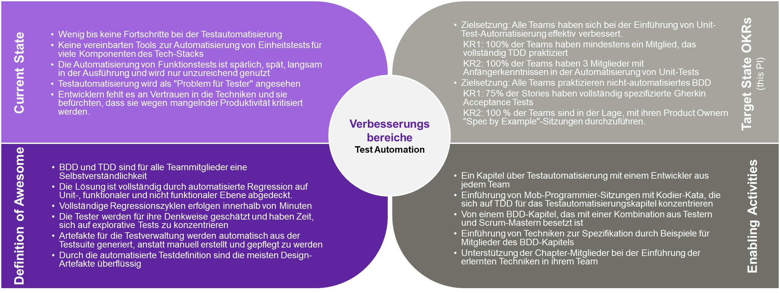

1. DXC capabilities to support agile development

This method is also ideal for optimizing quality indicators.

Automotive SPICE is used for the evaluation of software development processes in the automotive environment. SW development processes will be used that have at least a capability level "Level 2" in an A SPICE Assessment (KGAS_2074).

CARIAD has defined a standard that includes processes and deliveries as concrete requirements in the "Appendix R_Group Basic Software Requirements LAH 893.909 – Version 3.7".pdf.

In the course of the project, it is therefore necessary to optimize the requirements from the quality assurance methods, the processes and from the traditional project reporting with the agile methods. This also applies to the quality indicators.

The quality of the software development services is evaluated taking into account the following overarching quality characteristics:

* Meet functional requirements
* Meet non-functional requirements

The specific requirements are listed in the "Appendix R_Group Basic Software Requirements LAH 893.909 – Version 3.7" .pdf.

The following section describes how DXC focuses on ISO/IEC 9126 quality features for similar projects. A focus is placed on tools/methods that are also used at CARIAD. The area of security from the main category Functionality is listed here as the main category (see also ISO 25010).

**Functionality**

Products should implement the expected functionality. Agile methodologies are currently the best way to ensure that the software meets the expected functionality. With regard to functionality, the following points should be emphasized:

* Requirements management  
   The aim is to define and communicate the requirements. The future requirements are explained in the form of a backlog in a sufficient level of detail. These are, for example, high level epics/features during PI planning and user stories/tasks in a higher level of detail depending on the time of implementation. The team is in constant contact with the Product Owner, so the team gains a common understanding.
* Definition of Done incl. acceptance criteria  
   The acceptance criteria specify which criteria must be met in order for a work item to be completely completed. This is also presented and examined in concrete terms. In addition to the examination of functional and non-functional requirements, additional work such as documentation, tests, scan results, etc. Part of the Definition of Done. Finished work items are the core of agile reporting.
* Early testing (fail fast)
* Core functionality is implemented with priority so that end users can check critical elements at an early stage. In early phases, mock-ups are used for this (e.B. UI design tool).
* Early integration tests with other systems/teams lead to the fact that communication and understanding of interfaces are checked in early phases. In addition to the pure technical transfer, process steps etc. must also be coordinated and documented, including the non-functional requirements.
* In the agile area, it is necessary to distinguish between changes in a sub-area and an overall view of the system. The changes in a sub-area are described as a backlog item in the form of user stories or tasks. Over the course of a product's lifecycle, these changes are not sufficient to understand the current functionality. It is therefore necessary to provide an updated overall view of the system. It is advisable to document near the code and to version the documentation with the software (e.B. asciidoc, Markdown) and if necessary. Create documents/web pages.
* The 4-eyes principle in code reviews etc. is mapped organizationally or via the development tools in the development process. Code reviews are also an essential part of knowledge transfer within the teams.

**Safety**

Quality in terms of security generally includes unauthorized access to data and systems or the prevention of authorized access to data. (e.B. Denial of Service Attack).

The requirements regarding security in the networked world have risen sharply. This also means that some of the systems used so far have been developed under different security requirements than they are considered standard today. This makes it necessary to set up a risk management system with regard to the systems and, if necessary, to adapt the security.

With automated systems, the number of deployments also increases, so security processes with approvals that take place at the end of a release can lead to delays. Therefore, it is necessary to consider security as an integral part of the lifecycle process. DevOps processes address these challenges.

With regard to the quality feature safety, the following points should be emphasized:

* Security standards must be defined, communicated and monitored.
* One focus is also on data protection and data storage (validation, admissibility, encryption, storage period, ...)
* Introducing DevOps
* Include security features throughout the lifecycle
* Code scans with static and dynamic analysis tools. These scans are often semi-automatic and require time.
* Automate processes with Quality Gates
* If necessary, schedule security audits (e.B. penetration tests). The additional time required must be taken into account. Likewise, during this time, the products to be tested must be available in the ordered versions.
* Security functions should be implemented via standard libraries in order to exclude errors in a special field.
* The long product life cycles require that components be identified whose support is expiring or that are no longer being maintained. There may also be changes to licenses, etc. For an application portfolio, software portfolio management tools with analysis functions such as CAST Highlights are available.
* Another standard is the regular scanning of components for known vulnerabilities (e.B. CVEs, weak ciphers) and code scans regardless of the fact that specific build processes, deployments have been started.
* Test cases must also include security-relevant cases. These can be, for example, tests of the correct access of different user groups (positive, negative).

**Reliability**

Reliability means that the software must be able to maintain a certain level of performance over a certain period of time and under certain conditions. To achieve these goals, DXC uses the following procedures:

* Resilience in architecture
* Plan and communicate reactions to errors (Circuit Breaker)
* Micros-Service architectures, including the required services, address many reliability issues. It should be noted that the complexity of requirements is not reduced by considering only partial requirements. The integration then takes place in the orchestration of services (e.B complete process steps with several components). This also means that test scenarios have to be moved to later test levels with several systems. This also implies that the process environments must be designed flexibly (e.B. Kubernetes).
* Testing
* Extend test automation to multiple levels to continuously test reliability
* "Chaos Testing"With the number of systems involved, the combinatorially conceivable test scenarios also increase. The aim here is to cause failures in a targeted manner in order to ensure that services can continue to be provided during test drives.

**Usability**

The quality of usability in the "backend" area is ensured from the point of view of the end users who work with the interfaces, processes and APIs, and from the point of view of the developers. Another goal is to create a working environment that is attractive for developers/users. The focus is on the following aspects:

* The team uses usability patterns (style guides) established by the users. In the case of new concepts, these concepts are tested in early sprints with prototypes, etc. This ensures that users can familiarize themselves with the systems quickly and with as little training as possible.
* The teams use popular tools/technologies that are attractive to users (administrators, developers, API users, ...). This ensures that personnel are available to the required extent.
* Also use automated testing to reduce the "fear of change".
* Fast organizational and technical processes lead to a good working atmosphere without waiting times. They increase efficiency and satisfaction. This applies to various dimensions of everyday work such as: account generation, build duration, fast deployments, etc.
* High availability also of dev environments to avoid waiting times in the short agile cycles or during load peaks. Typical case: Dev environment has no service on weekends in case of malfunctions.

**Efficiency**

DXC has a focus on "Green IT", which aims to increase the efficiency of IT. In the area of software development, for example, the following areas are addressed:

* Benefits of "On Demand Computing" e.g. im area Kubernetes, Serverless etc.
* Examination of the runtime behavior and the algorithms during the pair review in the development process.
* Checking the runtime behavior via monitoring.
* Migrations to container runtime environments (e.B. Kubernetes)
* Use of optimizations in the field of Java, e.g. via RedHat Quarkus
* Load testing as needed as part of the pipeline.
* Guild Sessions address typical "efficiency traps" (e.B. object-relational mappers, JSON/XML structures, remote calls)

**Changeability/Maintainability**

DevOps teams play to their strengths, especially in the area of changeability and maintainability, as the teams already place a special focus on situations during development that lead to abnormalities in the company. This applies in particular to the areas of logging, monitoring and fault diagnosis procedures.

The core of good changeability/maintainability is always a clear system design with defined interfaces and clear responsibilities of the components (separation of concerns).

The following activities promote the quality of maintainability in typical DXC projects:

* Use of standard frameworks according to standard conventions, so that tools and developers can easily understand the technology.
* Documentation in the code repository with text and graphical models (e.B. PlantUML) to visualize processes, for example.
* The developers use uniform definition of formats, style guides, etc. in the development environments.
* Static code analysis (incl. Linter) to identify errors and set up standard programming rules. It is necessary that the rules are available to the same extent at all levels. Sonarqube offers, for example, IDE plugins.
* Architecture Documentation with a decision log documenting the reasons for development decisions so that developers could understand the basis on which decisions were made.
* Testbarkeit
* Traceability with regard to test and requirement, which is the basis of the test.
* Documentation of what is tested also in automated tests (e.B. BDD with e.g. Cucumber).
* Tests start at the unit level and use mocks for dependencies. This also means that mocks of the respective systems in the relevant version are required for the various tests.
* Automated tests are available to secure changes in the system and, in particular, to avoid side effects.
* It must be ensured that all relevant systems are available in the required version during tests. This requires test coordination. (Example: Hotfix and test a newer version in a test environment).

**Transferability**

DXC addresses the quality characteristics of this category in the areas of adaptability, interchangeability, installability, coexistence and compliance with the following points, among others:

* Software modules require a clear description of the functional and non-functional properties as a black box in order to enable transferability. It is also necessary to define the dependencies.
* The installation should be automated and must be documented.
* Transferability is easier to achieve if standards are adhered to, as tools, best practices, etc. are aligned with conventions of standards. Likewise, according to the agile approach, it makes sense to implement only actual requirements. Upcoming requirements (backlog, architectural runway) must be taken into account when finding solutions.
* It often makes more sense over the lifecycle to implement "keep it simple" solutions that are quickly understood by software maintenance teams without constant changes.
* Outsourcing of configurations, credentials, etc. to standardized services enables these tasks, which are often environment-dependent, to be separated from the actual program code.

Many aspects mentioned here are described, for example, in an architecture documentation according to Arch42.

### Exkurs: DXC CyberApplikation Security

#### DXC Cybersecurity Solution for CARIAD

The DXC overview of cybersecurity services for CARIAD can be assigned to three major cybersecurity areas (Cybersecurity Services Box):

* Digital Identity – this area covers all activities and controls related to identity and access management, including Privilege Access Management (PAM)
* Privacy – this area covers all activities and controls related to the management of certificates, keys and licenses
* Cyber Defense – this area includes all activities and controls related to vulnerability management

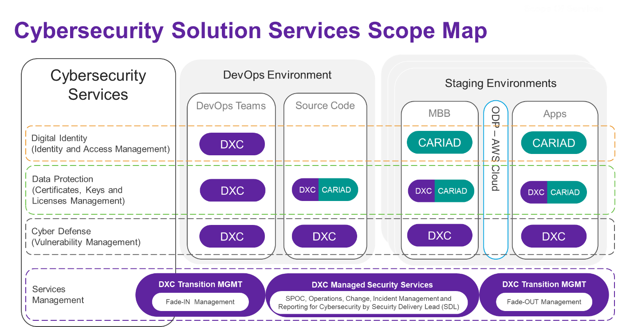

1. Cybersecurity Solution Services Overall Scope Map

Each of the listed areas of cybersecurity services can be extended to the listed environments and their main components. The following basic building blocks are represented in the diagram above as important different environmental areas and their components:

* DevOps environment consisting of two main components:
  + the DevOps teams, their work environment (workstations and tools, etc.), and
  + the source code of the applications
* Staging environments - The staging environments represent the underlying IT infrastructure of CARIAD. It is logically divided into identical environments (composed of similar components). The purpose of these environments depends on the phases of the application development process - testing, pre-live and live. The most important building blocks for the staging environments are:
  + The modular backend module (MBB),
  + the One Digital Platform (ODP), which operates through the AWS cloud environment, and
  + the applications themselves, which are considered here as a separate object for the assessment of cybersecurity services

The basis for the entire cybersecurity solution is Security Services Management. This service component represents DXC's entire Cybersecurity Service Delivery Management.

#### Applications Security (AppSec)

Attacks on application software have become more dangerous these days. Applications are critical to the operation of each customer's value chain.

DXC's Applications Security Testing Services make it easy to test applications for vulnerabilities with industry-leading technology securely hosted in the DXC cloud and are also cost-effective. This applies to every version, to every source (internal, outsourced, vendor, open source) and to every platform.

Application security is an important service component of the vulnerability management service.

##### Komponenten des Application Security Services

DXC Application Security Services consists of the following service components:

* **Static security testing:** Static assessments provide security scans, audits, and reports for a variety of programs. Using industry-leading tools, application source code analysis is performed with expert validation and reporting.
* **Dynamic security testing:** Dynamic assessments provide security scans, audits, and reports for any web-based application in an active environment.
* **Mobile security:** Mobile assessments provide security scans, audits, and reports for all business applications for iOS and Android devices.
* **Static security testing:** Static application security testing, also known as source code scanning or SAST, is a type of methodology for testing application security.

DxC Applications Security Service uses an automated application security testing tool to scan an application's source code in a non-runtime environment to identify potential security flaws and vulnerabilities in the application. Static testing provides a more thorough inspection of the application, including its inputs and outputs, than is possible through dynamic web scanning alone. The service also includes expert review by a DXC application security expert to identify and reduce false positives and duplicate vulnerabilities uncovered in the automated test report. This extends the SAST method from its classic, pure test form to an assessment service.

DXC uses Micro Focus Fortify software technology to perform automated static security testing when deploying the DXC Applications Security Service.

Micro Focus Fortify software is hosted and operated in a secure, DXC-managed environment.

* **Dynamic Security Testing:** Dynamic Application Security Testing (DAST) is a method of testing application security. Dynamic assessments provide security scans, audits, and reports for any web-based application in an active environment.

Dynamic application security scanning uses an automated application security check tool to scan an active Web application in a runtime environment and detect potential security flaws and vulnerabilities in the application. This test can be run on applications developed in all web languages. However, it should be noted that dynamic evaluation can only examine the parts of the code that are currently running.

DXC uses Micro Focus Fortify software technology to perform automated dynamic security testing when deploying the DXC Applications Security Service.

#### Aligning the DXC AppSec process with the CARIAD security cycle

The DXC AppSec process and the CARIAD Security Cycle overlap to a large extent. Some of the similarities are:

* Both consist of similar steps or phases:

**CARIAD Gate 1** relevance corresponds to the **DXC Step 1 plan**

**CARIAD Gate 2** concept corresponds to **DXC Step 2 design**

**CARIAD Gate 3** test results correspond to **DXC Step 4 test**

* Both consist of the concept of seamless integration of cybersecurity into the entire development cycle of the applications

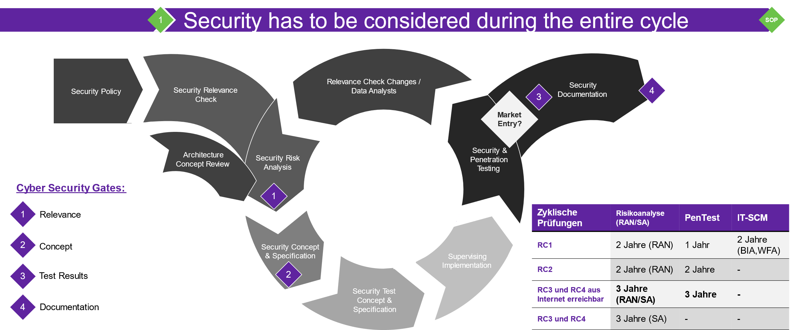

1. DXC AppSec Process

#### DevSecOps Integration

DevSecOps is an approach to developing, testing, and sharing application software that focuses on collaboration and communication between development, security, and operations teams. The aim is to offer business users added value much more often than with conventional methods, without compromising and often even improving the quality, reliability and security of the delivered software. Automating and integrating the various interactions that take place throughout the lifecycle of applications is key to achieving the benefits of a DevSecOps approach.

That's why Applications Security provides access to a variety of plug-ins for immediate integration with many popular application lifecycle management and automation tools such as GitHub, Visual Studio Team Services, Jenkins, and JIRA. Plug-ins are also available for popular integrated development environments such as Eclipse and Visual Studio. The plug-ins enable a fast and seamless integration of applications security into the customer's software development processes. The service also includes a full set of REST-based APIs to enable integration with products for which plug-in support is not available.­

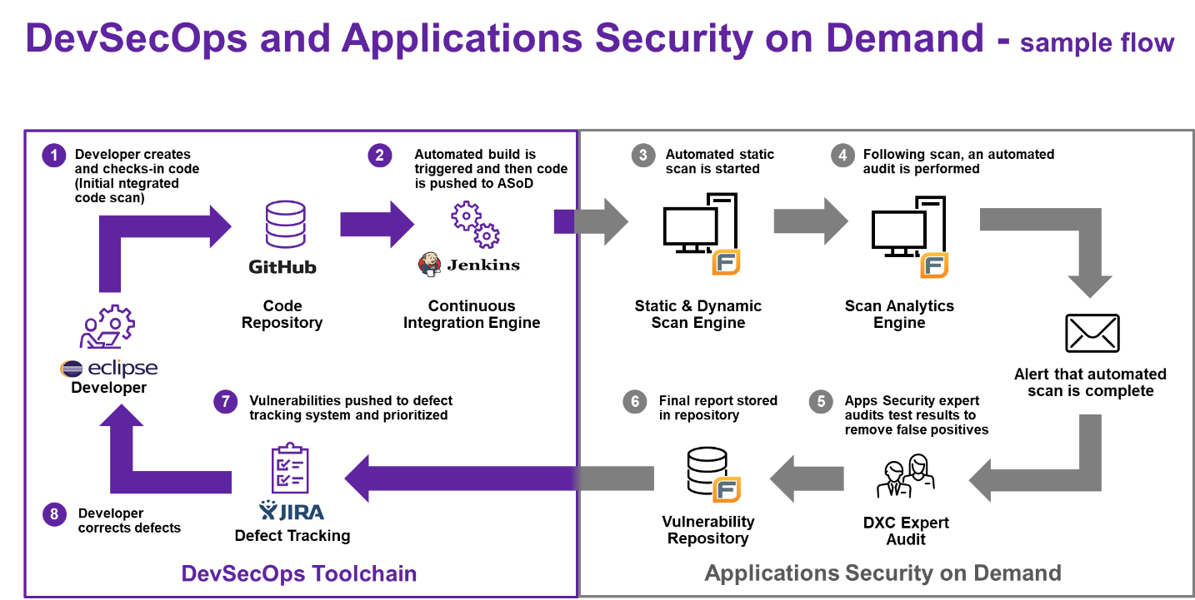

1. Example DevSecOps integration and process flow

The figure above illustrates how the service can be integrated into the DevSecOps toolchain. This is an exemplary development process, and integration with many other application lifecycle automation tools is supported by the Applications Security Service.

In this example, a developer uses Eclipse to push a new version of their software to the project's GitHub repository. This project applies continuous integration to automate the build, test, and release process of the software, using Jenkins as the underlying orchestration engine. Jenkins detects the developer's change and initiates an automated build and test of the new software. The Jenkins plug-in is used to automatically submit the build to the Applications Security on Demand service to initiate a static application security test of the new software. This will immediately start an automatic static scan of the new build with the Fortify software. Once the automatic scan is complete, a DXC application security testing expert is notified to review the test report to reduce false positives. Once this step is complete and a final vulnerability report is available, the security flaws are submitted to JIRA for review and prioritization by the development team.

This integrated approach to using the service ensures consistency and significantly reduces the number of manual interactions required throughout the software development, testing, and approval process – saving time and reducing costs. This is an exemplary development process, and integration with many other application lifecycle automation tools is supported by the Applications Security on Demand service.

#### Cybersecurity Services Management

DXC can offer the role of Account Security Officer, who oversees compliance with general services and is the primary point of contact for all operational, security, and compliance matters.

**Compliance with regulations and guidelines**

One of the main responsibilities of the Account Security Officer at DXC is to ensure compliance with internal, external and legal regulations as well as the smooth delivery of services. He is responsible for monitoring compliance with all services and acts as the primary point of contact for all compliance-related matters.

**Account Security Officer (ASO)**

The Account Security Officer (ASO) is the central point of contact for the operational provision of security services and compliance with security regulations for CARIAD.

The OSA is responsible for ensuring that the security compliance of services and obligations is met in all services provided to the account.

This includes monitoring the security compliance of other service centers working for CARIAD and overseeing all cyber managed security services provided to the customer. The ASO represents DXC vis-à-vis CARIAD in all matters of IT security and compliance and, if necessary, calls in additional cyber resources to meet this obligation.

The ASO is the main interface to the DXC DevOps teams and works closely with DXC and CARIAD representatives at the delivery executive level.

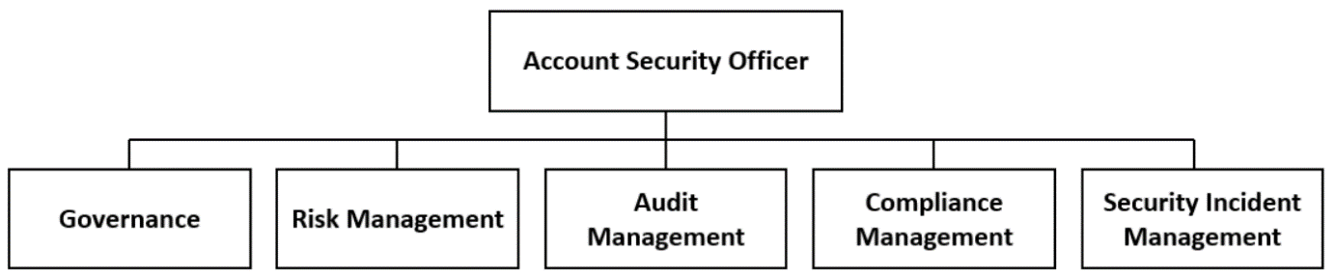

1. Areas of responsibility of the OSA

An OSA offers the following advantages:

* Continuous improvement of safety
* Assist in meeting regulatory requirements and providing evidence of compliance.
* Recommendations for remediating vulnerabilities
* Streamlined and efficient audits

### DevOps Model

|  |  |
| --- | --- |
|  | **CARIAD Question 8:** 1.1.4.b) How do you implement the required DevOps model? |

From your specifications, we can see that the development activities (DEV) are strongly aligned with the SCRUM process model. With currently over 27,000 active application developers, we have been driving the work according to SAFe, SCRUM, Agile Working and DevOps environments for years.

Based on our experience, we would like to introduce you to our cooperation model in this document.

In the following remarks, we have adhered as much as possible to your naming conventions and would complete your model with additional roles, instances, tools, etc.

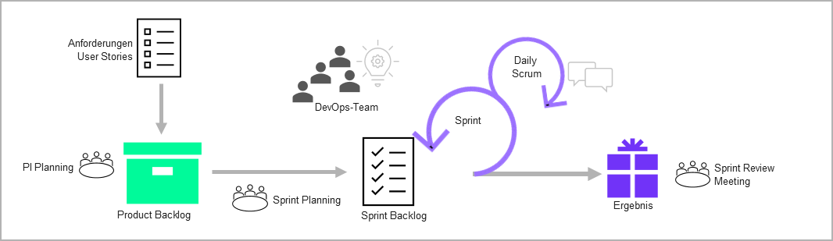

1. Basic process (Source: CARIAD Specifications V1)

At this point, we would like to explain what we have included in our considerations, how we can best support the above methods for your project in the CARIAD environment.

#### Adaptation of the CARIAD DevOps model

However, before we get into the adaptation of their model, we would like to introduce and confirm some naming conventions in our CARIAD model.

Among other things, we use the Spotify model, which has proven itself on the market.

For the provision of the requested delivery services, we divide our delivery team into three defined tribes. According to Spotify's definition, a tribe is the merging of several sprint teams into a larger organizational unit. Several sprint teams are brought together to form a tribe on the basis of a common context. All sprint teams (within a tribe) work together on a work result.

In order to gain a common understanding according to SAFe, a tribe provides an organizational framework for the DXC delivery unit used and an Agile Release Train (ART) embodies the functional/solution-oriented framework.

Forming an organization in this way allows us to focus on collaboration, gain scalability, and create a community that works on or generates similar content. Within the predefined tribes (CORE, CAR2X and eV) we use a number of sprint teams, as they can be found in your definition.

The following terms are adopted in our model and are not explained in detail in this document:

|  |  |
| --- | --- |
| * User Stories * PI Planning * Product Backlog (SAFe – Program Backlog) * Sprint Planning * Sprint Backlog (SAFe – Teil des Team Backlogs) | * Sprint * Daily Scrum * Result * Sprint Review Meeting |

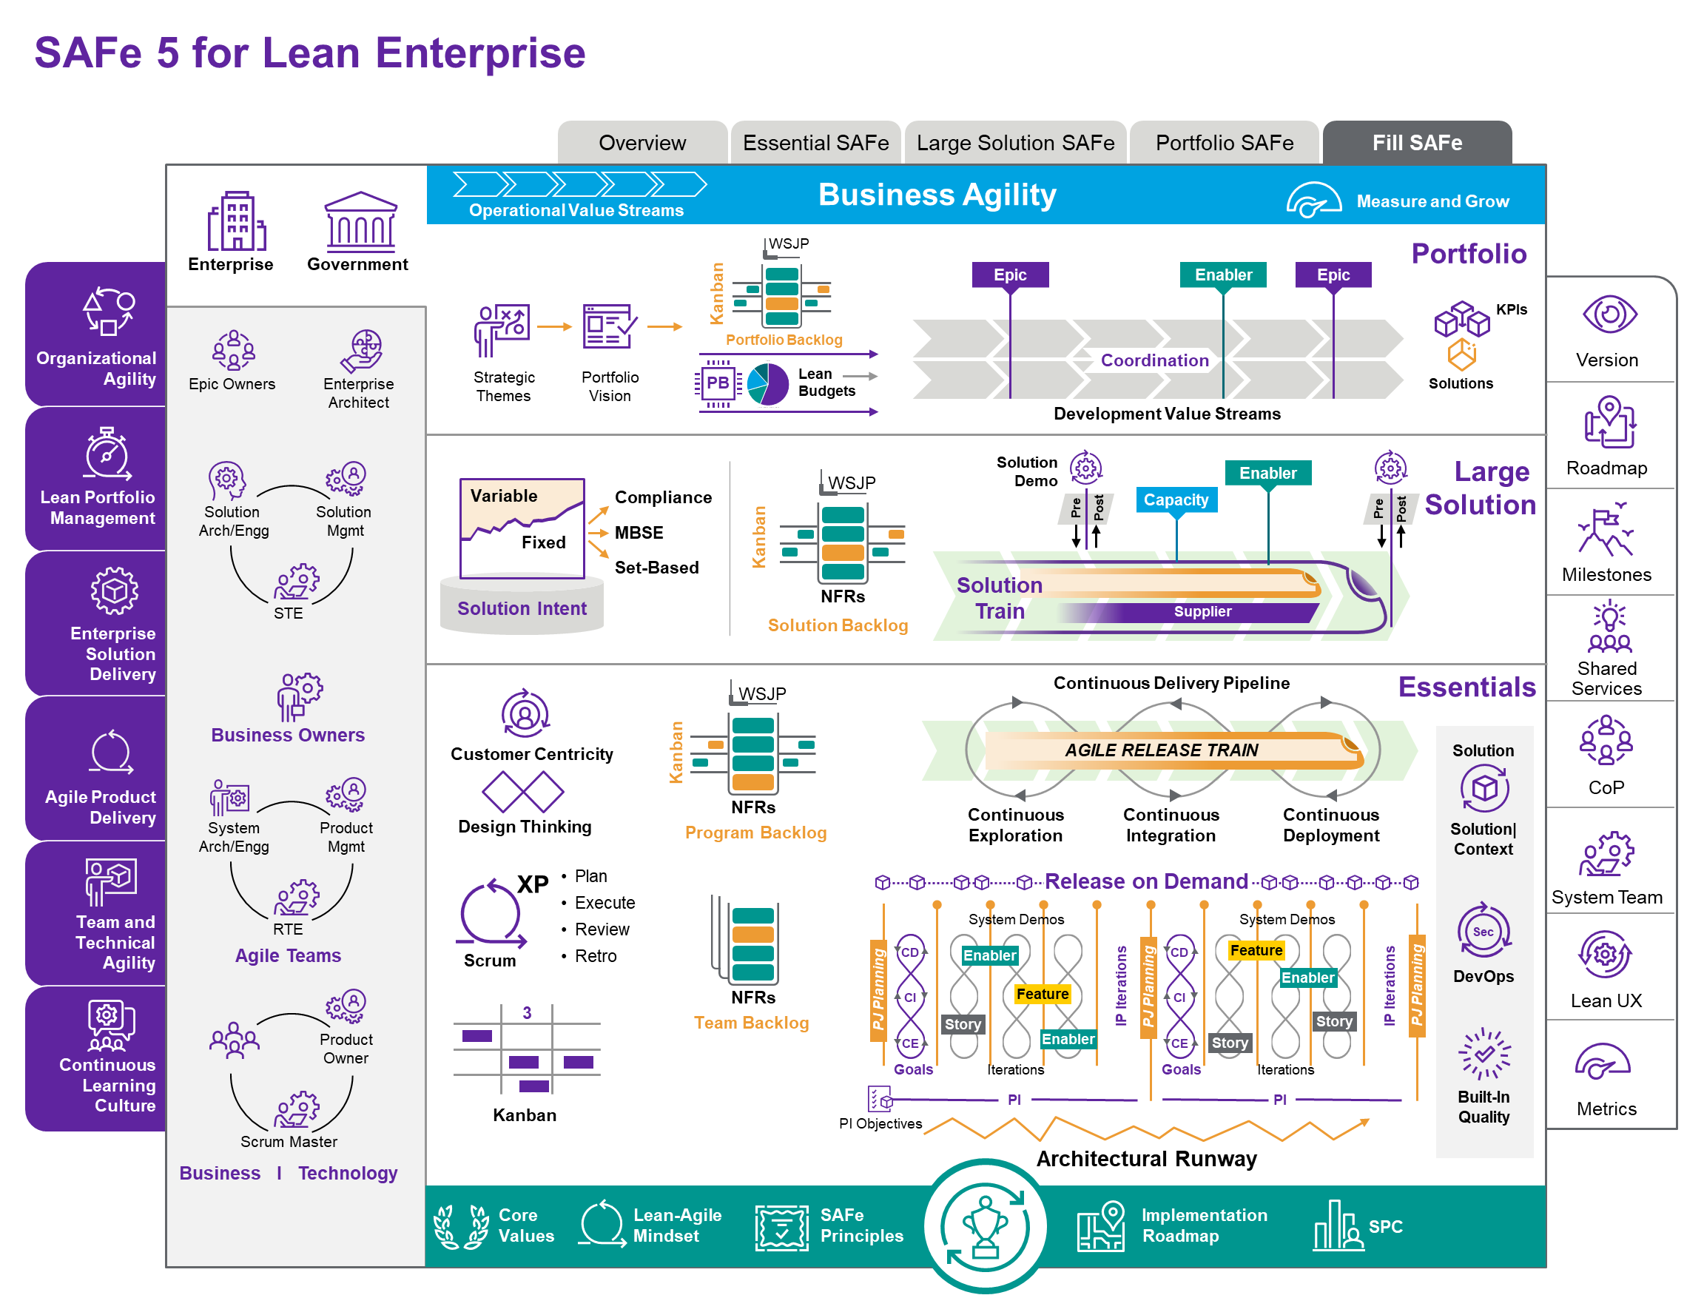

1. SAFe 5 Framework

For the sake of completeness, we would like to transfer your complex project into an SAFe-adapted model. If this is already fully implemented in your company, we will adapt your framework and thus ensure smooth cooperation. We would further deepen this together as part of the tendering process.

The SAFe model generally offers us a practical and intuitive framework from the vision to the implementation of the work. The complete SAFe delivery model enables four (4) levels of progressive planning and feedback loops across the organization. Our core mission is to focus on both the team and program level with appropriate interfaces to the other areas.

We will discuss these interfaces in more detail later in this document. It should be mentioned that the integration of the required ITSM processes takes place in the same way as described in the chapters provided for this purpose.

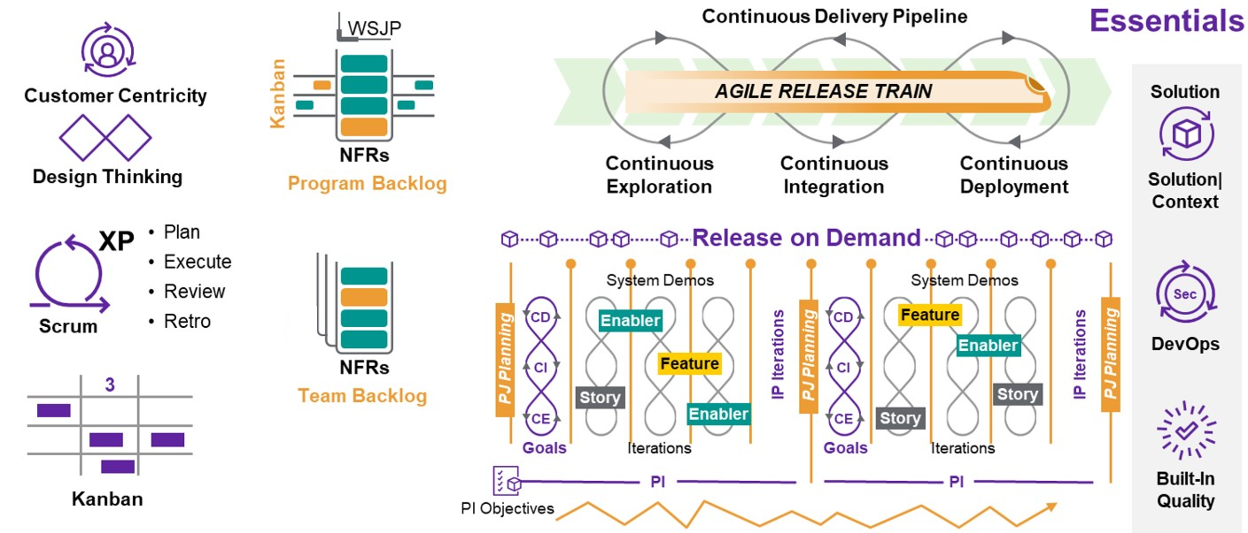

1. SAFe Focus on Program & Team Level

**At the team level (4):** Each program (Agile Release Train) is provided by one or more DevOps sprint teams (tribe). The Product Owner of CARIAD is responsible for the team backlog and is supported in day-to-day business by DXC's Proxy Product Owner. The epics in the Backlog program are worked out by the Scrum teams and transferred to the Team Backlog.

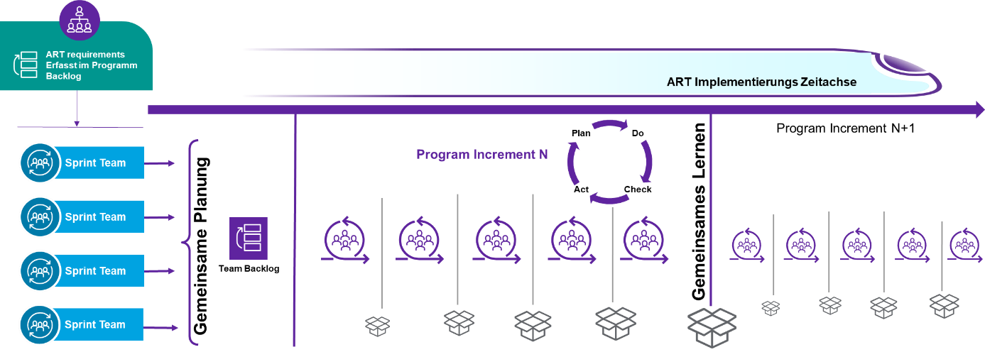

1. Team Backlog Development under SAFe

The teams continuously maintain the backlog and create the product increments according to the principles of continuous delivery and DevOps.

**At program level (3):** Each element in the Solution Backlog leads to program backlogs, which can be processed by several teams depending on the size of the order. The Backlog program belongs to the Product Owner or the Value Stream Owner and is geared towards an Agile Release Train, whose guiding principle is continuous delivery. The release trains are carefully planned and aligned to ensure optimal efficiency of the program's DevOps teams, which can be spread across multiple service providers.

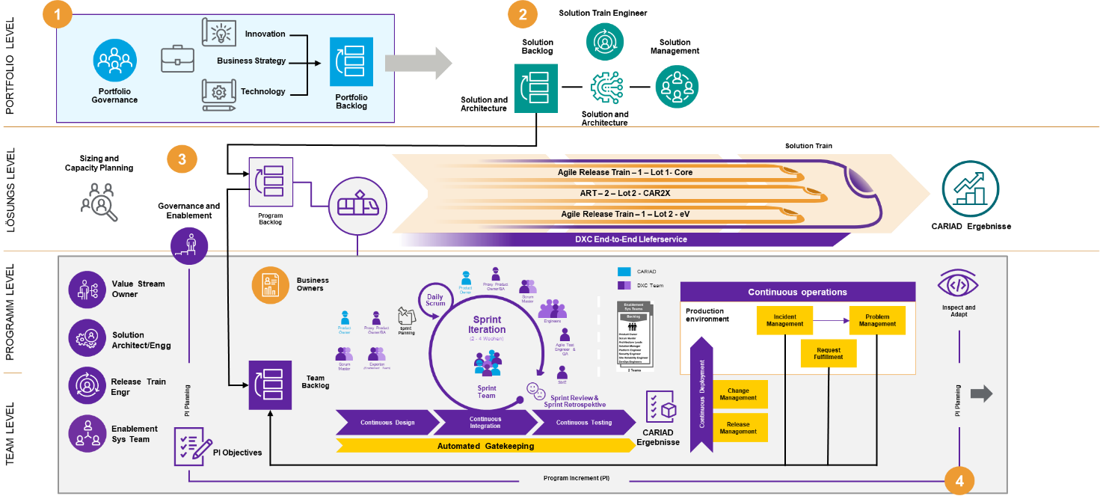

1. Proposed delivery model – based on SAFe

As a supplementary description for the SAFe model listed above, our definition of the remaining SAFe levels follows:

**Solution level (2):** Allows you to create a solution backlog, a list of approved programs, or product increments for different business units, departments, and/or service providers and partners. This solution backlog is prioritized based on business needs and with dependencies and constraints in mind. This provides clear direction and transparency at the time of initiation and defines the path for governance.

**Portfolio Level (1):** Allows you to create a portfolio backlog that compiles a list of ideas, innovation topics, business functions, and technology aspects that the portfolio/company is aiming for. This portfolio backlog will be created based on business needs, feasibility, and feasibility, and the prioritized items will feed into the solution backlog. Visualization, design thinking, and experience management techniques provide a proven approach to backlog development.

The step-by-step processing of requirements from the portfolio to the solution and program level to the team level in combination with the feedback loop from the team level back to the solution/enterprise level provides an elegant and practical approach to agile development at scale for large enterprises.

The integration of agile methods into the CARIAD processes with ITIL-based processes and ITSM tools is a key success factor and is subject to a continuous service improvement process in order to introduce lean processes. Here, lean demand management processes at portfolio level are a critical success factor in shortening the time to market.

Since the ART setup has only just been introduced, DXC suggests using the DXC transformation approach. The aim is to enable the CARIAD teams, the DXC teams and the teams of other providers to systematically practice the delivery model and continuously improve the level of maturity. SAFe provides a standard framework that can provide a common understanding to all stakeholders (portfolio managers, program managers, developers, testers, automation and platform teams, partners, etc.).

DXC's approach of continuous maturity improvement through assessment, goal definition, practice and evaluation enables a steady rhythm of incremental maturity improvements and the transformation of portfolios and programs. This delivery model is able to meet the requirements of a large company such as CARIAD. This includes end-to-end responsibility, standardization, transparency, collaboration, governance across multiple teams and/or vendors, as well as efficient processes and thus cost savings.

DXC has extensive experience in transforming large teams through best practices such as player coach models, training, dojos, and Agile Transformation Office, as detailed in the Knowledge Management and Training chapter.

In the above-mentioned setup, concrete implementations at solution/program level must be verified in the evaluation phase of the project. The "New Demand" / Change Request process is typically a candidate for optimization towards lean processes.

Since CARIAD services are strongly linked to many partners, it is also necessary to use SAFe's ART approaches with coordinated integrated demos and deliveries that follow Agile best practice:

The strategic identification and definition of ARTs ensures that the solution and program increments shorten the time to market, increase productivity and quality, and increase customer loyalty.

CARIAD has established 2+1 ARTs that will "run" team-level teams with DevOps Sprint, which we serve in the form of a tribe organization:

#### End-to-end responsibility for Connected Car Services

CARIAD expects to assume end-to-end responsibility for Connected Car Services, as highlighted in particular in the specifications in Chapter 2.1.7. The following figure shows that the delivery model we have chosen takes into account the adoption of this central requirement. It also demonstrates how DXC's delivery model maps end-to-end responsibility (simplified).

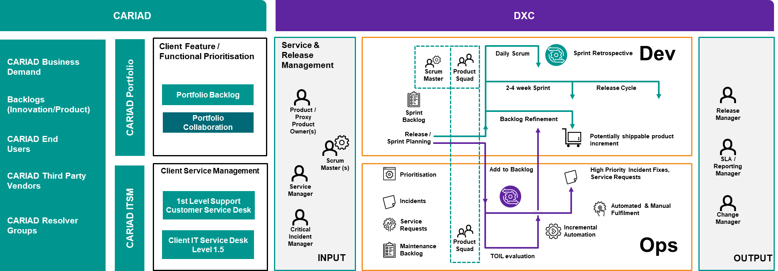

1. Input channels into end-to-end responsibility

In the fade-IN phase, DXC will develop a concept of how end-to-end responsibility is measured, how failures trigger notifications and how they are tracked. Our concept will then also describe in concrete terms how DXC coordinates and controls disruptions that are beyond our responsibility.

#### DevOps Sprint Teams

Within a tribe, the teams answer the DevOps development and operations activities including support, **so that an overall responsibility for the product during the life cycle lies with the teams.**

This also means that the teams have to cope with the challenges of plannable and non-plannable activities (e.B incidents ). These 2 different task categories are mapped in many classic organizations with 2 workflows.

**Dev Workflow**

The team makes deliveries at a fixed time, in particular to achieve integrations with other teams. This corresponds to the classic Scrum development approach.

**Ops Workflow**

The Ops workflow distinguishes between plannable and non-plannable or roughly plannable activities. A particular challenge here are high-priority incidents, which are passed on to the 3rd level support via the support organization, as they require fast monitored processing and cannot be specifically planned.

In the classic agile delivery model with separate development and Ops teams, Scrum is typically used for the development area and Kanban for the Ops area. The CARIAD model provides for classic development teams at times when additional requirements are added to a task area that can only be covered by additional temporary teams. The standard planning is based on teams that cover the DevOps functionalities.

#### DevOps - „Scrum“

For teams that provide DevOps functionality, DXC uses a process that is essentially scrum-based and in particular requires a well-prioritized backlog and a critical product owner/proxy product owner.

**In the context of end-to-end responsibility** , this is one of the key success factors in addition to cultural readiness. Especially in the case of unplanned events, a smooth management of these events in the development process is of enormous importance. We categorize them as follows:

Planned/plannable activities:

* Epics, user stories, related to product and product functionalities
* Standard and Normal Changes
* Innovations from the Innovation Board
* Release Dates
* Etc.

Unplanned/Unpredictable Activities

* Incidents/ Critical Incidents
* Problems
* Emergency Patches
* Emergency Changes

The following figure shows the possible influencing factors on the CARIAD backlogs in a simplified way.

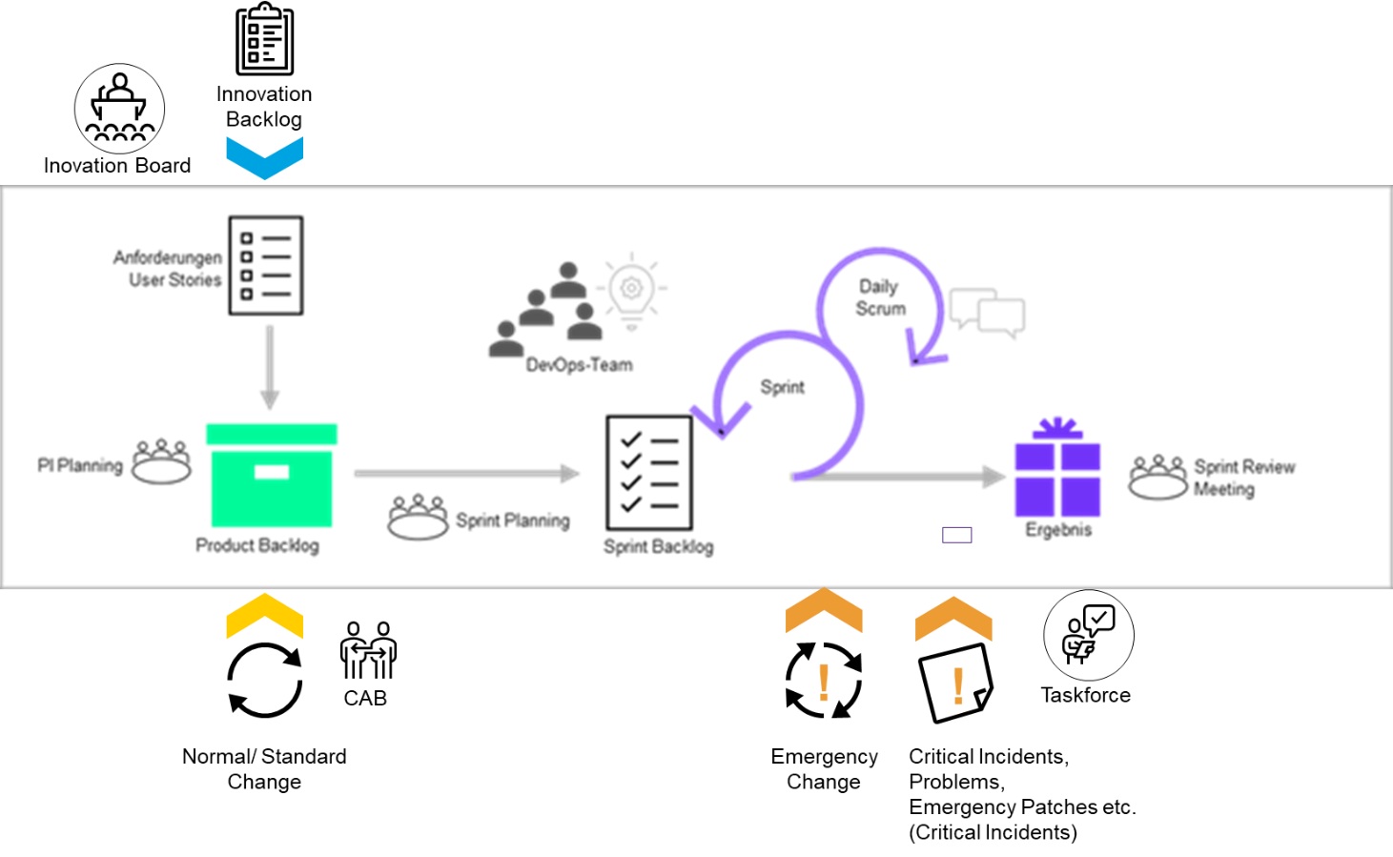

1. Influencing factors on the development process

For this presentation, we assume that the SAFe Program Backlog corresponds to the CARIAD Product Backlog and that the Sprint Backlog results from the SAFe Team Backlog in Sprint Planning. Input and output channels, priorities and recommendations for action depend on the existing processes and SLAs. DXC will discuss this overall picture in further tender discussions and offer it accordingly.

During a sprint, the sprint backlog is locked for processing, i.e. it should only be changed in exceptional cases. In the agile DevOps model, highly prioritized analysis/incident processing tasks from the support area become such exceptional cases. If necessary, they will be included in the sprint backlog during the sprint.

**Incident, Problem & Change Management Einflüsse**

For these unexpected activities, a percentage capacity is kept free as a support buffer at the beginning of the sprint. The size of this capacity is based on experience and the state of the development cycle. For example, larger capacities are planned in the hyper-care phase than in phases without changes.

Plannable activities from the area of operations are part of the team/sprint backlogs and are prioritized accordingly in the team backlog. They are assigned to a sprint in the sprint planning meeting and confirmed accordingly by the team. Larger plannable activities (updates, etc.) are usually handled at program level.

The following figure gives an overview of the processes:

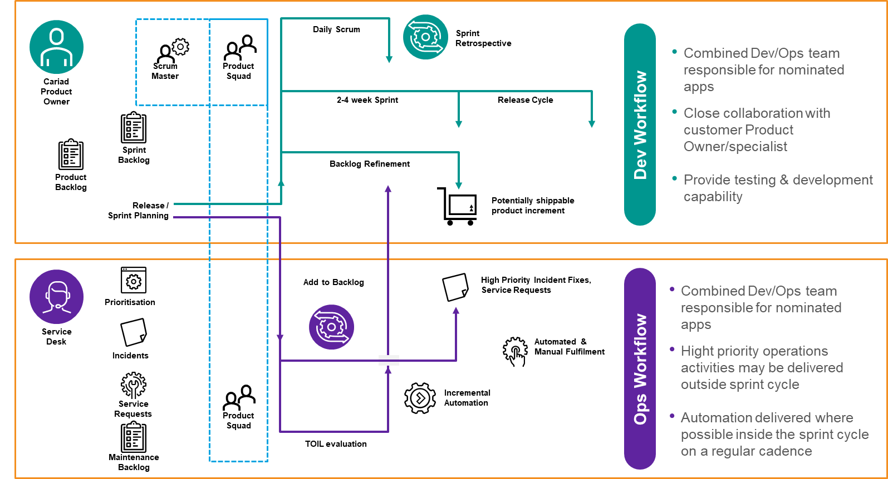

1. Integration Dev Workflow und Ops Workflow

The highly prioritized incoming support tasks are assigned to the team. Then the team decides with the Product Owner / Proxy Product Owner via ChatOps or, if the priority is lower, at a time of Daily Scrum, which support tasks are transferred to the sprint and processed with the assigned priority.

High urgency, e.B in the case of incidents, leads to the temporary suspension of ongoing tasks and the handling of incidents being tackled in accordance with SLAs.

The following graphic illustrates how the prioritized support activities of a team are processed in the sprint:

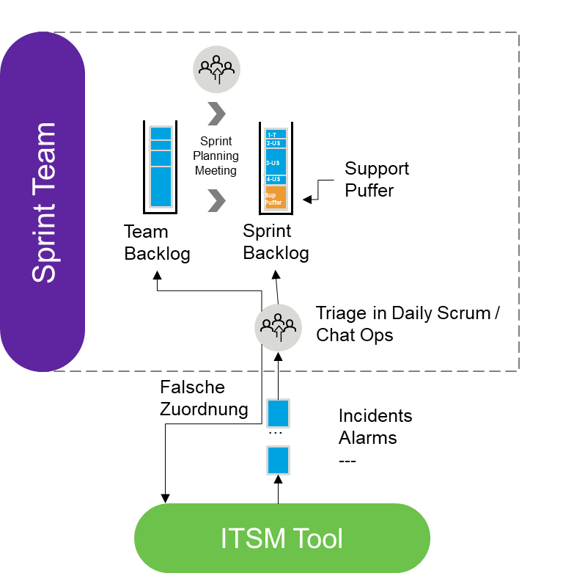

1. Sprint teams integrate incidents, alarms into the current sprint

In cases of complex support requests or a high volume of support tasks, the Service Manager also participates in the assignment coordination to ensure a better communication flow.

In the case of complex problems (Critical Incidents), the Critical Incident Manager (CIM) takes over the coordination of the solution and the DevOps team solves the incident or helps to find a solution.

The DXC team covers all requirements of this highlighted task of the CARIAD specifications for Incident Manager, Critical Incident Manager with regard to the role description, naming and accessibility. (including 2.3.3.8 Incident Management, 2.3.3.8.1.2 Major Incident Management, 2.4.4.3 CIM Phone)

The process described here requires process steps that can be optimized with the help of tools, artificial intelligence, etc. As a rule, a data exchange between systems (ITSM, Jira, etc.) is also necessary here. To ensure that this optimization potential can be realized quickly, optimization tasks are planned here in the early project phases.

One goal here is also to protect the sprint and to transfer non-plannable activities in the direction of plannable activities. SLAs for service requests must also be adapted to the Agile cycles so that the highest possible commitment can be achieved with predictable deliveries per sprint.

**Innovations**

Any form of innovation is subject to a predictable nature. They are identified, prepared for decision, approved or rejected in the appropriate committees. After approval, the transfer to the respective responsible authority takes place for the purpose of realization.

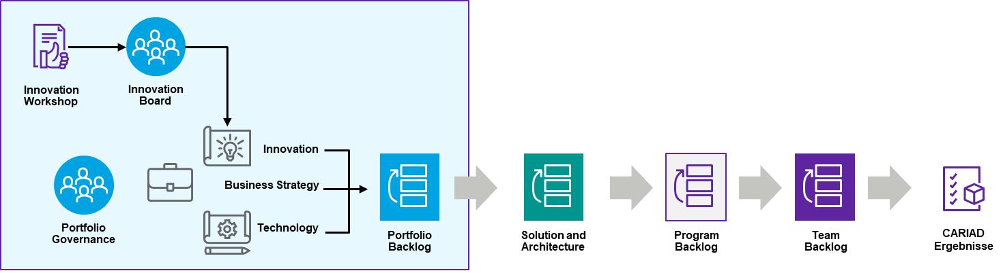

1. Inclusion of approved innovation topics in the backlog

For more information on our innovation approaches and processes, please refer to Chapter 2.8.1.2 and following.

#### Proxy Product Owner

In the team, a proxy product owner, who is in contact with the product owner and other stakeholders, manages the requirements of the team. He is also responsible for the transfer of ITIL processes into the agile SAFe world in terms of requirements, work items, etc.

The requirements are made, for example, via change requests, which must be incorporated into the respective SAFe backlogs after approval. The transfer of ITIL processes into agile DevOps processes regularly entails corresponding media breaks and requires increased effort in the area of traceability/documentation/coordination.

In the team, the necessary capacities regarding estimates, technical/professional advice, etc. must be provided and planned accordingly. The aim is to carry out the following events at team level with the product owner during the sprint and to communicate the business goals in the best possible way and without loss of communication.

* Backlog Refinement
* Sprint Planning
* Sprint Review

In Germany, the proxy product owner model is often represented for 2 reasons:

* Clearer separation between team and client
* Setups with different delivery locations, so that there is a local contact person.

The following figure reflects the role of the Proxy Product Owner:

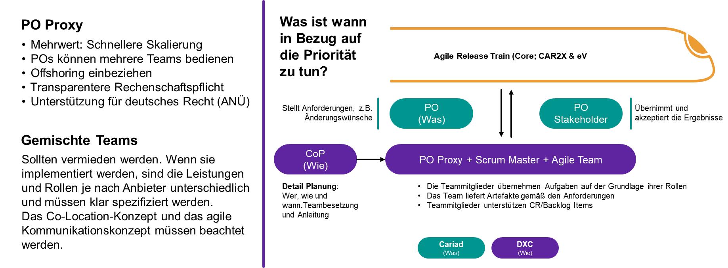

1. Proxy Product Owner Schematic Role Distribution

DXC uses proxy product owner models in customer-specific variants and has experience to efficiently integrate or transform classic business processes into the SAFe models.

### Supportstruktur

|  |  |
| --- | --- |
|  | **CARIAD Question 9:** 1.1.4.c) How do you provide the required support structure? |

DXC's application management offering offers a comprehensive set of service features to meet all of CARIAD's support needs. This will be provided from the service and release management layer of the DXC delivery model, which will provide the interfaces to the underlying DevOps teams.

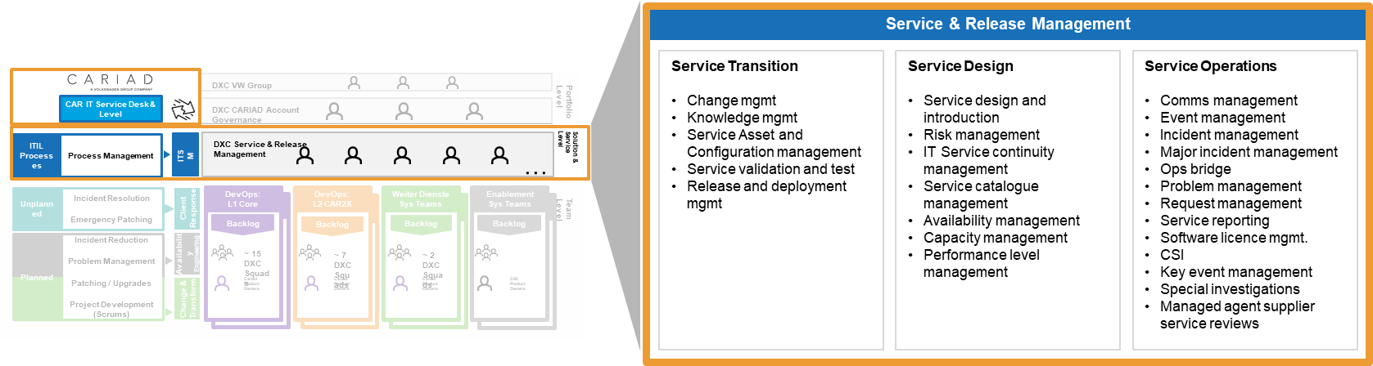

1. Service & Release Management Aktivitäten

All activities within the CARIAD service area are carried out in accordance with the relevant policies, processes and procedures.

These processes are in the context of an end-to-end service management architecture. DXC has extensive experience in the implementation of application-oriented service management and the cooperation of all parties involved and which require mandatory compliance with common processes. DXC has extensive experience in implementing an ITIL process framework. DxC will apply DXC's best practices as part of the implementation of the Service Operations Process to meet the needs of the CARIAD environment.

DXC will use the CARIAD service management toolset as the master repository for incident and knowledge management.

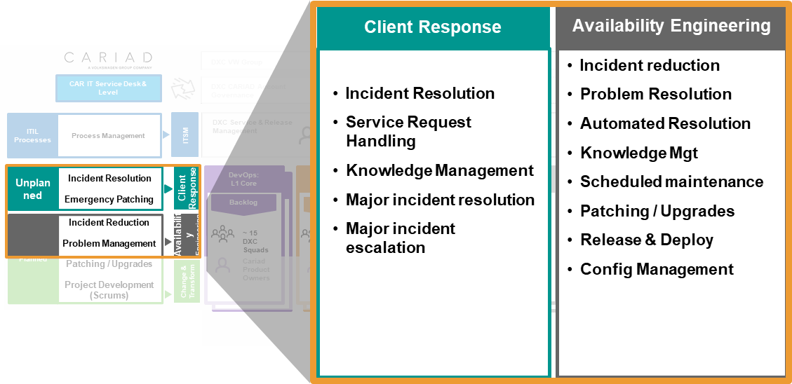

1. Service Management Activities

The table below provides a brief overview of these service features and the capabilities they provide.

| Function | Skills Provided |
| --- | --- |
| “Client Response” | The underlying sprint teams are logically set up to cover unplanned work, including incident, critical incident, and emergency patching. This is managed and prioritized through the service and release management layer. DXC provides 24x7 coverage to ensure consistent delivery of services in the event of emergency changes outside of business hours.  Opportunities for automation and prevention will be passed on to the enablement teams, and the agreed points will feed into the backlog.  This service function is made up of interdisciplinary qualified engineers who are empowered to complete tasks from start to finish without transferring them to others.  The logical function will use DXC's Application Service Automation (ASA) solution.  This solution uses analytics, AI/ML and lean processes to gain a better understanding of the service and increase the speed and efficiency of the service through automation. |
| “Availability Engineering” | As we move on to planned activities, the goal of this logical function is to prevent incidents and provide predictive capabilities to avoid service interruptions.  This is achieved by proactively ensuring availability and using automation tools and observation platforms such as Dynatrace.  The team will create backlog items for non-functional extensions. The team will identify the causes of incidents and identify potential automation opportunities. The team manages the deployment of patches and tries to reduce the technical impact.  This feature is supported by SMBs in the enablement teams that train and support the product-focused functional teams. |
| “Change & Transform” | When making functional changes, teams create solution and cost estimates for complex projects.  Teams focus on reusable components and incorporate analytics and testing into the end-to-end delivery of changes to production.  The teams work together with the Service & Release Management function to advance the releases until they are transferred to production.  Changes are initiated with standard change management processes. It depends on the stage of the demand process how detailed the estimate/solution for the change must be. Since it is a team level (team epic), the team's deputy product owner supports the PO and controls the change request process. The solution and estimate is maintained by the Sprint team of the Proxy Product Owner and, if necessary, other SMEs. The goal here is to complete the solution tasks as planned tasks.  The Sprint team will focus on reusable components and incorporate analysis and testing into the end-to-end delivery of changes to production.  The teams work with the service and release management function at the solution/ART level (e.B. RTE) to advance the releases to production.  In the event of major program epic-level changes that require multiple teams, these must be coordinated by the sprint teams affected by the change request in the sync meetings. |

1. Skills Provided

The DevOps sprint teams are set up horizontally to ensure support for the entire application portfolio and to eliminate individual sources of error and knowledge gaps. This allows for 24x7 support when needed.­

This means that we operate the support on a "leveraged" basis. Although the individual employees belong to the product-oriented teams with specialist areas, they also gain knowledge of the entire portfolio in order to contribute to the solution in the event of problems. This helps to distribute workloads more efficiently and take costs into account.

The sprint teams are structured in such a way that they can handle unplanned work - client response - in a highly responsive manner. This is handled by allocated capacity, as described in DevOps - "Scrum" .

If the allocated capacity is exceeded, the CARIAD Product Owner is notified. Then priority decisions are made about which backlog items can be re-prioritized in favor of the demand for incidents.

The Availability Engineering process works on the planned service backlog and is designed to eliminate the "technical debt" and ensure that the services are patched and maintained according to the required standards.

DXC ensures that all applications in the area of responsibility operate at the optimal level, that regular reviews of performance and capacity are carried out, and that all service measures are implemented.

DXC will proactively initiate reviews of application changes and work with the infrastructure vendor to establish governance processes to better understand needs and effectively implement the impact of changes on the service.

DXC is responsible for the application delivery processes using OLAs and RASCI (Responsible, Accountable, Supported, Consulted, Informed) that DXC has agreed and implemented with the third parties.

To clear up misunderstandings in delivery and operations, DXC will use the OLAs and RASCI and adhere to the incident, problem and change processes, with a focus on avoiding service interruptions.

DXC provides similar application support requirements for a sample customer:

**Zurich Insurance Group AG**

DXC has made continuous operational improvements to optimize service performance, such as.B:

* Automated regular health checks for legacy and modern applications;
* Automated monitoring and self-healing of middleware applications;
* Automated restarts of mission-critical applications;
* Automated detection of Batch job errors in legacy applications; and
* Automated monitoring of legacy application interfaces.

DxC proactively introduced a high level of automation in service delivery to ensure consistency and optimize costs. The aim is to support Zurich on its way to ZeroOps and to shift the workload to development, project and modernization work.

DXC has driven automation forward with a "bot factory" that has implemented 463 bots to date and automated 87,000 man-hours in the last three years.

The daily checks were automated with bots whose reports feed into a mobile Power BI application called "BAR - Business Availability Report". This was an initiative driven by DXC without customer requirements.

The application has mobile push notifications that provide updates on application portfolio status, availability, and critical service notifications. The application and notifications are distributed to the business group CIOs and service delivery leaders, improving visibility and communication about the status of the application portfolio. At the same time, users have gained the assurance that problems that arise will be quickly identified and processed.

An additional 370 automation applications with IT operations management tools, including Ansible, have been implemented and resulted in a reduction in ticket volume of approximately 40% in the last 12-18 months.

The automation approach reflects a very mature business-as-usual (BAU) process. New one-time tickets are evaluated to determine the potential for automation when repetition occurs. Overall, automation has saved an estimated 135,000 hours of manual effort over the past 12-18 months.

Application monitoring is performed by DXC using Dynatrace technology, with DXC having a specialized unit and being Dynatrace's leading system integration partner worldwide. As CARIAD already uses Dynatrace, DXC will contribute its expertise in making the most of the tool set to achieve quality improvements and integrated automation.

### Interfaces

|  |  |
| --- | --- |
|  | **CARIAD Question 10:** 1.1.4.d) What interfaces are there to other delivery units involved? What do they look like? |

DxC works in the agile SAFe model with "breathing" organizations that are able to cover additional requirements based on capacity management. For this purpose, the teams responsible for the respective components are supplemented. This is realized through new teams or by additional team members. The processes required for this are described in Chapter 2.5 .

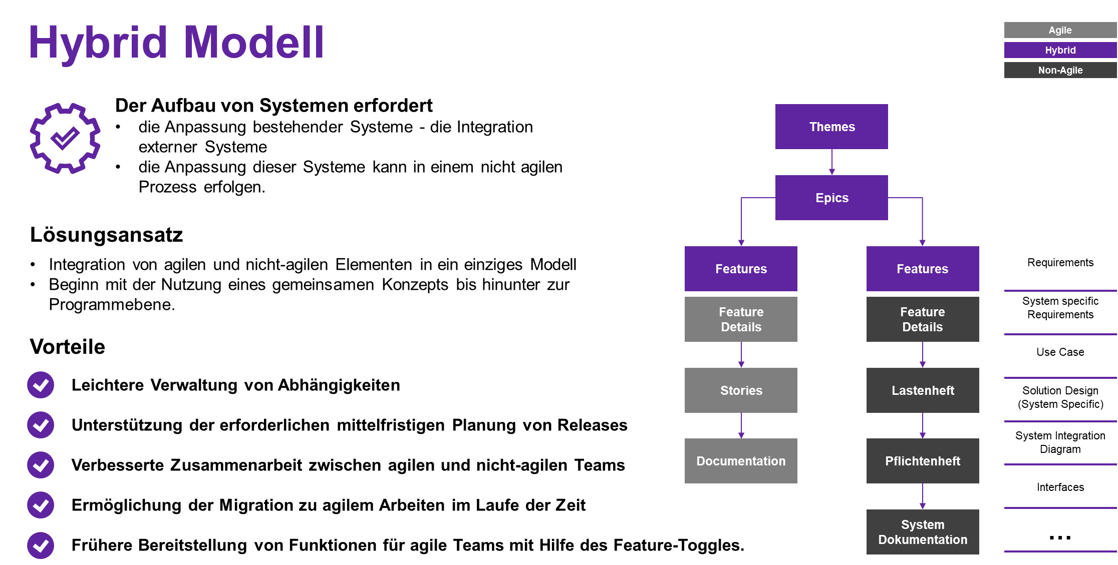

1. Hybrid Liefermodell

In addition to the agile roles in the SAFe model, it is also required to cover non-agile project management processes and reports. These tasks are taken over by the Project Manager Integration as a project manager with a focus on integration projects. It is located in the DXC PMO.

In the SAFe model, the corresponding processes are available to integrate non-agile deliveries from external partners (internal, external) or deliveries with different sprint durations.

The following figure shows an example of a hybrid model in which an agile delivery and a delivery according to the waterfall method are compared. Possibilities for dovetailing the two methods are also presented.

In all cases, the integration of the teams with external deliveries starts in PI planning and provides the dates for integration points (planning, design, integration tests, demos). The aim is always to enable early integration in the area of interfaces, which in addition to technical communication also includes process steps and thus allows early integrations. The figure below illustrates the influence of the different setups regarding the teams' delivery times on the ability to show integrated demos at the end of an iteration.

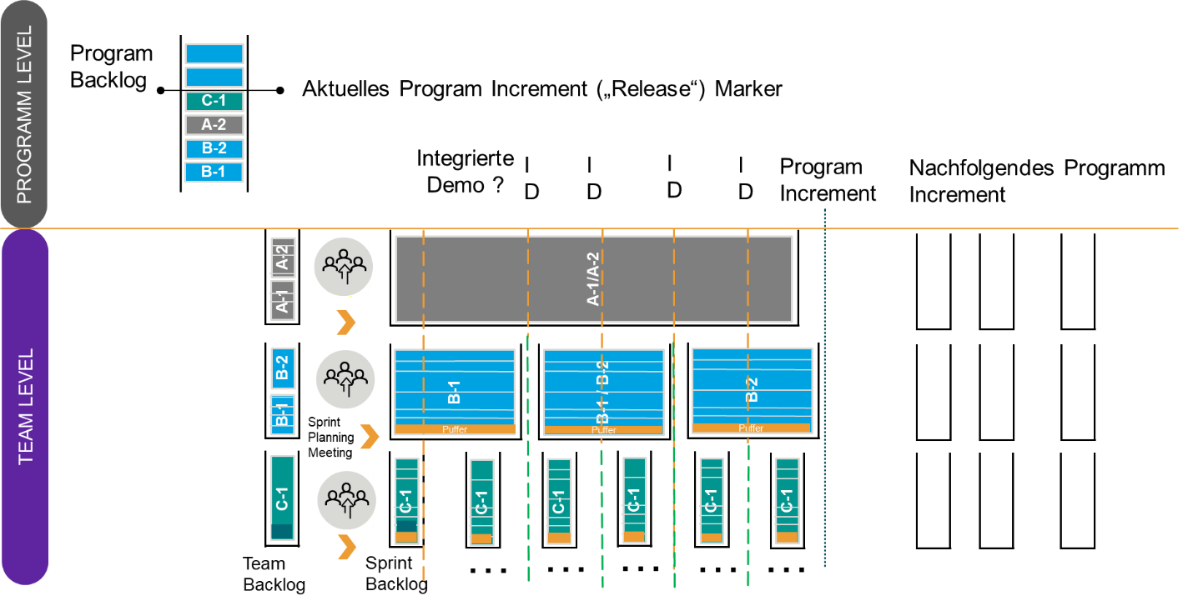

1. Different delivery cycles in the development process

It becomes clear that agile models with synchronous cycles, as they are realized in ART via the train metaphor, enable early integrated integrations of work packages of the program level (here epics). In the illustration, for example, the Epic A1, A2 is realized in the waterfall and could therefore only be tested at the end of the program increment.

Such cases must be avoided. Here, timely (partial) deliveries must be coordinated with the partners in PI Planning.

See also Chapter 2.4.3.2 "End-to-End Responsibility for Connected Car Services"

### Zusammenarbeitsmodell

|  |  |
| --- | --- |
|  | **CARIAD Question 11:** 1.1.4.e) What is your cooperation model with other service delivery units of the WORKING Group? |

See also reply to d)

DXC will develop and maintain a comprehensive backlog of change in the form of product roadmaps divided into short-, medium- and long-term changes. In addition to the presentation in the relevant CARIAD committees, we will release the backlog in collaboration tools for communication with an extended CARIAD community. DXC will also maintain a stakeholder map for all product components of the solution for direct and proactive communication.

We will promote timely impact assessments of all parties affected by a change and include appropriate integration testing in our change plans. Before changes are released for execution, corresponding impact assessments are approved by all product owners and CARIAD.

**Program Releases**

DXC's Change Manager is responsible for complying with carIAD's guidelines for changes and maintaining close collaboration with CARIAD. The role includes:­

1) to be a permanent member of the CARIAD bodies and to cooperate with the main stakeholders of the entire ecosystem;

2) Proactive work with CARIAD to understand the end-to-end roadmap and program priorities;

3) Identification, evaluation, documentation and confirmation of changes under the CARIAD programme that may affect the specific product roadmaps.

All such changes are first evaluated and a change recommendation for CARIAD is submitted for review and commissioning via the Change Control Process.

The DXC Change Manager is responsible for ensuring that CARIAD governance bodies are sufficiently informed to understand how changes to product releases need to be handled in order to work with the broader CARIAD Group.

### IT-Service Continuity Prozess

|  |  |
| --- | --- |
|  | **CARIAD Question 12:** 1.1.4.f) Describe your proposal for building the IT Service Continuity Process. |

From the point of view of CARIAD and also DXC, the IT Service Continuity Management (ITSCM) is an important process, whereby a corresponding alignment of the existing processes on the CARIAD and DXC side is necessary. In addition, integration into the overarching business continuity process of CARIAD must be ensured. This chapter explains the basic organization of the IT service continuity process, which is used in all areas of DXC relevant to the delivery of services. Part of this process is also the individual elaboration of disaster recovery (DR) plans including necessary DR tests, as well as the corresponding documentation.

To align, harmonize, and create a common IT service continuity approach, DXC proposes to use a proven risk-based approach. This makes it possible to focus and prioritize the analysis, planning and execution of ITSCM (DR) processes based on the technical maturity of the individual applications and their business criticism.

The advantage of the risk-based DXC approach is that it minimizes operational disruption while controlling costs. Operational impact is minimized by a full validation of the ITSCM implementation approach for all areas or applications, giving CARIAD and business leaders a high level of confidence in the proven ITSCM capability for their applications.

From DXC's point of view, the implementation of the integration is as follows:

In the planning, testing and takeover phase, the following points are taken into account:

* Identification of additional ITSCM (DR) plans and ITSCM test plans (DR) by DXC;
* ITSCM plan and previous ITSCM (DR) test plans are reviewed to determine the level of development and adherence to DXC best practices of each application.
* Gap analysis and applicable ITSCM (DR) plan approaches, including infrastructure providers, issuing and 3rd party application providers where appropriate
* Each application is assigned to a DR risk group based on the review and evaluation results. This builds on the risk-based category assignment definition shown below, which is done for each application.

The risk-based approach takes into account the following key factors as inputs:

* Technical aspects, e.B. dependencies and complexity
* Date of last update of the DR document
* Date of the last DR test
* Complexity
* Criticality

DR approach (e.B. fallback configuration, procedure-based recovery process).

* ITSCM (DR) creates or updates test plans and recreates a DR failure event. The ITSCM execution and schedule is shared for agreement with CARIAD and other suppliers, including the DR failure event to be reproduced;
* Initiation and management of the CAB process for the Transition ITSCM (DR) execution plan in cooperation with the CARIAD ITSC/BC planning group;
* "Tabletop walk-through" of a DR event and its ITSCM (DR) test plan will be conducted under the leadership of DXC with support from infrastructure and network providers and CARIAD.

|  |  |
| --- | --- |
| **Risk categorization** | **Description of the criteria** |
| Low | * Recently validated, review accepted * Easy to use |
| Medium | * DR plan or DR test plan missing for some applications * Part of the previous DR test cycle, but test not run |
| High | * DR plan or DR test plan missing for applications |
| "Managed" | * SaaS Applications |

1. Risk-based categories

**Operational phase**

In the operational phase, the DR test projects are executed according to their plans for business-critical and non-business-critical applications:

The applications are converted to dynamic, cyclic DR testing in risk-based category priority order.

* Representative pre-production environment:
* For non-mission-critical applications, a DR-Test is performed in the pre-production environment
* For non-mission-critical applications, execution begins within the first 6-9 months
* The DR test is run during normal business hours;
* Produktionsumgebung:
* For business-critical applications, a DR test is carried out in the production environment
* For business-critical applications, execution begins within the first 3-6 months
* The DR test is carried out outside business hours (weekday / weekend)

DXC agrees and documents the IT Service Continuity requirements for the in-scope applications in an overarching IT Service Continuity Management Plan. The ITSC plan shall include at least the following sections:

* Introduction:
* When and how to apply the plan
* Scope of the plan
* Strategies used
* Goals
* Dependencies, Assumptions, Problems & Risks
* ITSCP-Aufrufprozesse:
* Aufrufprozess
* Authorized people who can activate the plan
* Authorization of Third Party Services
* Emergency Command Center
* Roles & Responsibilities
* Reporting
* Critical services to restore:
* Critical Services
* Ressourcenanforderungen
* Execution of the ITSC plan:
* Steps to use the plan
* Time schedule and steps for restoring services, data centers
* Return to "normal operation and restore of the application instance"

The ITSCM plan will also include details on:

* Mandatory and optional document approvals
* Responsibilities of the approvers
* The distribution list of the plan

In addition to named persons, this may also include references to secure CARIAD and DXC document locations, e.B. external or online disaster recovery vaults.

As part of the aforementioned approach to meeting ITSC requirements during the transition, DXC will revise and optimize the existing individual ITSC plans and ITSC test plans for each application under the contract. The ITSC plans are drawn up, if necessary, 30 days before the date of commencement of the operational service (OSCD) and agreed with CARIAD and other suppliers.

The ITSCPs contain the detailed technical recovery procedures or runbooks required to restore application components. In addition, the ITSCPs include or reference installation/build recovery procedures or runbooks required to install or restore software/applications/databases.

Each DXC delivery center is equipped with a dedicated Business Continuity Management System (BCMS). It is part of the overall management system that ensures the continuation of business activities. It is implemented, operated, monitored, checked and improved by us – after detailed agreement with CARIAD. The main objective is to continue the provision of products and services after an incident at an acceptable predefined level. The BCMS is officially registered and certified by Lloyd's Register according to the ISO 22301:2012 standard.

The management system includes the organizational structure, policies, planning activities, defined roles and responsibilities, practices, procedures, processes, resources, and a set of tools. An established dedicated Project Management Office regulates the annual maintenance cycle and continuous improvement of the BCMS. There is a methodology that manages the process of covering the new services offered to our customers as part of the BCMS. It is also subject to frequent internal and external audits.

For BCMS, the centers have business continuity plans and supporting business recovery plans for teams that support our customers. The framework provides multiple recovery strategies that can be implemented for six crisis scenarios – depending on requirements and cost constraints: site unavailability, city unavailability, country unavailability, people unavailability, IT unavailability, and other specific dependency unavailability.

The main sites that provide services to our clients have their own resilience measures that must cover and not be limited to:

* Redundancy in the power supply with UPS and/or power generator
* Fire detection and suppression systems
* High availability configuration for office telecommunications.

The main recovery solutions for the six scenarios mentioned above are:

| Failure Scenario | Wiederherstellungsstrategie |
| --- | --- |
| Location not available/accessible | Other accessible location  Office à Home Office  Home office à office |
| City not available/accessible | Other accessible city |
| Country not available/accessible | Services are provided from another country  Employees are moved to another country |
| People not available | Deputy Regulations  Documentation of knowledge  See also the following chapter 2.4.8  Knowledge management |
| Loss of IT components  (internal applications or critical infrastructure/equipment) | DXC telecommunications and network equipment is designed in a high availability configuration for critical components.  Schneller DXC Hardware-Austauschprozess.  When using the customer's IT systems and applications, we rely on the customer's validated DR plan. |
| Loss of key dependency – (DXC Ecosystem/External Suppliers/Partners/External Applications) | N/A |

1. Wiederherstellungslösungen

DXC considers employee training and awareness to be a key factor in successful BCMS operations. For this reason, at least one special training is required for each employee every year. All new hires receive training for the orientation of new employees, which includes BCMS. In addition to the training, a formal KPI is defined.

For mission-critical systems and services, DXC can provide complete managed services disaster recovery solutions according to ISO22301 requirements and include not only IT systems, but also applications and business processes.

### Knowledge management

|  |  |
| --- | --- |
|  | **CARIAD Question 13:** 1.1.4.g) Describe your concept for building and managing knowledge. |

In our approach, the DXC knowledge management concept covers all areas of DevOps factory operations. We see knowledge as capital that must be made efficiently available to all parties involved and managed sustainably. For us, it is our top priority that there is no loss of knowledge regardless of possible influencing factors and that knowledge is effectively replicable and reusable.

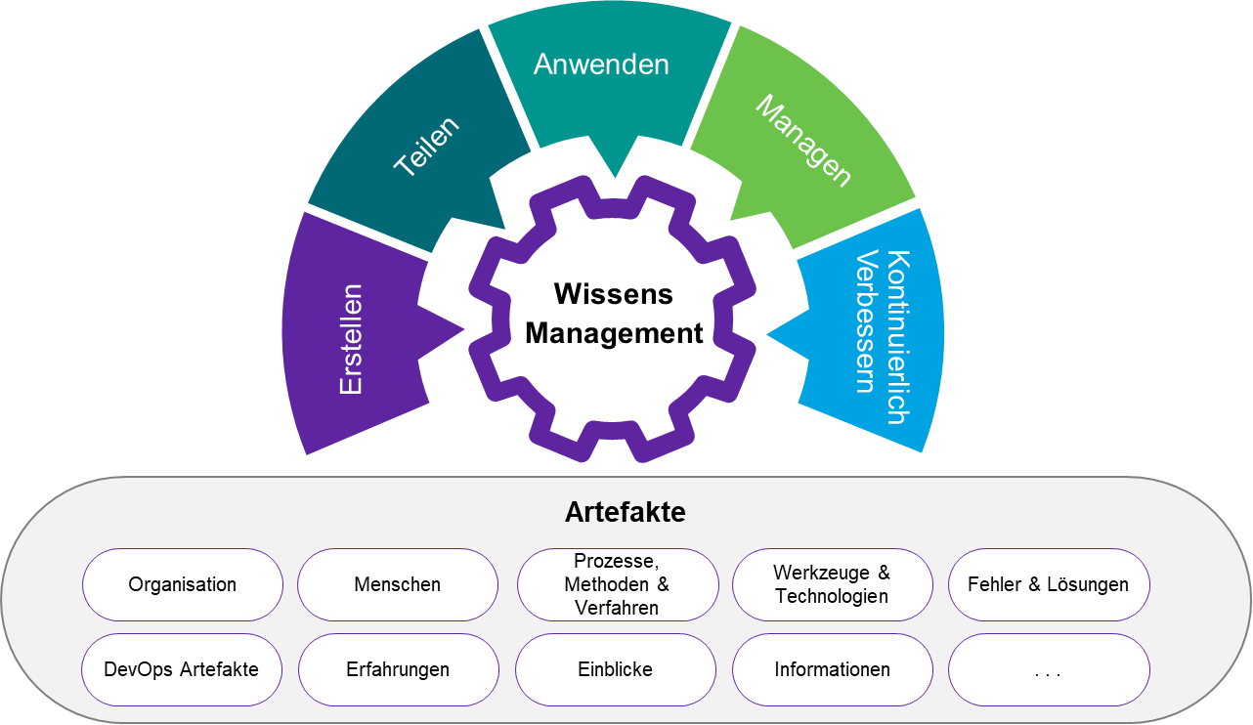

1. Knowledge Management Cycle & Artifacts

This applies equally to development- and operation-relevant activities in the CARIAD DevOps factory offered. The life cycle of knowledge follows a logical sequence of activities. These are to be continued until the specific partial knowledge has reached a degree of maturity that enables a complete and qualitatively flawless service provision.

When applying our knowledge management, we divide the knowledge to be imparted into three main areas:

* **Knowledge culture and conception**, in the context of the DevOps factory, motivation, structures, channels, etc. as well as order-relevant content and environmental parameters, methods and technology knowledge, innovation topics and approaches for the continuous improvement of workflows as well as developed solutions
* **Development-relevant DevOps knowledge**, processes and workflows, coding, repositories, testing, etc. to increase development quality and speed
* **Service management-oriented knowledge**, which is developed, monitored and provided as required via suitable processes and information channels for problem solving

#### Conception and culture

With its DevOps fabrics, DXC stands for service quality and scalability of teams, among other things. To ensure this, we consider it essential to continuously impart knowledge and share it with employees across borders. We believe that the dependence on individuals or knowledge carriers (monopoly knowledge) can be eliminated by various measures and thus the effect of a tribe or sprint team can be significantly increased.

However, it should be noted that a stable and appreciative working environment as a healthy foundation favors, among other things, the participation of each individual employee in supporting our cultural idea of knowledge management. As core components of a tool-supported knowledge management, we see the following points, among others:

* Knowledge provision and transfer
* Documentation & Guidelines
* Communication and exchange of information

**Wissensbereitstellung & -transfer**

Employees are our greatest asset. If there is no stable and attractive eco-system for the employees employed in the DevOps factory, this is immediately reflected in the quality and efficiency of the products and services provided.

How we as DXC provide an attractive ecosystem as part of a DevOps factory:

* Continuously observe and identify top executives of "Next Generation"
* Record and consider career aspirations vs. industry trends and requirements
* Create and actively pursue career development plans for the individual employee
* Expand talent management and skills
* Develop and communicate promotion strategies
* Run coaching and mentoring programs
* Establishing mandatory innovation as a motivational driver
* Promote flexible rotation/partial transfers within and between teams
* u.v.m

The future CARIAD DevOps Fabrik is designed as a distinct learning engine that will continue to evolve in its level of knowledge. Employees of your DevOps Fabrik are subject to a constant transfer of knowledge, based on a specially developed, global, DXC Blaupause.

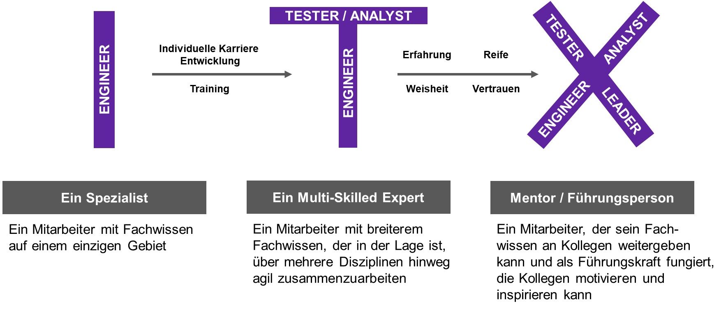

1. Career & Knowledge Transfer Mission Statement "ITX Model"

As part of their DevOps factory, we follow a so-called "I-T-X Evolution" approach. It is our continuous endeavor to develop from an engineer with individual technical knowledge to a multi-skill expert and mentor who can be used in a variety of ways and thus promotes the basic idea of agile development methods.

Further details on talent management and the expansion of personal skills are explained in more detail in chapter 2.5.3 – Further education and training.

This approach gives us a model that allows teams to scale through broader expertise. In this way, we achieve the necessary independence from expert knowledge for you in the CARIAD environment in order to react to the corresponding operating situations and requirements for the DevOps factory at an early stage.

According to this model, our employees in the Tribes/Sprint teams all have approximately the same skills and change their role in the team from time to time. Through this approach, we ensure that all technical tasks can be carried out equally by our Sprint Team members.

The above-mentioned model is based on the approach of motivating employees to acquire a broader knowledge base and thus to gain a professional form of flexibility in their working environment. The transfer of knowledge will take place in four main stages:

1.)Other observation and copying (shadowing)

2.)Apply what you have learned and have it accompanied by a mentor (reversed shadowing)

3.)Deepen the acquired knowledge and exchange it with its environment (See Guilds Chapter 1.1.5 Question b)

4.)Actively work as a mentor for others

Through this process, we promote a culture of constant exchange in which the accumulation of monopoly knowledge does not provide an advantage as a positive quality and is rewarded.

**Documentation & Guidelines**

In addition, we set up regulations in our DevOps factories on how, where and who has to document and communicate acquired specialist, niche or specialist knowledge in order to make it replicable. We use tools such as Jira, Confluence, GitHub MSTeams/SharePoint and others.

|  |  |
| --- | --- |
| Tool | Use |
| Lap | Project documentation, backlog instrument and status of the respective assigned work |
| Confluence | Data storage for project information as well as knowledge database (wiki) for instructions, trainings, etc. (manuals or comparable documentation) |
| GitHub | Data storage for project and code information as well as knowledge database (wiki) for instructions, trainings, etc. (manuals or comparable documentation)  GitHub is a network-based versioning service for software development projects. |
| MS Teams | Communication tool & information management tool with integration to the Microsoft product range and partner applications to enable cross-border cooperation. |
| SharePoint | Library, document storage, tracking and reporting tool |
| Miro/ Mural or comparable | Collaboration tool for interactive and hybrid collaboration (physical / virtual), whiteboards, Kanban user stories etc. (template-based and e.B. integrative with Jira & MS Teams) |

1. Tool Overview Knowledge Management Support

The use of these tools is subject to a predefined concept. Like all relevant DevOps factory operational information, this is communicated and taught to employees in advance. The handling of knowledge as well as the use of tools for the documentation and distribution of the created information are stored centrally in advance in a knowledge library and continuously further developed by the employees.

Guidelines extend the radius of the documentation specifications and help the employees of the DevOps factory to understand processes and procedures in the development and operation for their MBB and ODP Platform, to carry out work steps in everyday life efficiently and repeatably. In addition, these guidelines help to ensure high quality in code generation and to make its documentation comprehensible and quickly understandable for outsiders (e.B. new employees).

* Methodenhandbuch
* Styleguides
* Coding Guidelines
* Dokumentationsanweisungen
* Templates
* Checklists
* Etc.

In the course of the introduction of DevOps for the MBB and OPD platforms and the increase of the CI/CD maturity level through a transformation of the entire ecosystem, the documentation of code as the primary method for knowledge management in this area plays an essential role (see Chapter 2.4.7.4).

**Communication & Information Exchange**

We foster a culture of constant collaboration, knowledge sharing and process improvement in our DevOps factories and Innovation Labs. We bring innovation to the teams and equip them with the ability to be inventive for them. We do not carry out "frozen" qualification requirements, but an agile realignment with new methods and technologies that arise in agile projects, digital innovations and transformations.

The communication required for this as well as the continuous, qualitatively flawless and addressee-oriented exchange of information is promoted by us through the agile working approaches:­

* Within the framework of the working methods prescribed by agile working methods, an exchange of content information takes place in the daily stand-up meetings, weekly Scrum of Scrums meetings, retrospectives and PI planning, etc.
* Cross-team validation of working methods as well as solutions to avoid effort, by replicating already known.
* Use of a common and addressee-oriented knowledge base for the exchange of information.
* Continuous development and the operation of guilds to establish a platform for professional knowledge transfer and exchange of experience

#### Our Guiding Model - Adaptation of Spotify

In our DevOps factory approach, we live a culture in which monopoly knowledge cannot arise in the first place. To optimally support this in a factory like yours, we will use the Spotify model. Among other things, it describes the organizational structure in an agile environment, communication and the exchange of information within the framework of a large knowledge transfer.

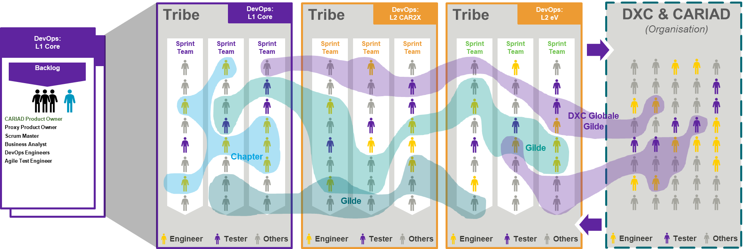

1. Adapted Spotify Guild Model

* Analogous to the delivery model already presented, we use the remaining components of the Spotify model to optimally support the success of day-to-day business through a stringent knowledge management tool.
* In particular, the chapter (chapter) and guild structure is suitable for cross-border communication as well as a targeted exchange of information.
* The members of the enablement teams are integrated into this structure across functions and, through their expert knowledge, make a significant contribution to knowledge transfer through mentoring, coaching, training and the continuous transfer of relevant CARIAD specialist, technology and methodological knowledge.
* The tool support recommended for the realization of chapters and guilds focuses on the use of Microsoft Teams/SharePoint. This platform provides functionality required to operate the following instances:
* Organize meetings, meetings & trainings
* To lead and document discussions
* Document results and store them centrally and accessible
* Conduct and document surveys
* Support workshops through integration with Microsoft products and its functionalities
* In addition, it makes sense to use tools such as Confluence, GitHub and others for documentation purposes. The use of these is subject to final coordination between CARIAD and DXC, within the chapters and guilds.­

**Chapter**

Professional networks within a tribe: This is where all colleagues with the same profession are professionally united. For example.B, all designers within a tribe belong to the same chapter. At the same time, the chapter lead also assumes leadership responsibility for the employees in his chapter. This management responsibility relates to the professional development of employees and the development of uniform standards. There is no authority to issue instructions with regard to the services to be provided and the operational objectives. These remain untouched in the Sprint Team, in which the employee participates. This provides a flexibility that supports the scaling effect described above through the ITX model.

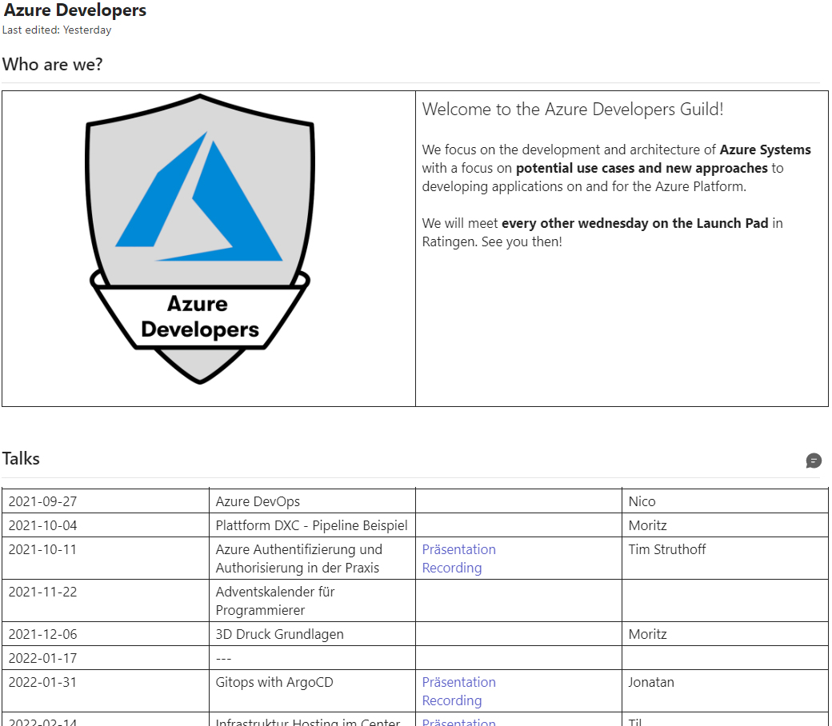

1. Application example from a DXC chapter

Ideally, the chapter model is based on the core roles of the CARIAD delivery model. In this way, we ensure that the exchange of knowledge is focused on relevant methods, technologies and technical content of CARIAD MBB and ODP. We therefore recommend that you make a pre-selection of relevant chapters as part of the further tendering process.

**Guilds**

Overarching Voluntary Communities: The guilds are voluntary communities that also go beyond the boundaries of a tribe. Especially in the operation of a DevOps factory, this creates opportunities to exchange ideas with the global DXC beyond the borders. In this way, we contribute to one of the most important agile principles - voluntariness and self-commitment - becoming an essential part of the organizational structure of the DevOps factory. The guilds are maintained through self-organized and regular meetings and mailing lists. Not only professional exchange takes place in it. It is much more important that there is also an exchange and networking across the borders of existing ­tribes or factories.

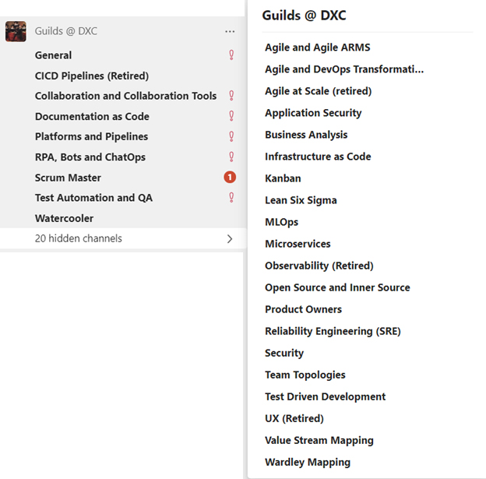

1. Excerpt from the guilds currently operated at DXC

We can imagine the following implementation examples (initial, minimal setup) for use at CARIAD in the DevOps factory model. A final coordination of the "guilds" to be founded initially takes place in the transition phase between CARIAD and DXC.

| Content | Focusing |
| --- | --- |
| Car2X | Business |
| home | Business |
| Telematics | Product |
| Infotainment | Product |
| Security & Authorization | Product |
| CI/CD | Methods & Technology |
| Architecture | Methods & Technology |
| Agile Working & BA | Methods & Technology |
| Testing | Methods & Technology |
| Java Backend Development | Methods & Technology |
| Container / Kubernetes | Methods & Technology |
| Micro Services | Methods & Technology |

1. CARIAD Guild Examples

#### Knowledge transfer in the CARIAD MBB & ODP environment

The exchange of knowledge with the CARIAD environment proves to be a critical success factor for DXC. The assumption of development and operational activities can only take place smoothly and successfully if the existing state of knowledge can be conveyed to DXC in a complete and comprehensible manner. Once this has taken place initially, a bidirectional knowledge management develops in which clients (CARIAD) and participants (DXC) keep each other up to date with information (knowledge). In order to give this knowledge management more structure, we divide the knowledge transfer into six (6) different categories in our concept.

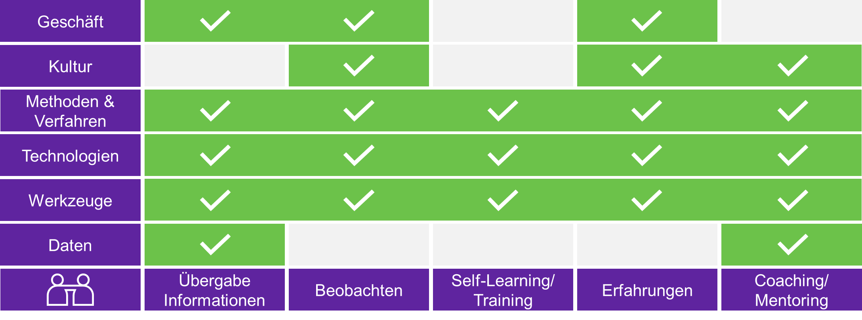

1. Knowledge Transfer Categories

**Business**

DXC understands the CARIAD strategy, the objectives as well as the MBB and OPD business model and will translate them into a generally understandable profile or personas. This helps DXC Fabrik employees get an idea of where the focus needs to be and why the work done by the Tribes and Sprint teams is so important to the success of CARIAID's product/service.

**Culture**

A successful DevOps implementation primarily requires a company to make a cultural change. By transferring knowledge about your (existing) corporate and DevOps culture, we can adapt to how the implementation of the DevOps factory can be successfully designed. We can also gain important insights into how acceptance at all levels of the organization between CARIAD and DXC must be created or optimized. In addition, we will learn which influencing factors must be taken into account for successful change management in transition and transformation.

In return, you get continuous insights into the agile way of working and our further developments in ­this direction, with the opportunity to transfer what you have seen and learned for your company.

**Methods & Techniques**

We learn from you which methods and techniques are already used in the CARIAD environment and can get an idea of how this fits together with our DevOps Fabrik Blueprint and can be adapted or implemented in a future-oriented manner.

In return, a knowledge transfer from DXC to CARIAD takes place, which gives you insights into our understanding of DevOps, SAFe, Scrum, Kanban etc. as well as into our factory approach.

**Technology**

We will get a first overview of the currently used CARIAD MBB & ODP technologies, their application scenarios as well as the required configurations etc. With a comprehensive overview of technology/architecture, we are able to continue and further develop both the development business and the operative business together with you. At the same time, we will look for automation potential that will continuously optimize the quality and efficiency of future fabrics.

**Tools**

By instructing on the tools used for conception, planning, development and testing as well as the transfer to production, we are able to understand the scope of tool-based support and include its areas of application in the DevOps factory concept.

A continuous tool validation takes place to check whether the application corresponds to the latest state of the art, has a sufficiently supportive effect and is used effectively. New tools that are developed on the market are continuously examined, evaluated and proposed as a solution alternative in the future (according to relevance).

**Data**

Analogous to the knowledge transfer in chapter 2.4.8.3, it is important to familiarize yourself with existing guidelines, guidelines, documentation, etc. The filing and dissemination mechanisms should be named and shown in order to empower the employees of the factory. In return, this is explained in Chapter 2.4. 8 described knowledge management integrated into the day-to-day business, new procedures and methods as well as documentation are taught and ongoing changes are proactively communicated.

**Step-by-step approach to the state of knowledge**

Across the (six) categories mentioned above, we operate a knowledge transfer model adapted to the service transition. It consists of the following steps:

* Step 1: Provision of information,
* Step 2: Observation (shadowing),
* Step 3: Self-oriented & motivated training,
* Step 4: Exchange of experience and practiced (own) experiences (reverse shadowing)
* Step 5: Coaching/mentoring of teams or individual resources.

**Role-based knowledge & information transfer**

In addition, the Agile Setup under SAFe & Scrum implicitly offers methods to spread knowledge within the sprint teams and/or tribes to be applied at Ihnen and to build up cross-team knowledge.

In particular, the following events/processes are to be emphasized, which are set up in the DXC processes:

* High-level requirements are coordinated with the entire team in a PI planning.
* In the SAFe/Agile setup, various sync meetings take place on the different working levels
* At team level, there is a constant exchange of information with all team members in the Daily, Backlog Refinement, Sprint Planning Meeting, Review Meeting.
* A 4-eye principle in code reviews imparts knowledge and increases quality
* As well as the construction of guilds, as described above, in which different teams exchange ideas in a thematically organized way.

As part of the daily cooperation between representatives of CARIAD and DXC DevOps Fabrik, an additional, bidirectional exchange of information and knowledge takes place in addition to the knowledge management approaches described above. Depending on the implemented role model, this results in further channels that are used for this in day-to-day business.

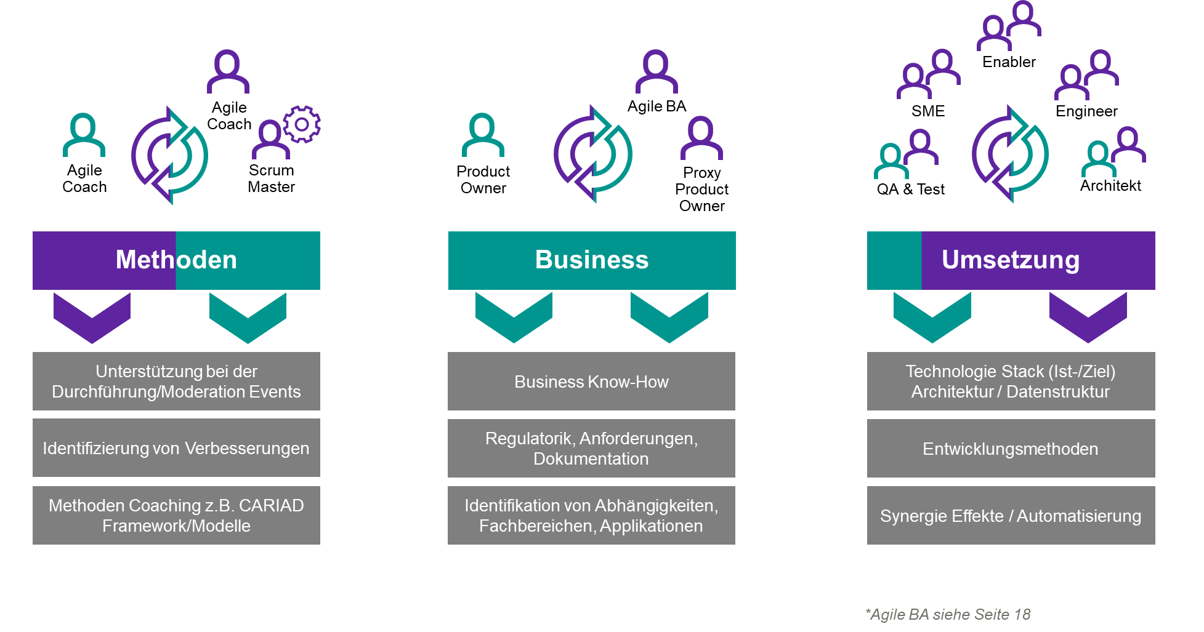

1. Role-based knowledge transfer

The role model underlying the delivery model is used here.

#### Development-relevant DevOps knowledge

**The use of a DevOps coach**

DevOps is a concept based on the knowledge areas of Lean and Agile that drives business agility in a company. DevOps isn't just about implementing new tools and technologies. It is also about the need for a change in thinking and behaviour. The company must bring about a cultural change. To ensure that this cultural change takes place smoothly, we as DXC favor the use of a DevOps coach in your company. The DevOps coach works together with our Agile coach and takes on the task of acting as a central point of contact for all questions of cooperation, knowledge transfer and as a source of inspiration for the operation of a smooth DevOps operation. Our DevOps coach supports the teams of Fabrik, CARIAD and DXC stakeholders and the entire (relevant) CARIAD organization in the implementation of their DevOps concepts and principles and enables all participants to change their mentality that promotes the DevOps culture.

**Code Documentation & Filing**

The envisaged, agile, development model is designed for cooperation and promotes an implicit and explicit exchange of knowledge. Our agile development projects use:

* Code reviews as part of the development process
* Participation in Scrum/SAFe events, which serve the coordination and exchange of information
* Co-location of the teams, so that the unconscious exchange of information is promoted.
* Moderne Kommunikationsmittel (Collaboration via Teams, DXC Virtual World)

Our goal is to transfer this approach to the DevOps factory and to successfully implement it for all participants as part of the transition and to optimize it step by step in subsequent steps of a transformation.

According to the "Everything as Code" approaches, the version/code-related documentation is part of the code repository. Tools/methods are used here, such as

* Markdown / ASCII Doc
* Diagrams from code (e.B. PlantUML) to visualize components, processes, sequences in particular.
* Code Comments
* Version control with traceability functionality and macros

If required, corresponding PDF/Word documents are generated in order to obtain documents in accordance with carIAD requirements. Overall, our goal is to generate documentation as automatically as possible and to avoid media breaks or inconsistencies.

It should be noted that in addition to the documentation of changes (change requests, user stories, etc.), the overall state of the system is consistently documented for a version.

A list of repositories to be used will be worked out in the further cooperation and jointly determined between CARIAD and DXC.

#### Service management oriented knowledge management

DXC will professionally support CARIAD's Service Management (SM) oriented knowledge commitment to ensure the effective, efficient and convenient use of information and knowledge in the future. The requirements defined in the specifications V1 - Chapter 2.3.3.11 Knowledge Management are fulfilled by our SM Knowledge Management concept.

Our aim is to achieve continuous quality improvement through a structured approach to

* the definition,
* the structure,
* reuse, and
* the exchange of knowledge,

to review the existing concepts and content, to continuously develop them further and to adapt them to changing framework conditions. This includes information, skills, working methods, solutions and problems alike.

With the implementation of service management-oriented knowledge management, DXC pursues the following goals:

* Improve the quality of decision-making by ensuring that reliable and secure knowledge, information and data are available throughout the lifecycle of application services;
* Enabling efficient and improved service quality, increasing satisfaction and reducing service costs by reducing the need to regain knowledge;
* provide a Service Knowledge Management System (SKMS) that provides targeted and controlled access to knowledge, information and data; and ­
* Collect, analyze, store, share, use, and maintain knowledge, information, and data across the enterprise.

**Interfaces to service management processes**

Several service management processes have interfaces to the knowledge management process. The following figure shows some important interfaces for illustration:

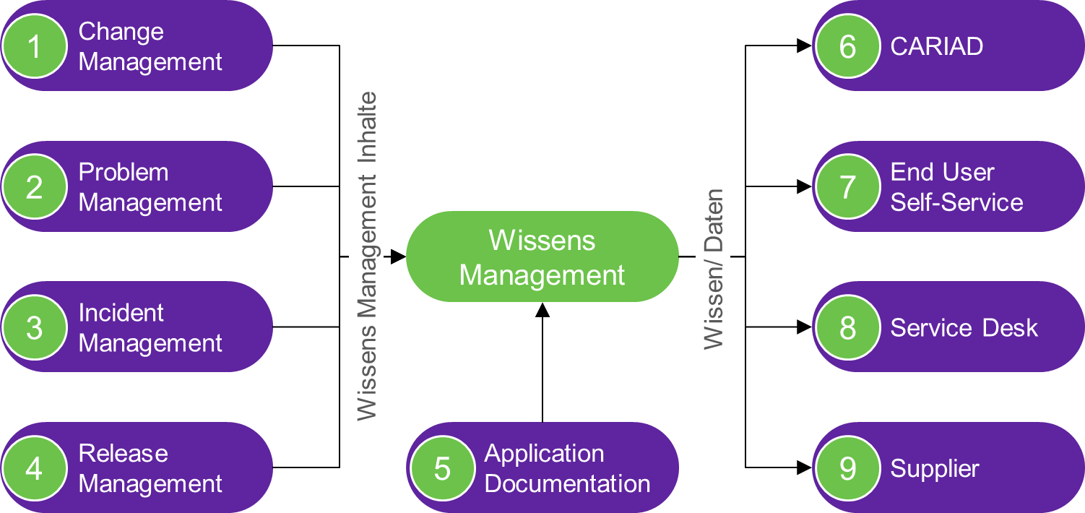

1. Service management oriented knowledge management

* Change Management provides known error scripts and other supporting material identified by the DXC Operational Teams as part of the change process.
* Problem Management provides known bugs and workarounds for all operational areas, as well as supporting material identified as part of the Problem Process.
* Incident Management provides incident solutions that enable rapid identification of the cause of incident and methodologies for workarounds and other supporting material identified by DXC Operational Teams as part of the incident process.
* Release Management provides Knowledge Management with data on known bugs that feed into production, as well as other supporting material identified by the DXC Operational Teams as part of Release Management.
* Other knowledge objects of the DevOps service (architectural and technical documentation, low-level designs, application FAQs, guides and runbooks, etc.) specified in the Knowledge Definition document are made available in the SKMS, with the result that CARIAD's SKMS is a single source of application knowledge beyond the standard ITSM knowledge.
* Architectural documents, plans and low-level designs are made available to architects and stored in the secure knowledge store.
* Knowledge articles (known bug scripts, workarounds, tips, quick fixes, FAQs, and other supporting material identified in the process) are provided to the service desk to increase the initial resolution rate of incidents and to give the service desk the ability to assist users with information.
* DXC Knowledge Manager publishes knowledge articles, FAQs, and application guides on the Service Portal that can be used by end users.
* A DXC Knowledge Manager will publish FAQs, application guides, and runbooks to SKMS that can be leveraged by DXC teams, infrastructure vendors, and other vendors to ensure seamless end-to-end service delivery.

We consider knowledge management to be an important component in reducing unplanned work. We expect close cooperation with the Service Desk to continuously maintain and improve the knowledge articles in CARIAD's SKMS (Service Knowledge Management System).

During the transition, DXC will review the knowledge management definitions and processes provided by CARIAD and, if necessary, make arrangements for the management of the knowledge base(s).

We will carry out the knowledge management, after completion of the validation, as described in the following sections:

|  |
| --- |
| Filling the Service Knowledge Management System with data and information necessary for the administration of the services and providing first-contact resolution information. This information includes: tips, quick fixes and other methods for troubleshooting, known bugs and workarounds, service desk scripts, frequently asked questions, tower strategy, and architecture documents. |
| During the transition, DXC will coordinate the knowledge definition document with CARIAD.  DXC sets the basis of the available knowledge and validates the content of the SKMS by performing application discovery and knowledge transfer activities. DXC populates the SKMS with data and information required to:   * administer the services acquired; and * Assisting the infrastructure provider in deploying first-contact resolution. * This information includes (as a minimum): * Tips, quick fixes and other methods for resolving incidents; * Known bugs and workarounds; * Service-Desk-Skripte; * FAQs; and * Application Tower strategy and architecture documents.   In coordination, DXC manages a process for adding, publishing, and maintaining knowledge from various processes and DXC teams into the knowledge base.  Technical and architectural documentation, known bugs, workaround and troubleshoot scripts are also maintained as integral parts of the knowledge infrastructure. This more technical and detailed knowledge is provided and updated by the respective donors and labelled accordingly to ensure that it is accessible to the right technical resources.  As part of Business as Usual (BAU) activities, DXC Application Operations Engineers analyze the incidents received by DXC and evaluate ways to avoid, relocate, or automate unplanned work. Knowledge candidates are recorded within the DevOps services, which are introduced into the knowledge management process.  The SKMS will use the knowledge management functionality within CARIAD's ITSM tool to capture, manage and publish knowledge to all stakeholders within the Services.  In accordance with CARIAD's Knowledge Management Policy, DXC Knowledge Manager will manage the knowledge articles for the DevOps Services.  In addition to providing the knowledge articles, DXC will host technical training for the service desk as needed to facilitate the KPIs for the first contact solution for the service desk.  DXC expects to work closely with the Service Desk to continuously maintain and improve the knowledge articles. |

|  |
| --- |
| Conduct compliance checks and audits on a quarterly basis as directed to ensure the integrity and accuracy of the data on the services in the SKMS |
| The DXC Knowledge Manager, in collaboration with other process managers and DXC teams and other (relevant) suppliers, will initiate regular reviews of the SKMS data to verify knowledge utilization and assess integrity and accuracy. In addition to these reviews, the ­knowledge management process provides for an escalation process in which a knowledge article identified as inaccurate is marked for review. The respective support team at DXC or the other suppliers is then tasked with reviewing and correcting the item before it is resubmitted for inclusion in the SKMS after the agreed approval process. If the article proves to be outdated and is completely replaced, it can be archived or removed from the system. |

## Service Roles

|  |  |
| --- | --- |
|  | **CARIAD Question 14:** 1.1.5.a) Show how you map the required roles in your service organization. |

The table below illustrates the roles that meet the requirements in Section 2.4.6 of the Specifications, along with the processes supported in Section 2.3.3 of the ITIL Standard Processes and the collaboration forums in which they will participate.

|  |  |
| --- | --- |
| **Role Name** | **Process responsibility / assignment** |
| Service Manager | Serviceerbringung; Vertragskonformität; Prozessanpassung; Service Request Fulfillment, Service-Planung, |
| Quality Manager |  |
| Process Manager | Operational control and management |
| Project Manager (Integration) |  |
| Critical Incident Manager CIM) | Critical Incident Management; Problem Management; Event management, inkl. KPM |
| Change & Release Manager | Change Management, Release Management; Service Validation and Testing, Deployment Management |
| Availability & Capacity Manager | Availability, Capacity Management und Service Reporting |
| Asset and Config. Manager | Service Asset and Configuration Management, Knowledge Management; Certificate and License Management |
| Service Request and Catalogue Management | Service Catalogue Management, Service Request Management |
| Security Officer | Identity and Access Management, Schwachstellen-Management |
| Service Continuity Management | This includes disaster recovery and IT service continuity testing |

1. Service & Release Rollen

|  |  |
| --- | --- |
|  | **CARIAD Question 15:** 1.1.5.c) How do you ensure that there is no dependence on individual employees due to their monopoly knowledge? |

As described in chapter 2.4.8.1 of our offer, we as DXC carry an eco-system in our DevOps factories, which does not promote or allow a monopoly knowledge as described in the literature.

Our developed ITX model provides the necessary framework. According to this model, employees in the sprint teams all have approximately the same technical skills and change their role from time to time in the team. This ensures that all technical tasks can be carried out equally by all Sprint Team members. In daily stand-up meetings based on an agile process model, the team keeps up to date on the various tasks of the day on a daily basis. The employees also use a common knowledge base in the team. With these measures, we are living a culture in which monopoly knowledge cannot arise in the first place.

|  |  |
| --- | --- |
|  | **CARIAD Question 16:** 1.1.5.b) How do you reduce dependence on individuals? |

In our approach, the DXC knowledge management concept extends over all areas of DevOps factory operation. We see knowledge as capital that must be made efficiently available to all parties involved and managed sustainably. For us, it is our top priority that there is no loss of knowledge regardless of possible influencing factors and that knowledge is effectively replicable and reusable. The concept is set out in the chapter Knowledge Management.

|  |  |
| --- | --- |
|  | **CARIAD Question 17:** 1.1.5.d) How do you and your team cope with peak performance? |

The individual tasks of service delivery are all delivered by teams of at least 3 people. The teams are structured in such a way that the team members are skill - technically all at about the same level. The ITX model described in chapter 2.4.8.1 describes this approach of a cross-trained team based on our DevOps sprint teams. We will extend the approach equally to all other operations teams. This ensures that we are not technically dependent on one person in the respective role. In addition, we distribute the tasks in the teams so that one and the same task is not done exclusively by a specific person over a longer period of time. Thus, everyone in the team remains up to date on all tasks. In order to exchange knowledge about certain processes or systems within the team, we use wikis and other methods for exchanging knowledge.

In the chapter Knowledge Management we go into more detail about our 4 sub-points of knowledge transfer.

|  |  |
| --- | --- |
|  | **CARIAD Question 18:** 1.1.5.e) What is your specific proxy regulation? |

Substitution rules for holidays as well as for unforeseen personnel absences are regulated differently depending on the different roles and tasks. Each task in the company is carried out by a team of at least three people, who are not always involved in a specific task full-time, but can fully represent each other in their absence. In the Agile Scrum Teams, we use cross-trained resources.

This means that a certain team member masters several tasks and techniques, so that ideally everyone in the team masters all technical tasks of the team from frontend development, backend development, quality assurance, deployment to application operation. The team-internal documentation in the ticket system, in the wiki as well as the daily stand-up meetings according to an agile process model also ensure a smooth start of work on running tasks.

In the account management team, there is a separate representative for each role, who, in the event of an outage, takes over the work of the person concerned or the responsibility and temporarily transfers tasks to other team members so that the entire account team can temporarily compensate for the outage. Should a person be absent for a longer period of time, DXC can usually provide an adequate replacement within 2 weeks due to its size. Our Client University offers a solid standard structure for a quick familiarization of new employees in the specifics of the customer project.

|  |  |
| --- | --- |
|  | **CARIAD Question 19:** 1.1.5.f) Represent the number of resources (FTE) per team, including anonymized skill profiles and their respective professional experience, and for which task/process they are intended. |

Our understanding from the bidding questions is that the technical documentation will still be made available in the current tender phase. The following estimates are based on the indications presented by CARIAD in the specifications (15 Scrum teams for Lot 1-Core and 2 Scrum teams for Enablement): The specification takes place after receipt of the technical documentation. Anonymized skill profiles are attached to this offer.

| **Alignment of the process** | **Role** | **FTE Count** | **Average work experience in years** |
| --- | --- | --- | --- |
| Architects | * Cloud Architect * DB Architect/ Designer * DevOps Architect * Enterprise Architect * Java Architect * Solution Manager/Architect | 10 | +8-10 years |
| DevOps -Dev | * Analytics * Backend-Java Developer * SQL Developer * Support Engineer * Automation Tester * Functional Tester- Automotive | 151 | +6 years |
| DevOps Roles | * Agile Coach (1 per ART) * Apps Security (1 Per ART) * BA-Proxy Product Owner * DevOps-CICD * Project Manager/Scrum Master * RTE- release train engineer/ Program Coordinator/ Chief Scrum Master) | 45 | +6 years |
| Account/Governance | * Account Manager * Account Start Up Activities/ Process * Account-PMO Coordinator * Account-PMO Lead * Capacity Coordinator * Critical Incident Management * Offshore Coordinator * Offshore Governance * Ops Lead * Process Manager * Quality Manager * Service Management * Service Manager * Site Reliability Engineer | 17 | +10 years |
| **Total Steady State** |  | 223 |  |

1. Resource overview (number/ experiences)

|  |  |
| --- | --- |
|  | **CARIAD Question 20**: 1.1.5.g) Make as transparent as possible how you came to the quantitative planning of resources and explain your calculation scheme. |

The starting point of the DXC calculation is the quantitative information provided by CARIAD - volume service requests, incidents, problems, number of teams for the provision of services in lot 1 and lot 2. CARIAD's assessment of the complexity of the applications and in particular of the technical and non-technical environment of the Volkswagen Group as a global player, number of countries, etc. were used as qualitative input variables. We have also incorporated our own experience from existing DXC services in the Volkswagen Group (AUDI, VW, Skoda, etc.). As a third input factor in the calculation, we used internal comparative data that we obtained in projects of similar size and complexity. DXC has also used industry standards and external comparative data.

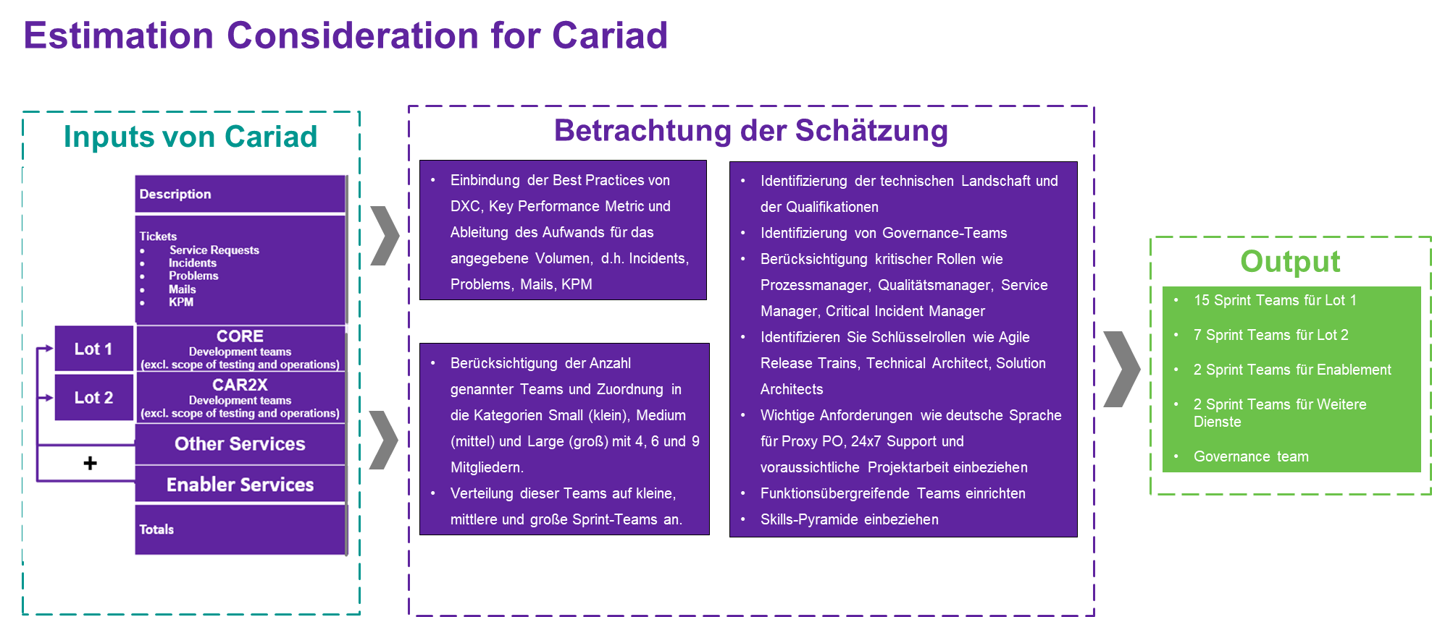

1. Schätzungsvorlage

For the quantitative planning of the delivery model and the associated resource estimation, these input values were evaluated using DXC's internal best practices such as e.B. solution times per ticket, number and team sizes of the sprint teams, etc. Comparative values were also used for the account organization, other enabler services, etc.

DXC has further included the following aspects in its estimates and has taken into account the empirical values:

* Maturity of today's supplier organization and the complex environment within the global Volkswagen Group or automation (DXC assessment is based on the tools and technologies used by CARIAD)

The following are the general principles of the agile team structure. Small teams are typically used in:

* Brainstorming/Design Thinking Phases
* Discovery Phases/Sprints
* in the initial start-up phase, in which a delivery team is formed, and before scale-up

Medium (large) teams are typically used in:

* Brainstorming/Design Thinking Phases
* In the normal delivery phase

Regular teams are typically used in:

* In the normal delivery phase

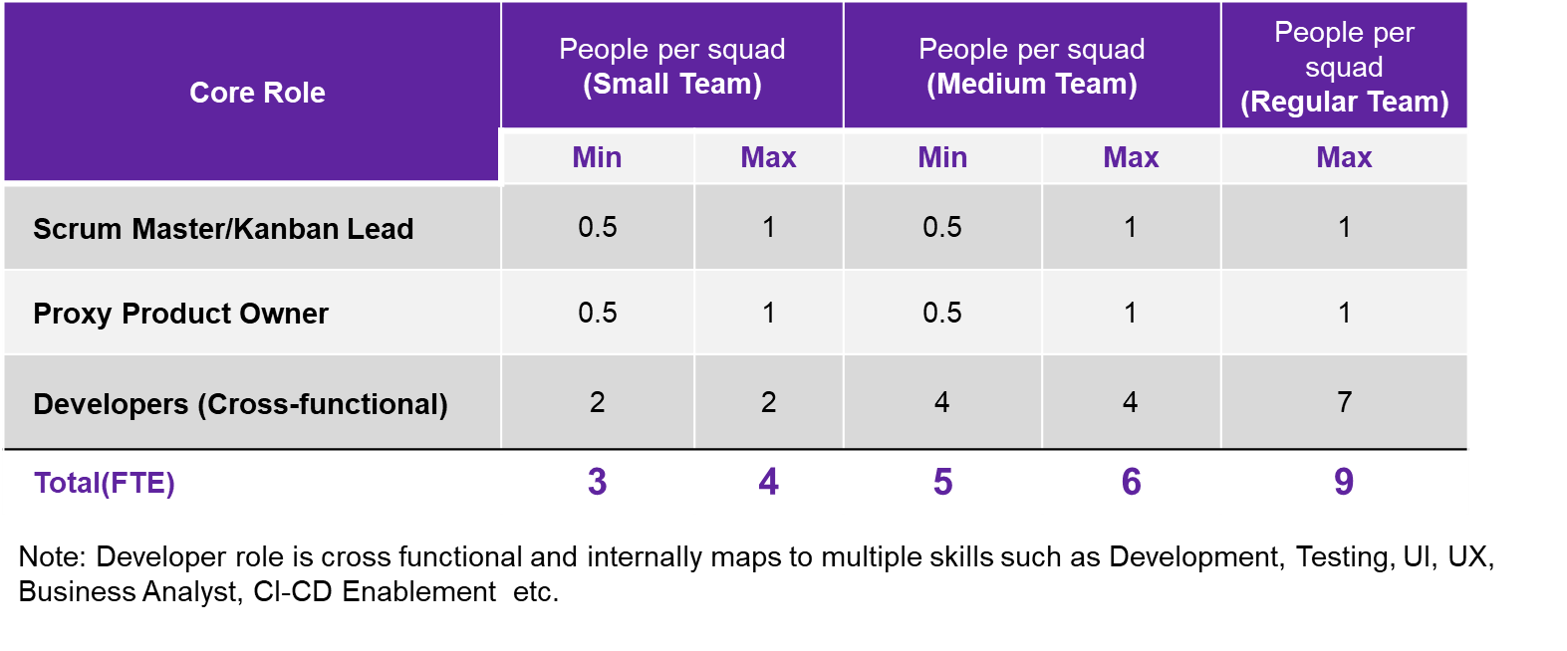

1. Quantitative planning of resources

|  |  |
| --- | --- |
|  | **CARIAD Question 21:** 1.1.5.h) How do you ensure that the full number of planned resources can be made available at short notice, no later than 14 days after signing the contract. |

DXC has performed some of the largest agile transformations in the world. We are considered an industry leader in Agile at Scale with more than 27,000 application experts. The following figure shows the DXC global capabilities.



1. DXC Application Services in Zahlen

DXC will start planning in advance of the transition in good time to identify the necessary resources for the CARIAD project.  As part of RESCUE Mission II at CARIAD, DXC has proven that DXC can build and deploy a large number of qualified employees in a short period of time.

|  |  |
| --- | --- |
|  | **CARIAD Question 22:** 1.1.5. i) Which resources work with which tasks at which delivery location (absolute and % distribution)? |

**DXC Resource Model** includes a dynamic (agile) resource management instance that allows resources to be allocated from DXC's on, near, and offshore resource pools (Global Delivery) and, if needed, from partners. The model is based on 24/7 service time with best-shore approach with approx. 10 % on-shore (Ingolstadt), approx. 20 % from near-shore (Sofia) and 70 % off-shore (Bangalore). Should relevant aspects of the GDPR have to be taken into account, we will adapt the selected delivery model accordingly.

|  |  |
| --- | --- |
|  | **CARIAD Question 23:** 1.1.5.j) How many employees are there for the service in the company, how many would first have to be recruited in a targeted manner (data in % and absolute)? |

DXC has more than 29,000 employees in the field of agile software development and DevSecOps. DXC will employ experienced employees for all key roles in the DevOps factory.

DXC will need to make targeted recruitments in the order of about 10-20% . DXC will start the concrete planning related to individual employees in a next step after consultation with CARIAD.

### Further education and training of the deployed employees

|  |  |
| --- | --- |
|  | **CARIAD Question 24:** 1.1.5.k) What efforts are being made with regard to the further education and training of the staff deployed? |

Continuous support for education and training is one of the basic principles of career planning for each individual employee in the DXC. For the implementation of our talent management, within the CARIAD environment, we use various methods, which are used, among other things, for training. This includes the following: training classes with corresponding certifications, Online trainings or practical teaching of content, literature, coaching or mentoring. These are anchored in an established talent management of the factory.

Talent management not only focuses on technology-supported content, but also on soft skills and methodical content mediation.

#### Needs assessment

In doing so, we follow the principle of not pursuing rigid qualification requirements, but rely on an agile realignment of employees, adapted to DevOps with new methods and technologies. We promote the learning of additional skills at the horizontal level and deeper skills at the vertical level. A competency model is worked out for each employee in cooperation. This leads to the development and implementation of a training programme and measures that enable skills to be improved.

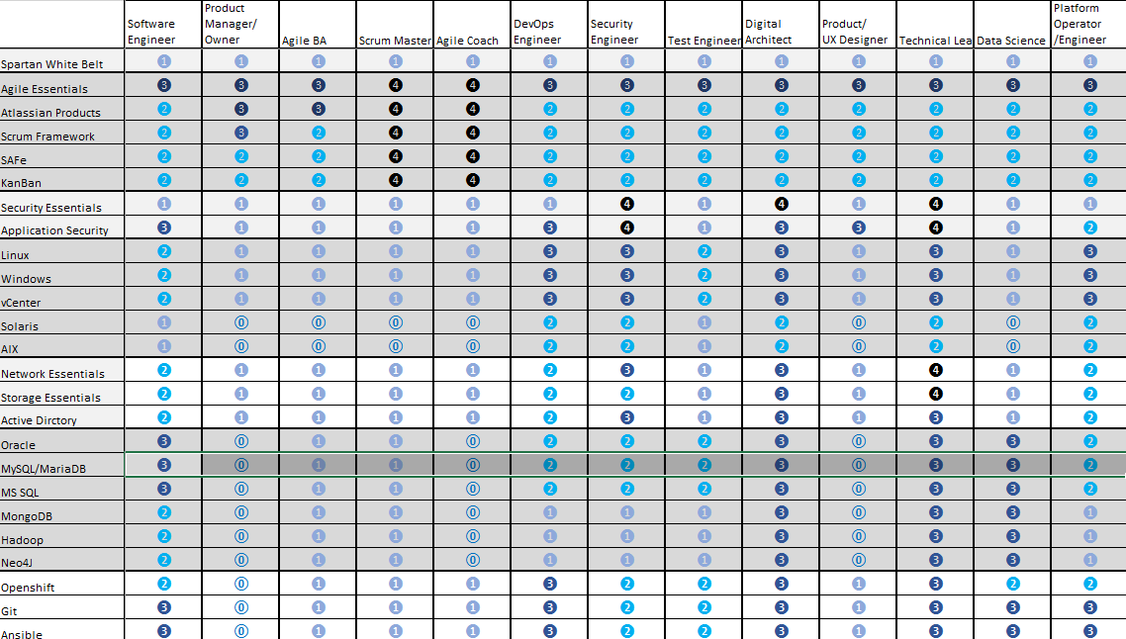

1. Example of a Skill Matrix for a DevOps Factory

In order to be able to carry out this optimally, it is important to carry out an inventory at the beginning and to reflect with a target state in order to enable a targeted and continuous further development of our employees.

The identified gap (per employee) provides insights into the learning content to be considered in order to bring the DevOps factory up to an up-to-date level of knowledge and thus to provide a high-quality service and increase the scaling possibilities of the sprint teams.

#### The learning approach and tools

The learning mix for our employees can vary depending on their learning style, level of knowledge and development focus. DXC's learning and development concept drives learning solutions that are strategic, effective and measurable. For this purpose, we use the DXC University and Percipio internally as a learning portal portal for us employees, which is available as DXC Academy for our customers (externally directed). These offer end-to-end learning solutions that are robust and results-oriented. Our Academy is part of our portfolio and is operated for a large number of customers (<https://www.dxc-academy.com>).

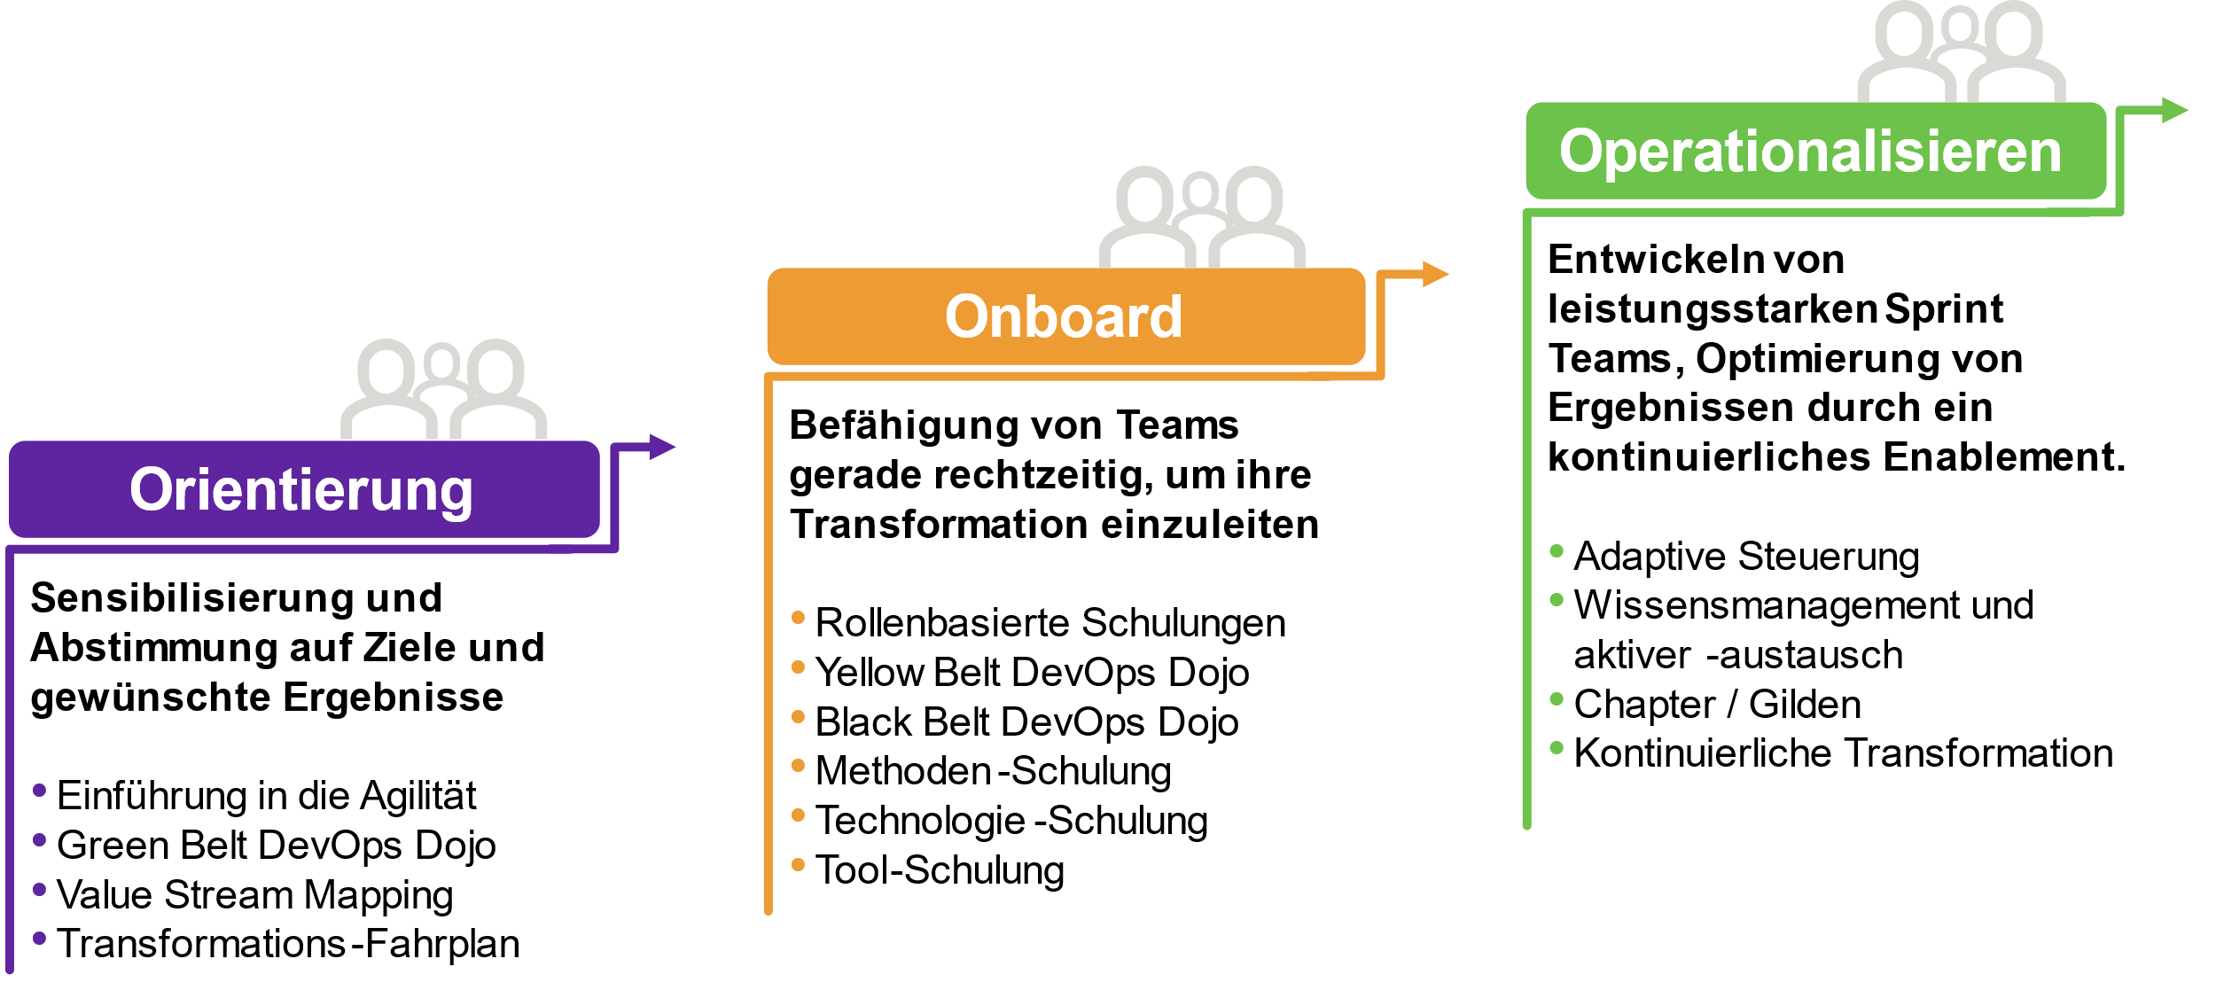

1. Continuous Agile/DevOps Enablement Framework

Specifically for Agile and DevOps transformation, a Continuous Agile/DevOps Enablement Framework is used as a holistic plan to promote true continuous learning not only through training, but also through workshops, effective Agile governance, and community activities.

These learning and empowerment activities are integrated into DXC's Agile Transformation Roadmap. The courses are offered to DXC employees through the DXC Academy. SAFe® courses can also be offered by DXC as an SAFe® Gold Partner for client organizations.

The mandatory courses are designed to help drive Agile DevOps transformation. All optional courses are at the discretion of The Transformation Agile Coaches based on their initial gap analyses.

#### Partner Network Training

Through active partner involvement, we are able to carry out partner training courses just as quickly and effectively, which specifically respond to their specific methods and products. ­

Our Alliance Partners & Suppliers training group provides a one-stop shop for the training content and resources of Alliance Partners and Suppliers available to DXC employees.

The goal is to help DXC employees receive necessary first-hand training directly from the manufacturer/vendor to stay competitive and differentiate DXC in the market.

Examples include RedHat OpenShift, AWS Cloud Services, Azure, and many more, which are an integral part of our competency development plans.

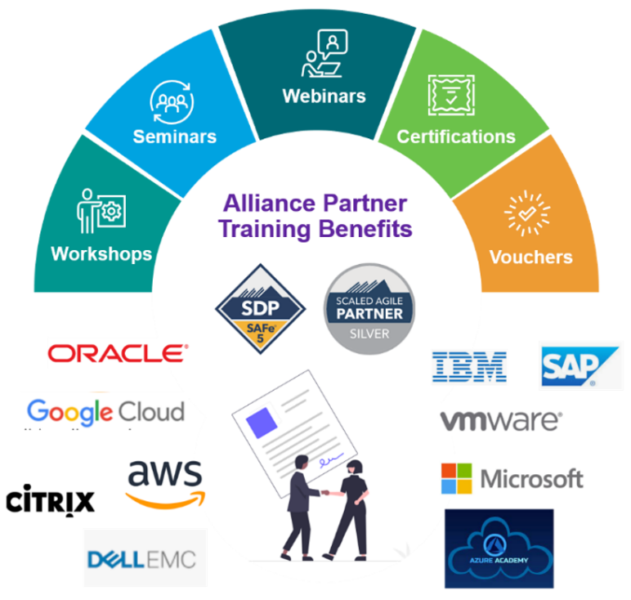

1. Partner Network Training

DXC has in-depth training and certifications for the specific roles and qualification requirements for custom requirements that go beyond the standard training topics.

#### Training and further education courses

The creation of rollen-based training catalogues as well as the application of the right mix of learning channels and tools takes place as part of the further tendering process, if more in-depth details about the CARIAD environment (processes, methods, techniques, technologies, etc.) are known and allow a reflection with the planned employee base.

## Reports and communication

Below we describe the CARIAD – DXC communication model

|  |  |
| --- | --- |
|  | **CARIAD Question 25:** 1.1.6.a) Describe the planned communication model vis-à-vis the AG. |

DXC has already found a detailed communication model in the CARIAD specifications. DXC adopts these requirements for the meeting structures (Specifications Chapter 2.4.7). These are ensured by DXC both for the fade-IN phase and for ongoing operation. In the following illustration, the communication structures and the escalation structures are summarized (Chapter 2.4.8 of the specifications).

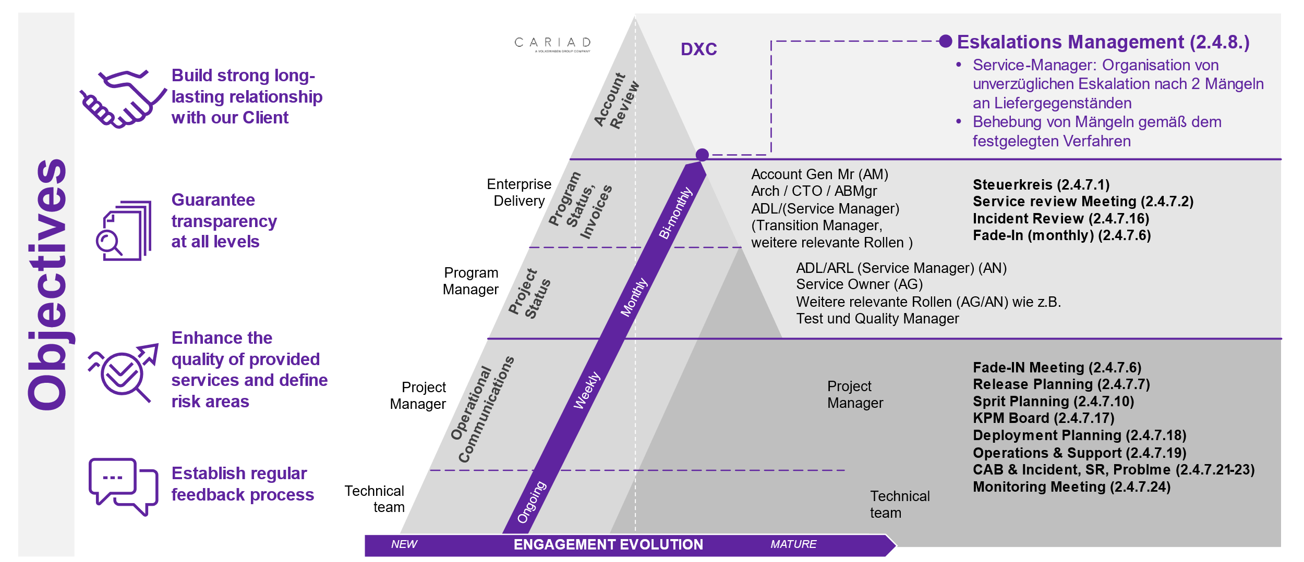

1. Kommunikationsmodell

The proposed meeting structure meets the requirements of Specification 2.4.7 and enables efficient, lean governance for service delivery with the DXC roles we have proposed.

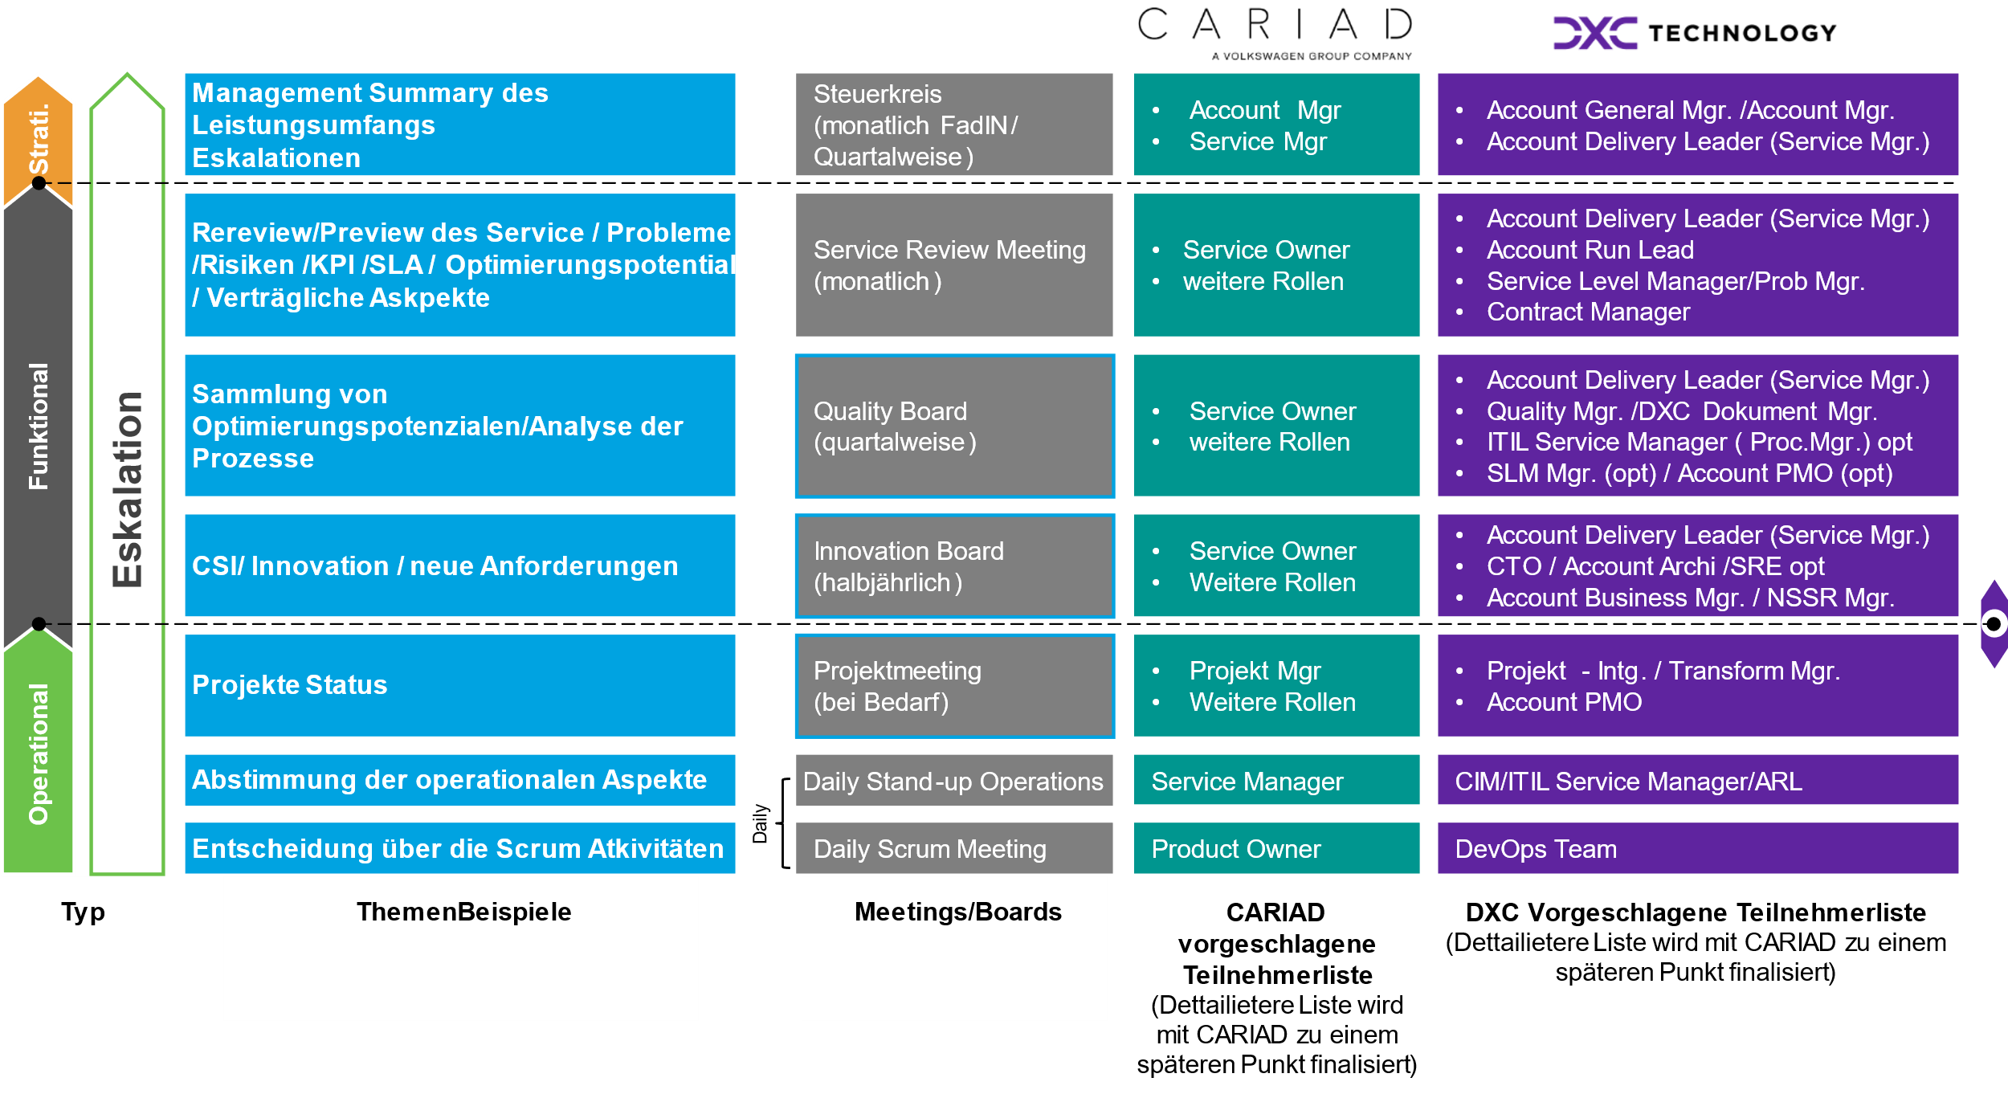

1. Meeting Board Structure (Part 1)

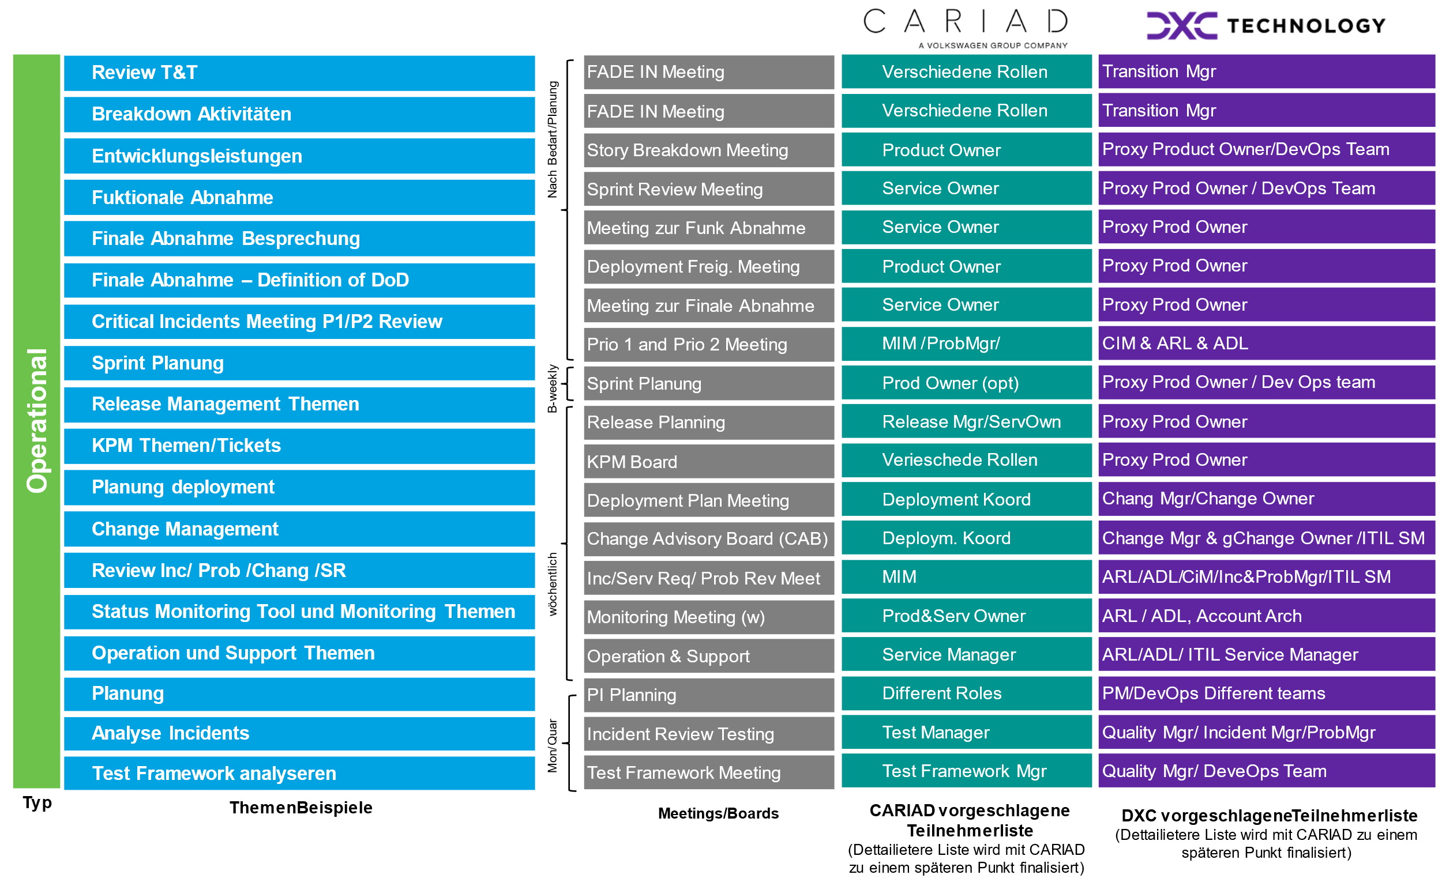

1. Meeting Board Structure (Part 2)

### Metrics and dashboards

|  |  |
| --- | --- |
|  | **CARIAD Question 26:** 1.1.6.b) On what basis are reports prepared? |

DXC will set up an appropriate reporting system for its services. The database will be based on raw data from CARIAD's own ITSM tool as well as on the agile DXC reporting data of the DXC DevOps teams (examples of reports / metrics see chapter 2.6.22.6.1) and monitoring tools.

With regard to the communication of reports, DXC provides for three ways of communication:

* Via SharePoint and e-mail via the DXC Account Reporting Team, (create, update and distribute reports in ways agreed with the customer, e.B. on SharePoint and via e-mail on an agreed distribution list)
* Via account: reports are presented and analyzed in agreed meetings
* Via dashboards: for tools that enable a dashboard/report (e.B. Jira)

The DXC team will also provide reports in a variety of formats, e.B. Excel, PDF and, depending on the report, in English or German. If other or further reporting formats are required, the details will be agreed and determined during T&T.

A key to promoting end-to-end transparency and accountability is to build a common set of goals, measurement points and nomenclatures for the entire data and analytics ecosystem.

Dashboards provide near real-time visibility into key aspects of implementing large programs, such as.B:

* Acceptance: Who uses analytics and how satisfied are your users?
* Data Monetization and Value Realization: How far have you progressed with the goals of value realization?
* Innovation: Does your innovation engine work and does it lead to solutions that are accepted?
* Project status: What is the status of your most important projects?
* DevOps and Infrastructure Spending: How Are Your Budgets Used?
* Quality: What is the quality of the various elements that make up your ecosystem (including compliance with CI and CD standards, resiliency, backup and recovery measurements, etc.)?
* Speed/Burndown: How do your teams behave compared to the original commitments?
* Operational scorecard: How is the service quality of the ecosystem developing?
* Obstacles: What are the biggest obstacles that require immediate attention?
* Necessary help: Is help needed from the management or from external parties?
* Risks/RAID Protocol: What risks occur and what is being done to contain them?

The data is collected at all levels of the company with different levels of granularity to ensure that the entire company works with a single source of truth and eliminates the need for manual reporting.

Agile/DevOps KPIs are also continuously monitored. The various metrics that are compiled and analyzed for improvements in the agile team include % decreased stories, efficiency factor and defect leakage. The effectiveness, feasibility, and measurability of these metrics will depend on Agile/DevOps practices, and therefore the adoption/decrease of these metrics will be staggered across the transformation phases.

| Metricen | Zielvorgabe | Formel |
| --- | --- | --- |
| Durchlaufzeit | To gain an understanding of how quickly the team can complete a user story within the sprint. | Aggregation of elapsed days for accepted user stories / number of user cancellations accepted in each sprint |
| Vorlaufzeit | To measure how long the Scrum team can deliver value to the customer based on priorities and commitments. | Aggregation of elapsed days of released features / Number of released features |
| % Abgenommene Stories | To measure how well the team is sticking to its commitments. | (decreased story points / promised story points)*100 |
| Defective leakage | Measuring the quality of the work products developed by the teams | Total number of defects in UAT and ELS / Total number of hours spent by the team developing the work products for release. |
| Average time to recovery | Measure how long teams can restore the system/service after a failure. | Aggregation of elapsed time for resolved P1 or P2 incidents / Number of P1 or P2 incidents resolved in the reporting month. |
| Deployment success rate | Measuring the quality of the releases that the team delivers to the customer. | (Number of successful deployments / Total number of deployments)*100 |
| Efficiency Fact | Measurement of the extent to which the effort of the team offers the customer added value. | (Actual effort for decreased user stories in a sprint / total effort for the completion of user stories in a sprint) * 100 |
| Agile / DevOps-Reifegrad | Measure the extent to which Agile/DevOps practices are applied by teams. | Result of the maturity level from the DXC Agile/DevOps Adoption Assessment |
| Net Promoter Score | Understand the customer's willingness to recommend the team's services. | (Number of respondents - Number of rejectors) / Total number of respondents |

1. Agile/DevOps Metrics

| **Metriken** | **Zielvorgabe** | **Formel** |
| --- | --- | --- |
| Sprint Speed | Measure the amount of work a team can do within a sprint. | Aggregation of story points earned in each sprint |
| Focus-Factor | Assisting the team in forecasting the results that can be completed per sprint. | Number of story points decreased in each sprint / actual effort in a sprint |
| Cost of lack of efficiency | Understand the cost impact of low efficiency. | Total effort for unaccounted user stories in one sprint * Blended Rate |
| Frequency of deployments | Understand how often teams deploy functionality in different environments. | Number of implementations for each supported environment (development, testing, staging, production) |
| Lead time for changes | Understanding the waiting time for changes | Total number of elapsed days in which the last accepted user story went from the "Done" status to the "Released" status / Number of changes released in each month |

1. Team-level metrics

### Beispielberichte

Below are some sample reports and dashboards. In the following bidding phase, we will further deepen CARIAD's reporting requirements from Specification Chapter 2.4.10 Reporting.

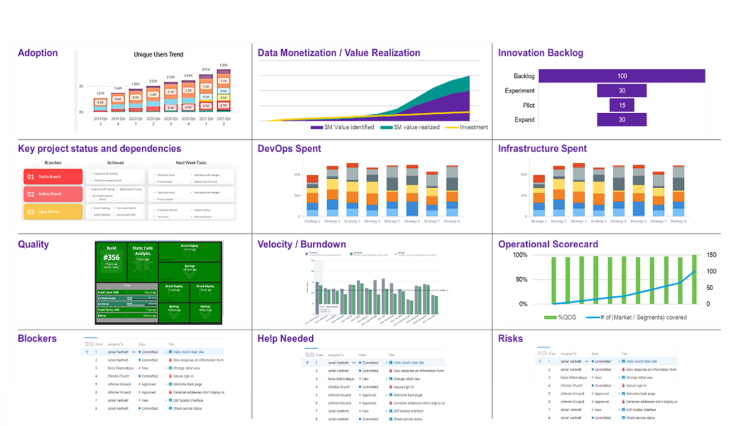

1. End-to-End-Transparenz - datengesteuertes Eco-System

## Service Level Agreement

|  |  |
| --- | --- |
|  | **CARIAD Question 27:** 1.1.7.a) Illustration/operation of service hours |

DXC will provide the service hours required by CARIAD as part of the selected 24x7 delivery model. It should be noted that

* DXC after the knowledge transfer phase (fade-IN) and the introduction of the service will take over the current existing AS-IS service levels,
* DXC expects much of the "workload" in the time window from 8 a.m. to 6 p.m. (CET) (orange "time window") with overlapping shift planning. If necessary, the shift model is checked and adapted to the real requirements. The continuous availability of German-speaking contact persons (e.B. CIM and CIM Phone) is taken into account – "German Dayshift" and "Bulgaria Dayshift" line (6 to 8 pm).



1. Service hours

|  |  |
| --- | --- |
|  | **CARIAD Question 28:** 1.1.7.b) Illustration/operation of the service level requirement |

* after the stabilization phase, the To-Be Service Levels (Plant I_Service Level Tablelle_V10) are adhered to. Our understanding from the bidding questions is that the fine-tuning of the service levels will take place in the current tender phase .

### Critical success factors

|  |  |
| --- | --- |
|  | **CARIAD Question 29:** 1.1.7.c) From your point of view, what are the critical success factors for compliance with the Service Level Agreement? |

From our point of view, the critical success factors for compliance with the required SLA are summarized below.

* Checking the Influencing Variables
* Scale agile (DevOps) project experiences to the overall organization by defining success factors for agile transformation at all levels
* Adjustment of the measured variables (SLA) in the course of the further development of the agile transformation.

The following table provides an overview of the critical success factors of the influencing variables humans, technology, methods, management and environmental conditions:

| **Influencing factors** | **Critical success factors** |
| --- | --- |
| **People:** | * Continuous review of quality: education, expertise, training accompanying work, sufficient time for further education, personal career development and job rotation,... * Quantity: Coordinated resource management, avoidance of overloads, |
| **Technology and tools:** | * Nutzung moderner „State of the Art Tools“ , permanente Weiterentwicklung der Tool-Landschaft, Automatisierung, AI, Bots, Robot Process Automation (RPA) etc. |
| **Methods and tools:** | * Quality management systems at project and organizational level: detection of missing or unclear processes (regular testing of processes), * Continuous Improvement for Agile Organizations |
| **Management:** | * Avoidance of unclear requirements, avoidance of lack of communication, "fault tolerance" |
| **Environment:** | * Disaster recovery planning (pandemic situations, "Ukraine",...) |

1. Overview of critical success factors

To scale agile (DevOps) project experiences, consider the following factors:

* The regular measurement and review of the typical success factors of **agile projects**:
* The relevant stakeholders identify, especially in focus: the regular cooperation with the customer. The customer's requirements and satisfaction have top priority.
* Identify the benefits and goals of the project (why do we do this? Who are we doing it for? What do we want to achieve in concrete terms?),
* Selection and discussion of the use of different agile approaches (Scrum, Kanban, etc.) "one size fits all" often does not work.
* Avoiding complexity, keeping every project as small as possible
* Promotion of transparent and open communication in the team (the be-all and end-all!), accompanied by regular retrospectives
* Organize agile coaching for all project participants (agile seminars, workshops and online trainings, project management training)
* Strengthening the personal responsibility in the project teams, so that the teams work more motivated, bring in optimization suggestions. Ensure a good mood in the team, which in turn has a positive effect on the product result.
* Strengthening ownership in the project teams by building a tolerant error and feedback culture as well as mutual trust, showing appreciation to the team and clearly communicating the project vision.
* Promoting team building measures

To drive enterprise-wide agile transformation, the following factors are critical to success:

* Top management must support agile structures
* Showing the urgency of the need for change
* Building cross-functional teams. Agile transformation is characterized by a continuum of cooperation and collaboration. Formation of interdisciplinary teams at all levels, demanding and encouraging personal responsibility.
* Communicate the line (tangible goals) and promote benefit transparency for all stakeholders.
* Reduction of obvious obstacles, line hierarchies, one-sided communication, lack of required resources, etc. or even the previously lived communication and approval processes themselves. The key to speeding up the process therefore lies in removing barriers as quickly as possible.
* Scale: Make the success of teams or entire departments visible to the entire company
* Promoting the pull effect, where others mimic the agile changes.
* Last but not least, the continuous adjustment of the measured variables (and thus the SLA) in the course of the further development of the agile transformation through the use of a suitable change management process is critical to success.

## Quality improvement / quality assurance

DXC fosters a culture of Continuous Service Improvement (CSI) and believes that all:

* Employees of the DevOps factory
* Employees from the relevant CARIAD environment
* As well as stakeholders,

who are involved in the provision, management and use of services contribute to the identification and implementation of CSI opportunities.

It must be clarified in advance whether an existing CSI process should be taken over by CARIAD, whether DXC should align itself with it or whether a separate CSI environment should be introduced. This must be clarified in the context of the further tender phases.

### Adoption and adaptation of an existing CSI process

|  |  |
| --- | --- |
|  | **CARIAD Question 30:** 1.1.8.a) Roadmap for the further development/optimization of the service over the term of the contract |

Based on the assumption that we connect to an existing CARIAD CSI Environment, we can make the following statements with our current state of knowledge:

As part of the transfer, we check the currently valid process and its interfaces. We plan the CSI process for our services, adapt, implement optimizations or standards and operate them. This will be done in accordance with their existing CSI policies, processes and procedures.

**Potential process improvements introduced by CSI will be driven by DXC's strong alignment with CARIAD requirements and will bring the following benefits:**

* **Increased productivity through annual improvements in the delivery of application services;**
* **Improved quality by reducing process throughput time through process optimization and use of LEAN techniques; and**
* **Support in the improvement of processes, methods and the use of technologies to improve the CARIAD service.**

To do this, we use the experience of our DevOps delivery teams, which work for all DXC customers, to drive the continuous improvement of their services (see Chapter 2.4.8 , which describes our guilds and the continuous exchange of knowledge).

DXC will use CARIAD's CSI management system to capture DXC's contributions to improving application services. This system will be connected to the relevant ITIL processes throughout the service delivery lifecycle. A DXC CSI process owner ensures that the CSI process is effectively connected to all other service delivery life cycle processes. The CSI process aims to formulate qualitative and informed proposals to improve IT services for CARIAD, based on:

* A constant evaluation of IT services;
* The evolving needs;
* The development of DXC's service portfolio;
* Developments in the market; and
* Innovative ideas.

All discovered initiatives will feed into the CSI process, analyzed to determine whether they should be included in the backlog, validated, prioritized and implemented according to the agreed plan. This is an iterative process that brings the best results when the entire company has internalized the culture of continuous improvement. The following describes DXC's approach to innovation and CSI.

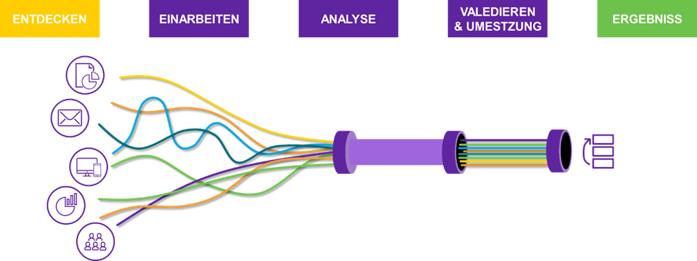

1. Containment process for possible service improvements

### The Continuous Service Improvement Approach

We take a collaborative approach to implementation that introduces and uses modern Agile, DevOps and Lean Kaizen principles and processes.

CSI opportunities are captured through multiple channels to identify, select, and implement new opportunities:

* forums led by CARIAD, DXC and other vendors to review and evaluate new technologies;
* Customer and partner feedback collected through IT satisfaction surveys, regular business reviews, and idea forums;
* Proactive problem management and root cause analysis recommendations;
* DXC works with the Service and Product Owner(s) to evaluate existing solutions and services and conduct regular reviews to analyze available benchmarking and audit data and maturity assessments;
* Evaluation of knowledge, experiences and case studies from other DXC customers and partners;
* Input from other suppliers based on their own analysis and experience; and
* Manage supplier performance management activities .

A DXC Quality Manager and this as an integrated function review the Business Services and Application Services with the aim of improving the quality of service as much as possible and finding more efficient, effective and economical ways of service delivery.

DXC will regularly evaluate the processes and identify areas where the desired process metrics are not achieved.

DXC proactively looks for trends or deployment issues that, while not impacting the delivery of the application service at the required level of performance, provide improved productivity or user experience.

CSI initiatives are specifically aimed at improving services and processes based on the results of service reviews and process evaluations.

CSI covers a whole range of improvements, from incremental improvements to existing IT services to the development of completely new services or the introduction of a completely new technology (innovation).

### Template support in the CSI process

DXC proposes standardized support in the analysis and validation phase for all further developments. It should be invested, migrated, a situation should be consciously tolerated or even a technology can be saved. The following table illustrates this approach as an example.

| **Components** | **Key Strategy Drivers** | | **Technical attachments** | **Alignment with the customer's** strategy | |
| --- | --- | --- | --- | --- | --- |
| „Invest“ | * Functional need for measures to improve processes, accessibility and compatibility of services * Availability of data exchange, information and integration * Optimizing the user experience | * Transform microservices when it is important to make changes to independent service components * Identify UI/UX improvements by recording sessions and analyzing optimization opportunities * Automation through CI/CD pipelines and integrated test automation with quality gates * Incorporate proactive automation when building-to-run improvements are made, with telemetry included and automated run-book handling of the operational aspects of application support | | | * Increasing expectations of employee self-service. * Placing data and information more at the centre of decision-making and evaluation processes * Improve digital investigative and forensic capabilities * Promote OpenData principles and use a number of third-party applications that use customer data * Empower employees with data to make faster and better decisions |
| „Migrate“ | * TCO of application-used platforms, proprietary expensive middleware * Alternative COTS / SaaS-based solutions * Ability of existing applications to support RPO/RTO targets in their current architecture | * Move to the Factory Cloud to enable lower operating costs by leveraging PaaS-based services * Mobile conversion as the first cloud approach of applications * Re-architecture to meet DR requirements | | | * Improve the customer's capacity and capabilities to leverage data and insights to increase operational efficiency and effectiveness |
| „Tolerate“ | * Supportability - Durability of the underlying technologies in their support lifecycle * "Technical Debt" - main driver of the total ticket volume * DR/Availability - Architecture of the application and its ability to support the RPO/RTO objectives * TCO of the application - platforms used, proprietary, expensive middleware | * Containerization to merge applications to mitigate the impact of components that are no longer supported * Application upgrades to achieve N-1 compliance and avoid "technical debt" and security risks * Subsequent automation through improved recognition processes, service requests and ticket processing, as well as run book automation using a data-driven approach based on effort adjustment in support. | | | * Support efficiency goals and increase the value and use of data for operational processes * MOPI and GDPR Compliance |
| „Eliminate“ | * Timeliness of the technology * TCO of the application - platforms used, proprietary expensive middleware * Business/data reconciliation with other applications as a prerequisite for consolidation | * Standardization and archiving approaches to preserve data without having to retain the entire application and infrastructure stack | | | * Konformität mit: Records Management Policy Toolkit - Management of Police Information (MoPi) Group Table to inform records Review Retention and Disposal (RRD) |

1. Schematic overview of a CSI decision template

### Input channels and dependencies

With continuous service improvement as a permanent part of the DXC delivery model, it is extremely important to continuously consider all conceivable input channels that are eligible for service improvements. Not only impressions and insights from the day-to-day operations of the DevOps factory as well as the user environment must be included. It is also important to take into account changing requirements for compliance, guidelines, certifications, etc.

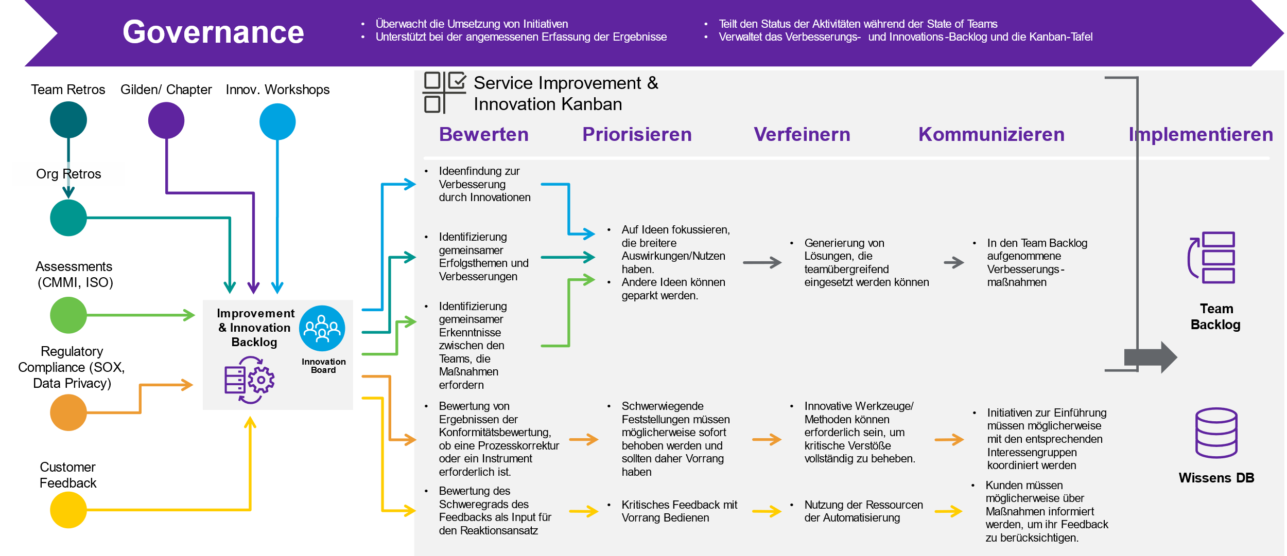

1. Input channels and processing steps of service improvement

The image above illustrates a schematic (consolidated) process to consider ideas and opportunities for improvement from innovation workshops, internal feedback loops, quality controls, standards and compliance audits, legal requirements and customer feedback. This enables a lean approach as a pioneer for inclusion in the CARIAD Agile/DevOps service operation.

Improvements are made based on KPIs and other pre-defined success factors that take into account various aspects of productivity, efficiency and overall performance.

If a list of ideas emerges from the service improvement process or innovation management (see Chapter 2.8.6.1), CARIAD and DXC weigh up whether the identified "item" is suitable for checking feasibility or for final development and production.

A final prioritization in suitable committees, as listed in the specifications, paves the way for the later implementation period.

The commissioning and implementation of agreed service improvements takes place jointly in consultation and coordination according to defined processes.

### Risks

|  |  |
| --- | --- |
|  | **CARIAD Question 31:** 1.1.8.b) What risks do you expect within the provision of the service and what are your risk minimization measures? |

DXC relies on consistent risk management from the transition to the end of the service. Our employees work according to best practice standards, such as .B PMI. We limit ourselves here only to the mention of the 6 process steps of risk management and then go directly to the risks themselves.

* Development of a risk management plan - deciding how to approach and plan risk management activities for a project
* Identification of risks - determination of the risks that could affect the project and documentation of their characteristics
* Risk Analysis - Conducting a qualitative risk analysis to prioritize their impact on the project objectives and (quantitatively) measuring the probability and impact of the risks and assessing their impact on the project objectives
* Risk management planning - applying strategies and developing measures to improve opportunities and reduce threats to project objectives
* Monitoring and management of risks - monitoring of residual risks, identification of new risks, search for risk triggers, execution of risk mitigation plans and evaluation of their effectiveness throughout the project life cycle
* Completion of risk management - review of the results of the risk management strategy. Document the lessons learned as part of the project completion process, record improvements to risk management processes, templates and tools, and record improvements to other project processes, templates and tools to enable future reuse or reduce future risk

From the current knowledge, we have identified the following main risk areas:

|  |  |
| --- | --- |
| **Key risks** | **Risk management strategy** |
| Organizational complexity, many stakeholders of a global supply organization | * Planning security right from the start by identifying all relevant stakeholders, regular open communication with CARIAD and third parties. Close coordination with CARIAD, * active governance structures and active escalation management |
| Supply bottlenecks (due to unplanned activities) | * Capacity management also related to the availability of third parties |
| Transition-relevant risks (onboarding, documentation gaps, delays within the transition due to lack of resources, missing or insufficient access authorizations, etc.) | * Risk management within the transition (for further details see the Tnansition document |
| Technical and safety-related risks | * Service Continuity Management, Security Management, |
| Loss of key employees | * Knowledge Management, Job Rotation, Keine „Kopfmonopole“ |

1. Risks & Mitigation

### Innovations Management

From DXC's perspective, innovations are new ideas and inventions that find their way into commercial use, make life easier, open up new markets and create added value. Only when ideas become new products, services or processes do we speak of a real innovation. At the same time, we associate innovation with the ability to see change as an opportunity rather than a threat.

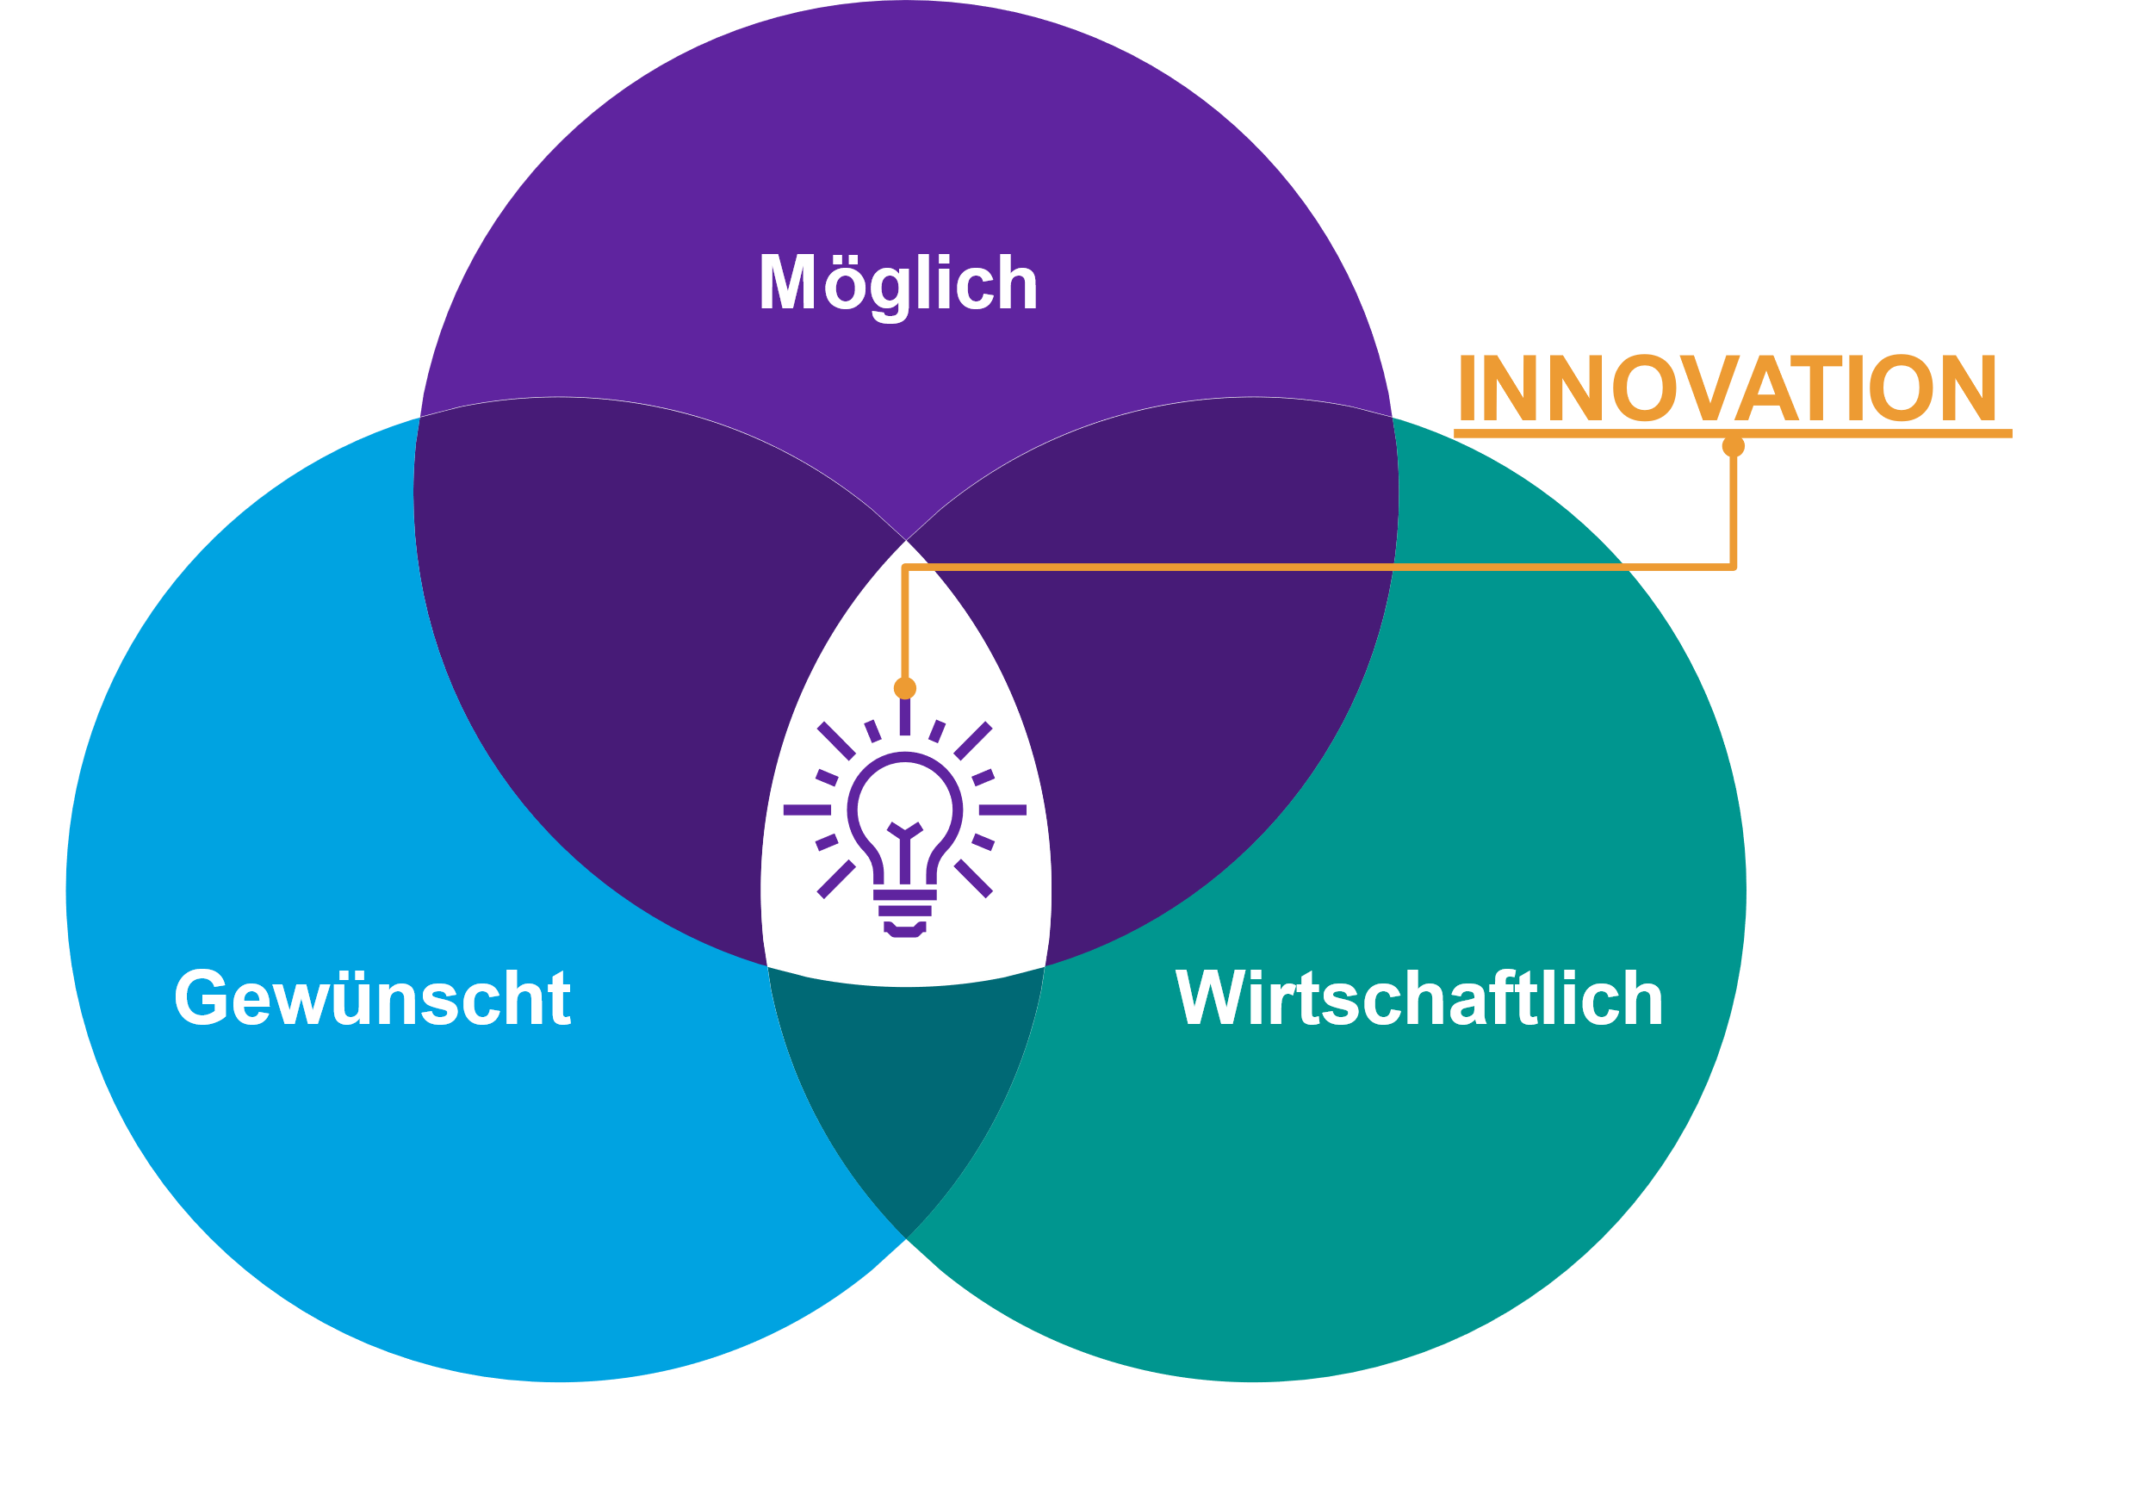

1. DXC's understanding of innovation

Innovation is at the top of DXC's agenda. As a company, we invest in digital and innovation centers and continuously build innovative capabilities within the company and with our customers. As part of this network, the digital technologists and experts work for customer products and services as well as in-house solutions.

We want to accompany CARIAD on its innovation path and work with Ihnen and other suppliers to identify, develop and implement innovative solutions and continuous improvements.

In order to support this in the best possible way, we offer them the cooperation with our Digital Network, to request experts if necessary and to gain impulses from outside within the framework of further investigations or workshops, which are relevant in the context of the innovation and service improvement process.

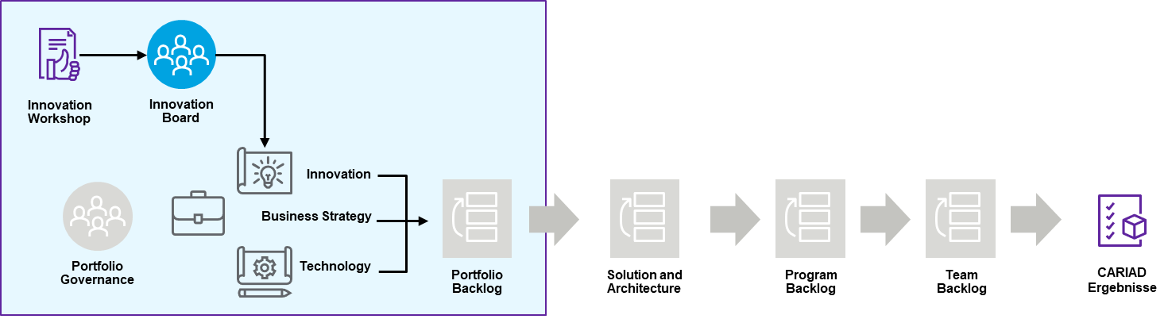

1. Entry point for innovations in the SAFe model

With this in mind, we have enabled our DevOps factory model to leverage a mature innovation management process to drive new results and build next-gen capabilities. In this way, we create an end-2-end approach to our DevOps factory. This enables us to get involved in brainstorming from the very first minute, if necessary. In this way, we can advance the idea to scaling and reach the desired product maturity.

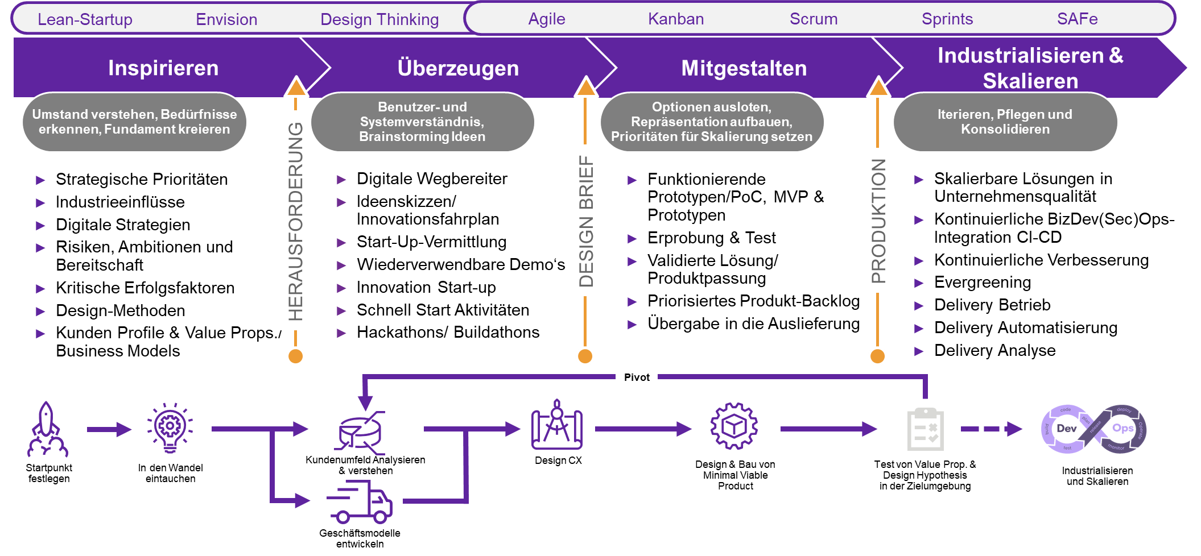

1. Innovation Process Model

The focus is not only on externally directed innovations (product features & services), but at the same time on internally oriented innovations, to consider oneself self-critically in day-to-day business (DevOps) and to continuously search for potentials for optimization through new and/or innovative solution approaches. True to the motto to prevent "who rests, he rusts"! Further details can be found under Chapter DevOps - "Scrum".

Overall, our innovation approach draws on the design thinking approach. This gives us the opportunity to understand the need in a structured, focused and end-2-end way, to think about solution alternatives / innovations and to prioritize a pre-selection of possible candidates for implementation.­

"Double Diamond" is the name of our lead model, which is based on the divergence convergence model. The two diamonds represent a process in which a topic is explored more comprehensively or deeply (divergent thinking) and then targeted action is taken (convergent thinking).

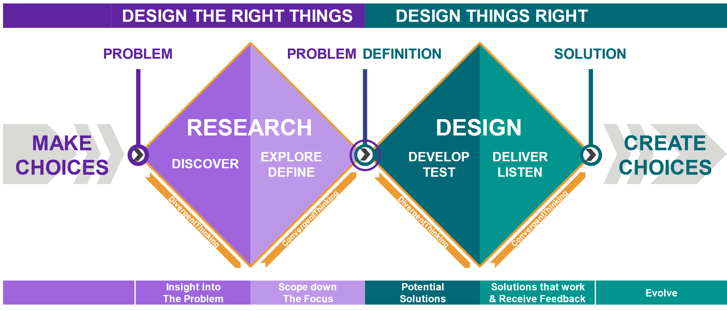

1. Double Diamond Approach

* **Discover** - Understand the problem instead of just suspecting it. Talk to affected people. Active listening and collecting.
* **Define** - The insights gained in the discovery phase can help define the challenge differently. Structured documentation and summary of findings
* **Develop** - Give different answers to the clearly defined problem, inspiration process and design of solution ideas, together with different people. ­
* **Implement**: Test different solutions on a small scale, discard those that don't work, and improve those that work.

We use the presented Design Thinking approach to ensure that there is a common understanding of the new or changed service. This includes the results to be achieved, objectively measurable success metrics, a high-level roadmap and a backlog of priorities. As the work progresses, these points are constantly repeated to ensure that the project can be adjusted according to changing priorities, as shown below.

The innovation process model allows a sequential or partial use of the preceding phases. It does not matter whether it is an already known MBB or ODP product problem in the initial situation or the drive after the search for product innovation and optimization.

Depending on the already existing progress in the problem description or idea generation, the DevOps factory can initiate the innovation process shown above and in individual cases fall back on resources and knowledge from one of the DXC Digital Innovation Labs.

The advantages of our innovation approach based on examples:

* An end-to-end supply chain
* Broad spectrum of experts and innovators from the DXC Innovation Network
* Provision of a test field for digitale innovations in which it is easy to experiment
* Help design and execute minimal viable products, POCs or prototypes and learn from them
* Early involvement of developers and operations specialists to ensure a smooth connection between all DXC functions
* Motivation of employees through participation in new topics (see Chapter 10 Knowledge Management)

#### Innovations Governance

In close coordination, the submitted innovations and other recommendations for action are released for implementation between CARIAD and DXC. The Innovation Board listed in "Specifications V1 – Chapter 2.4.7.4", with its activities listed therein, assumes this function.

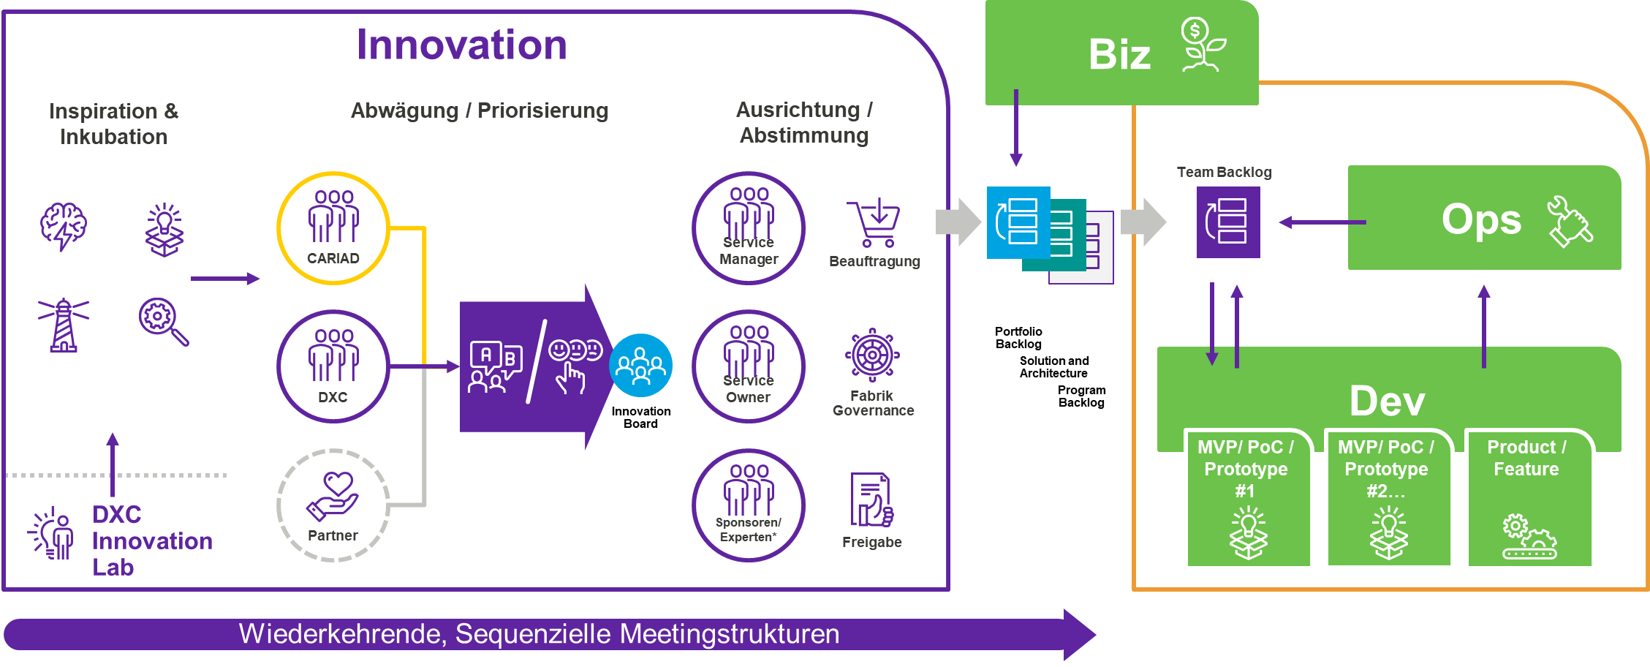

1. Innovation flow via the Innovation Board

We support an authority that acts as an innovation council. This focuses on developing a more disciplined, agile approach to identifying, tracking and incubating different solutions. However, we suggest that primary governance is to measure these ideas in terms of an appropriate ROI and evaluate innovation teams against quantitative and qualitative KPIs.

Approved activities flow into the central team backlog via the SAFe process and are transferred to the DevOps cycle for implementation.

The commissioning and implementation of approved innovations or service improvements takes place as described in the specifications V1 under chapter 2.4.7.4.

## Further

|  |  |
| --- | --- |
|  | **CARIAD Question 32**: 1.1.9.a) What experience do you have at the AG / in the corporate environment |

DXC has been working successfully with the Volkswagen Group for many years. DXC now supports solutions for the Volkswagen Group in the core markets of Europe, China and Latin America for the VW, Audi, Porsche, MAN, Scania, Skoda, Seat and CARIAD brands. DXC delivers comprehensive IT capabilities and proven solutions from enterprise IT to in-car IT.

The following figure gives an overview of the services that DXC has provided to the Volkswagen Group to date.

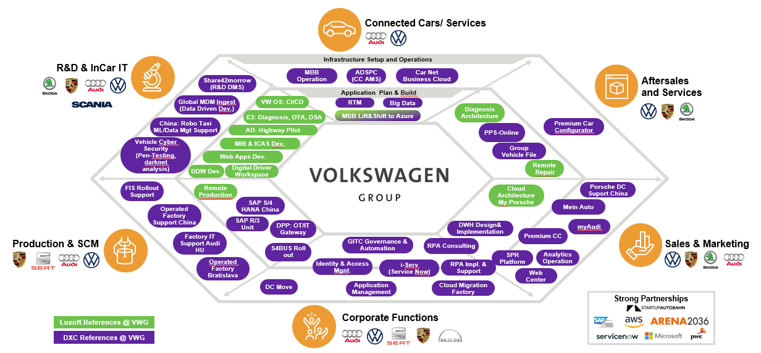

1. DXC Services for VWG

The presentation is based on the automotive value chain of R&D / in-Car IT via production, corporate functions, sales & marketing, aftersales / services and connected car services. In each section, both the diverse projects and the brands with which they were implemented are listed. Examples of this call are the extensive work in the MBB environment (Operations, Lift & Shift to Azure), WebCenter and CI/CD for the VW-OS.

In order to be able to offer VWG effective and innovative services, DXC involves its partner Eco-System wherever possible. This is where global partners come into play, such as AWS in the field of cloud hosting (CHC at Audi) and production (for the DPP/Digital Production Platform). But smaller solution partners and start-ups are also involved for the benefit of the VWG. DXC's Vehicle Cyber Security service at Skoda or the DPP solution OT/IT Gateway are examples of this.

Our in-car software development services are a success story in themselves, which will therefore be focused on in the following. After the acquisition of Luxoft 4 years ago, we jointly managed to develop from a partner of Tier-1 hardware suppliers to a strategic software engineering partner of VWG – we deliver an "end-to-end vehicle ecosystem without vendor lock-in". The following illustration illustrates this: Our team of about 450 people delivers projects in the field of infotainment, autonomous driving, VW. OS and backend platform. We will be happy to provide you with further details on various projects.

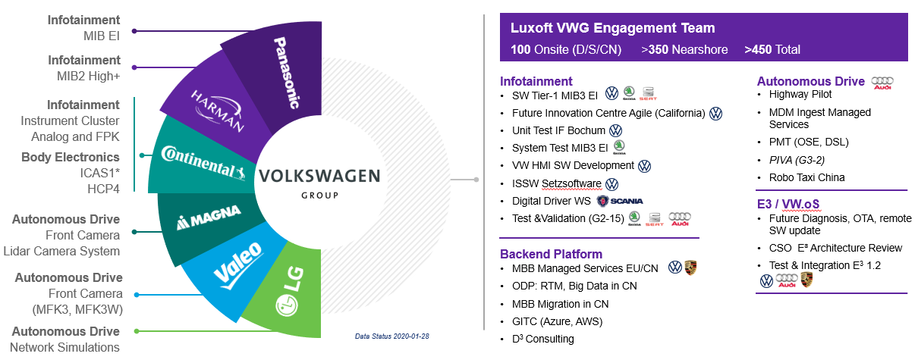

1. DXC-Luxoft Projects

# Annex to the reports

## Process Berichte

| Lfd. Nr. | Berichtsname | Description | Erstellungsintervall |
| --- | --- | --- | --- |
| 1 | Service Level Message | List of the achieved service level values (actual values) per service category (e.B incidents, service requests, etc.) per service level type (e.g. recovery time, response time, order time, etc.) with comparison to the service level target values (target values) to all services.  Dedicated display for at least the following views/sections:   * Service level achievement level per application/service cluster; * Service level achievement rate per priority; * Service Level Erreichungsgrad je Service Level Klassen. | Monthly |
| 2 | Management Service Level Report - Month | Management-oriented aggregation of the service level report with textual filing regarding:   * Management Summary; * Special incidents/operations; * assessment of the effectiveness of measures taken in the previous month; * Planned measures (short-term and sustainable measures); * Trend developments & outlook. | Monthly |
| 3 | Management Service Level Report - Year | Management-oriented aggregation of the monthly service level reports into an annual report for the past fiscal year, with textual filing regarding:   * Management Summary; * Special incidents/operations; * assessment of the effectiveness of measures taken in the previous month; * Planned measures (short-term and sustainable measures); * Trend developments & outlook. | Annual |
| 4 | License Management Report | Current results of the license balance (target/actual) with identification and explanation/order of changes to the previous month.  *Target = contractually agreed / available licenses*  *Is = licenses used* | Monthly |
| 5 | Asset Inventory Directory | Current asset inventory directory with ID owner, location, user. | Monthly |
| 6 | Anwendungsverzeichnis | Up-to-date application directory with identification of essential basic information (e.B. description of the application, manufacturer, application type [central/decentralized], etc.) as well as, among other things, Service level class, application owner, software stack, criticality, relevance batch processing, application cluster, etc. | Monthly |
| 7 | Contract Management Report | Contract management of contracts provided and transferred to DXC. Here number of contracts / turnover – payment instruction checked by the service provider. Execution of invoice data post-processing. | Monthly |
| 9 | Invoice Management Bericht | Information about the invoices issued by DXC for the fiscal year:   * invoice amount; * Invoice number (ID); * Rechnungskopf; * Zahlungsstatus CARIAD. | Monthly |
| 10 | Standard Request Fulfillment Bericht | * Number of orders per service (service catalog) by status (in progress, open, completed) and by beneficiaries incl. SLA achievement * Order figures over the last 12 months incl. presentation of the development towards SLA achievement | Monthly |
| 11 | Non-Standard Request Management Bericht | Information about the services currently commissioned by DXC via the Non-Standard Request Management process:   * Order volume (EUR); * Angebotsnummer (ID); * abbreviation; * Requesters of CARIAD; * Order figures over the last 12 months. | Weekly |
| 12 | Change Management Message | * The list and description of the changes made in the past week and changes planned for the next 60 days; * priority of changes; * Initiator of the changes and the approver; * Status of changes (e.B:planned, deployed successful/unsuccessful, rollback made, etc.). | Weekly |
| 13 | Incident Management Message | Display of all recorded tickets per service, solution rate of the tickets, solution times, number of escalations, solution within the service level, incident codes (e.B.: hardware, software, customer fault, service request). | Monthly |
| 14 | Incident Management Services for Daily Night Processing | Daily report of the night/batch processing for the deliveries and processes coordinated with CARIAD until 07:30 a.m. incl. update until completion from Event Management. | Daily |
| 15 | Problem Management Report | Presentation of all recorded problems, number of problems, problem resolution times, incidents per problem, time to problem identification, effort for problem solving.  Tracking, Problem Resolution Reports (bsw. Root Cause Analysis). | Monthly |
| 16 | Release & Deployment Management - Gesamtreleaseplanung | Contains all release processes (manufacturer/DXC releases as well as third-party releases) for decentralized and centralized applications and CARIAD applications  Presentation of the CARIAD relevant release target dates, milestones and release phases in chronological order of the next 15 months (7 months fine, 8 months rough) with indication of the dependencies (temporal / technical) related to test and rollout. | Ongoing update |
| 17 | Release & Deployment Management – Forecasting | Presentation of all release processes in chronological order (manufacturer/DXC releases as well as third-party releases) for decentralized and central applications in two forms:   * Always up-to-date for the lfd. year; * all scheduled for implementation in the following year (preparation annually at the beginning of the 4th quarter). | Ongoing update |
| 18 | Release & Deployment Management – Bericht Testumgebungen | Central overview of the availability of the existing test environments:   * Current utilization/assignment of the test systems; * Accurate overview of the execution order; * Early detection and display of bottlenecks and plan deviations. | Ongoing update |
| 19 | Release & Deployment Management –Release-Informationen | Report on innovations and changes included in the release, as a summary with detailed information. | Per release in the appropriate lead time |
| 20 | Release & Deployment Management – Bericht "Release Abnahme Test" | Report on:   * all open defects/error tickets with mention of the remediation date and * current degree of target achievement across all planned test cases. | Daily |
| 21 | Release & Deployment Management – Roll Out Bericht | Report on all outstanding defects/error tickets from the acceptance test with mention of the remediation date. | Weekly |
| 22 | Release & Deployment Management – Bericht Release Incidents | Report on all release-related incidents. For priority 1 and 2 incidents, each with a description of the cause of the incident and the measures for sustainable remediation. | Daily (up to min. two weeks after release) |
| 23 | Event Management Message | **The report is delivered as an export.** | **Monthly** |
| 24 | Availability Management Bericht | This report contains information about the availability of the service. Over a defined period of time, the report on the data is collected at regular intervals by the monitored systems. | Monthly |
| 25 | Performance (E2E) Management Message | Will present the performance management reports as a summary. | Monthly |
| 26 | Capacity Management Bericht | Capacity charts will show the actual previous month's usage against the forecast. The graphs will show up to 12 months of data. | Monthly |
| 27 | Configuration Management Bericht | This report contains the following information:   * Current configuration elements, inventory data * CI user roles with role descriptions | Monthly |
| 28 | Quality Management Message | The Customer Satisfaction Report presents the results of the customer surveys. The survey is conducted regularly - with predefined quality-relevant questions that include multiple-choice answers as well as answers in free text form. | Annual |
| 29 | Continual Service Improvement Bericht | Catalogue of measures relating to IT processes and the cooperation model as well as the assumed return on investment (ROI). Presentation of the measures already taken, with associated evaluation of the results. | Half-yearly |
| 30 | Results of the customer satisfaction survey | Summary and results of customer satisfaction surveys. | At least annually |
| 31 | Eskalationsbericht | List of currently open escalations with escalation level. | Monthly |
| 32 | Quality of telephone calls (MOS value) | Report on the quality of telephone calls based on the MOS value. | Monthly |

1. Sample reports: – Process reports

## Performance Reports

| Lfd. Nr. | Berichtsname | Description | Erstellungsintervall |
| --- | --- | --- | --- |
| 1 | Project Management Message | Report on the status of all open projects including actual values vs. planned values for scheduling, costs, risk and changes in scope. | Quarter |

1. Sample reports: - Performance reports

## Security Reports

| Lfd. Nr. | Berichtsname | Description | Erstellungsintervall |
| --- | --- | --- | --- |
| 1 | Sicherheitsverletzungen | Reporting of security breaches (e.g. ISO 27035, etc.) and events and conditions that could potentially lead to a security breach. | If necessary  on occurrence |
| 2 | Security-relevant events of central components | Evaluation, via the security-relevant events of all central components (servers, gateways, active network components) as well as their evaluation and possibly recommendations for measures (tool-supported). | Daily |
| 3 | Security | Evaluation (possibly tool-supported) of all security systems as well as evaluation of events and measures taken/recommended, in particular for:   * Firewall; * Web-Proxy; * anti-virus systems; * anti-spam systems; * Domain login and * VPN-Login. | Daily |
| 4 | CERT messages | Evaluation of the relevant vulnerability messages (CERT messages) as well as their evaluation and possibly Measures including status. | Daily |
| 5 | Patchlevel Message | Evaluation of the patch levels of all supervised systems as well as their evaluation and possibly Measures including their status. | Weekly |
| 6 | Security-related configuration changes | Overview of security-relevant configuration changes to hardware and software (including their justification and impact). | Weekly |
| 7 | Established user identities and permissions | Evaluation of all configured user identities and access rights for all applications (incl. Directories/file servers and e-mail group mailboxes). | Daily |
| 8 | Approved user identities and permissions | Evaluation of all approved user identities (in the IAM tool) and access rights for all applications (incl. Directories/file servers and e-mail group mailboxes) | Daily |
| 9 | Target-Actual Reconciliation Authorizations | Evaluation of deviations between the set up authorizations (actual) compared to a) the approved authorizations in the IAM tool and b) the target authorizations stored in the rights concept. | Daily |
| 10 | Readability test data backup | Evaluation of the readability test of the data backups. | Monthly |
| 11 | Quarterly Report Vulnerability Analysis | Technical (tool-supported) vulnerability analysis of all servers, gateways, and active network components. | Quarter |
| 12 | Quartalsbericht IT-Security Management (2nd-Line) | Overview of the measures implemented in the last quarter, the current and the measures planned for the next quarter to increase IT security, as well as the information and IT security risks. | Quarter |
| 13 | Quartalsbericht Notfallvorsorge (2nd-Line) | Overview of the measures implemented in the last quarter, the current measures and the measures planned for the next quarter to increase emergency preparedness. | Quarter |
| 14 | Cyber Risk Report (2nd-Line) | Overview of current cyber risks and measures taken, currently underway and planned for the next quarter.  Notes on optimising cyber risk management. | Quarter |
| 15 | IT Service Continuity Management Bericht | Report on the latest planning and test results (e.B. disaster recovery) as well as the technical and organizational implementation of emergency preparedness. | Quarter |
| 16 | Revisionsbericht (DXC) | Providing the information from the internal (DXC) audit report relating to the outsourced activities that enables CARIAD to perform its outsourcing management/monitoring obligations. This also includes all activities transferred to sub-service providers. | Quarter |

1. Sample reports: - Security Reports

## Risk & Compliance Reports

| Lfd. Nr. | Berichtsname | Description | Erstellungsintervall |
| --- | --- | --- | --- |
| 1 | IT-Compliance Bericht | Deviations from binding external and internal guidelines as well as their evaluation and recommendation for measures with regard to the internal activities and processes of the DXC and the activities outsourced to sub-service providers. | Quarter |
| 2 | IT-Risikobericht | Report on the risk situation of the DXC including all identified, assessed IT risks for the internal and outsourced activities and processes as well as the established, mitigating measures. | Monthly |
| 3 | Prüfungsberichte | Audit reports from internal and external auditors on the outsourced activities and processes of CARIAD, reports on the internal control system (IDW PS 951 Type II) as well as system and application audits (IDW PS 880 and/or IDW PS 850) including activities outsourced to subcontractors. | On occurrence |
| 4 | Follow-up reporting | Follow-up of deficiencies identified in the audit with regard to completion dates and actions taken. | On occurrence |

1. Sample Reports: Risk & Compliance Reports

# Other Annexes

## Assignment of the DXC expert to the required CARIAD technologies

**High:** more than 1000, **medium** more than 500, **low** less than 500 experts/specialists

| **Tools & Technologies Used** | **Beschreibung** | **Experiences DXC** |
| --- | --- | --- |
| **Access Management - Tivoli Webseal** | IBM Access Management Tool | High |
| **Access Management / Tivoli** | IBM Access Management Tool, authentication and authorization solution for corporate web services | High |
| **Atlassian Jira** | Ticket Tool (for some activities outside of pure service management) | High |
| **AWS Services (RDS, EC2, Cloudwatch u. a.)** | AWS Tools/Services | High |
| **Bitbucket** | Bitbucket is a web-based online versioning service for software development projects. | High |
| **Black Duck** | Solution for managing security, license compliance, and code quality risks arising from the use of open source in applications and containers. | Low |
| **CA-APM** | Application Performance Monitoring Tool Konzerntool | Medium |
| **Cassandra** | Datenbankverwaltungssystem | High |
| **Concourse** | Concourse is a pipeline-based, continuous program. | Low |
| **Connected** | Testing tool to test REST interfaces. These tests are already running automatically in the pipeline and are described as an XRAY. | Low |
| **Content Management - Adobe Communique (Day)** | Content Management Tool | Medium |
| **Contest** | Tool to test REST interfaces. The tool is available as source code in Bitbucket and as a description in XRAY. These tests are already running automatically in the pipeline and are described as an XRAY. | Low |
| **Cucumber** | Testing tool, / Opernsource, is available as source code in Bitbucket and as a description in XRAY. | High |
| **Directory Proxy Server SUN** | Proxy Server | High |
| **DNS - BIND** | Open-Source-Programmpaket | High |
| **Dynatrace** | Application Performance Monitoring Tool | Medium |
| **F5 Firewall** | Firewall | High |
| **Gauge** | Testing tool for REST interfaces, open source, mainly for functional smoke tests | Low |
| **Gradle** | Java-based build management automation tool, | High |
| **Grafana** | Monitoring Visualisierungs-Tool | High |
| **Heartbeat** | Monitoring Tool | High |
| **HP Service Center 3** | ITSM Tool of the AG | High |
| **Java** | Java -backend Development | High |
| **Jenkins** | Open-Source-Automatisierungsserver | High |
| **Kafka** | Messaging / Streaming | High |
| **Kibana (ELK Stack)** | Monitoring Logging | High |
| **KPM** | VW Group tool to support the error correction process (FAP) and group problem management process (ticket tool) | Low |
| **Kubernetes / Docker** | Kubernetes server runs within a Docker container | High |
| **Linux (Redhat u. a.)** | popular Linux-Distribution | High |
| **Maven** | Command line tool from the category of build tools | High |
| **Microsoft Domain Controller** | Domain Controller | High |
| **Microsoft Federated Identity Mgmt.** | Identity Mgmt. | High |
| **Microsoft Key Management Server** | Management Server | High |
| **Microsoft SQL Server** | SQL Server | High |
| **MongoDB** | DB | High |
| **MQTT (Message Broker)** | Message Broker | High |
| **NDM WebSphere** | Network Deployment Manager | High |
| **NFS** | Network File System | High |
| **Open API** | API | High |
| **Oracle** | Database | High |
| **Portal Liferay** | Portal | High |
| **Portale - WebSphere Portal Server** | Portal Server | High |
| **Repeat** | In-memory database | High |
| **Rsync** | Network protocol and also under the GPL program | High |
| **RVS** | Computers and distributed systems | High |
| **Selenium / Selenium GRID** | OpenSource / Testing Tool for Testing GUIs | High |
| **SonarQube** | SonarQube is a platform for static analysis and evaluation of the technical quality of source code. | High |
| **SPEAK/SMILE** | Group Monitoring Tool | Medium |
| **Splunk** | Monitoring Logging | High |
| **Swagger Hub** | Source of information for interface descriptions | High |
| **Again** | Testing tool + load generator for non-functional tests. Essentially, it consists of JMeter and load generators. The source code is present in the bitbucket. | Low |
| **Table** | Tool for data visualization of reports | Medium |
| **Teams Scale** | Tool for viewing and determining test gaps for the AG | Low |
| **Tivoli Access Manager Policy Server** | Access Manager | High |
| **Tomcat Application Server** | Server | High |
| **Translation – Web-Sphere Translation Server** | Translation Server | High |
| **WAF** | Web Application Firewall | High |
| **Web Scraping Software - Kapow** | Web Scraping Software | Low |
| **Web Server – Apache** | Web Server | High |
| **Web Server - IBM HTTPD** | Web Server | High |
| **Web Server - Microsoft IIS** | Web Server | High |
| **WebSphere Application Server** | Application Server | High |
| **WebSphere Message Broker** | Message Broker | High |
| **XRAY** | Addon to JIRA | Medium |

1. DXC Expert Assignment to CARIAD

## Overview of SAFe roles and responsibilities Portfolio up to team level

A key aspect of the transformation towards SAFe that leverages the DXC Agile delivery model is to ensure that clear roles and responsibilities are aligned between CARIAD and DXC. The following section suggests a description of the key roles for both the SAFe transformation and the future operating model. The roles described are in line with the task package and the role descriptions of the tender (specifications, Chapter 2.4 Service Organisation and Chapter 2.5 Responsibilities).

**Portfolio Ebene**

Portfolio Level - Roles and Responsibilities

|  |  |  |
| --- | --- | --- |
| Business Owner | Enterprise Architect | Agile Transformation Office |
| * Lead key business initiatives as an EPIC owner * Promote investment in the continuous delivery pipeline to improve ART's responsiveness and the quality of its solutions * Teilnahme am Lean Portfolio Management (LPM) * Participate in solution demos and provide feedback * Participation in the pre- and post-PI planning for the Solution Train. Assigns the business value during PI planning. | * Work with LPM to deliver a high-level version of enterprise solutions and technical initiatives * Participate in the strategy to align the various component teams and shared service teams. Helps identify dependencies during strategy development. * Advancing CI/CD and DevOps capabilities * Align the following disciplines across solutions: * Non-Functional Requirements (NFRs) * Solution User Experience * Prod Infrastructure * Sicherheit | * This office is a combination of roles that facilitates agile transformation and is explained in more detail in the document Transformation Approach. * Participation in the LPM * Responsibility for the backlog of agile transformation * Formulating the need for agile and DevOps training * Responsibility for initiatives to introduce the agile culture * Development of Agile Centers of Practice (CoP) for the transfer of agile knowledge * Define and control key transformation metrics * Design of LPM activities |

1. R&Rs SAFe Portfolio Level

**Lösungsebene**

Solution Level - Roles and Responsibilities

|  |  |  |
| --- | --- | --- |
| **Solution Management** | **Solution Train Engineer​** | **Solution and Architecture** |
| * Responsible for defining and supporting the development of desirable, feasible, feasible and sustainable large-scale business solutions for CARIAD. * Collaborate with the business owners, product management, solution and system architect/engineering and other stakeholders to identify and define customer needs, understand the solution context and develop the solution vision, solution roadmap and skills needed to meet them. * Work with Solution and Architecture to ensure that Solution Vision and Roadmap always reflect current business changes and customer requirements. He also ensures that they are in line with the portfolio roadmap. * Maintain the solution roadmap and manage the functional requirements for the solution. * Definition and prioritization of epics. * Responsible for the management of suppliers. Ensure coordination between solution train ARTs and suppliers. * Participation in Solution Train and Agile Release Train events. | * Coaching and guiding the Solution Train, including the leaders, the team and the Scrum Masters regarding agile and SAFe values, principles, values and practices. * Facilitate coordination and collaboration between all ARTs and suppliers in the Solution Train. * Manage and optimize the value flow through the Solution Train using various tools, such as .B. Solution Kanban. * Collaborate with product and solution management, value stream owners, product owners and other stakeholders to ensure alignment of strategy and execution * Facilitate regular reconciliations, such as .B. Solution Train Sync * Facilitation of Solution Train events such as System and Solution Demos. * Promoting relentless improvement through Inspect and Adapt workshops; Evaluation of the agility level of the Solution Train and support in its improvement. | * Responsible for defining and communicating a common technical and architectural vision for the Solution Train, ARTs and suppliers to ensure that the system or solution under development is fit for its intended purpose. * Definition of the Solution Context and cooperation with Solution Management in the development of the Solution Vision, the Solution Roadmap and the skills required to fulfill them. * Work with Solution Management to align Solution Train ARTs and suppliers with what and how to build it by creating the Solution Intent Repository. * Participation in Solution Train events such as pre- and post-PI planning, solution and system demos, solution train coordination and the ART and Solution Train workshops Inspect and Adapt (I&A). * Design and further develop the technological solution. * Manage requirements with Solution Management by defining non-functional requirements and compliance. * Collaborate with Solution Management to define and prioritize new investigations and reduce "technical debt" by defining and prioritizing enablers as part of Solution Kanban. * Responsible for creating the architectural vision and roadmap. Collaboration with the System Architect and the teams in the definition and construction of the architectural runway. |

1. R&R's SAFe solution level

**Program Level**

Program Level - Roles and Responsibilities

|  |  |  |
| --- | --- | --- |
| **Value Stream Owner** | **Release Train Engineer** | **System Architect/Eng.** |
| * Accountability for the most important decisions that affect the value that the Release Train delivers * Ownership and communication of the coordinated vision and charter for the service to the Agile Release Train * Maximize product value through the work done by the Agile Release Train by maintaining the program backlog * Responsible for escalations and transparent communication with CARIAD Business Owners * Collaborate with business owners, solution management, solution and system architect/engineering and other stakeholders to identify and define customer needs, understand the solution context, and develop the program vision, roadmap, and features needed to meet those needs. * Development and communication of the program vision and roadmap to the Agile Release Train * Responsible for compliance with governance and product backlog management * Responsible for coordinated KPIs and value creation for the customer * Participation in Agile Release Train events. If necessary, participation in Solution Train events such as e.B. Solution Demo. | * Coaching and guidance of the Agile Release Train (ART) regarding agile and SAFe values, principles and practices * Moderation of events and processes at ART level, including PI Planning Readiness activities, PI Planning, ART Sync, PO Sync and Scrum of Scrums. * Management and optimization of the value flow by ART using various tools such as program Kanban and other information radiators. * Support in managing and tracking risks and obstacles at the programme level. * Collaborate with product and solution management, product owners and other stakeholders to ensure alignment of strategy and execution. * promoting continuous improvement through Inspect and Adapt workshops; Assessment of the agility level of the ARTs and support for improvement. | * Responsible for defining and communicating a common technical and architectural vision for the Agile Release Train. * Participation in the planning, definition and high-level design of the solution and the investigation of solution alternatives * Teilnahme an Programm-Inkrement (PI) Planning und Pre- und Post-PI Planning, System- und Solution Demos sowie Inspect and Adapt (I&A) Events * Planning and developing the Architectural Runway to support new business functions and capabilities * Definition, exploration and support of the implementation of enablers for the development of solution projects in direct cooperation with agile teams * Support of the technological/technical aspects of Program and Solution Kanban. Monitor and drive the built-in quality and agility of the team and technology * Work with the Solution Architect/Engineering to ensure that the individual solutions created by each ART and supplier fit into and support the overall solution and direction. * Participation in architect synchronization * Collaborate with product management and key stakeholders on progress, budget, release strategy, and shareability of solution elements. |

1. R&R's SAFe Program Level

**Team level**

Team Level - Roles and Responsibilities

|  |  |  |
| --- | --- | --- |
| **Product Owner** | **Scrum Master** | **DevOps Team** |
| * Contribution to the overall product vision and roadmap * Participation in the refinement of the program backlog, in the elaboration/collection of requirements and in planning activities before the PI * Participation in events and votes at both program and team level * Collaborate with product management, other product owners, stakeholders, and the agile team to define and prioritize user stories in the team backlog * Responsible for maintaining the team backlog by ensuring that it is visible, transparent and clear, and that all backlog items are always arranged correctly. * Making decisions and answering questions and clarifications in a timely manner that the agile team needs * Responsible for the acceptance or rejection of work results at the end of each iteration | * Responsible for ensuring that agile, SAFe and Scrum practices and processes are effectively implemented and followed * Responsible for moderating agile meetings at team level such as iteration planning, review and retrospective * Promote and drive Agile/SAFe engineering practices to improve the quality of the agile team's results * Responsible for resolving conflicts and removing obstacles or constraints for the agile team * Responsible for monitoring aligned metrics to drive continuous improvement * Coaching of the agile team with regard to self-management and a high-performance team * Collaborate with other Scrum Masters to support and improve SAFe adoption in the organization | * Responsible for estimating, planning, and committing to work per iteration * Responsible for processing a single backlog based on priorities set by the product owner * Participation in program-level events where required, e.B. PI Planning and Inspect and Adapt. * Participation in all events at team level * Responsible for identifying opportunities for continuous feedback within the delivery team for review * Responsible for compliance with all implemented process controls * Responsible for adhering to all agreed metrics * Responsible for delivering coordinated work results at the end of each iteration |

1. R&Rs SAFe Team-Ebene

1. <https://uts-global.com>